“Letter From M.O.M.”
The Bi-Monthly newsletter of Moving On Ministry

WWW.MovingOnMinistry.com
www.PrisonMinistry.net/movingon
Volume 67 – July/Aug 2011 (Published since Oct. 2003)

“I Can Only Imagine”

As you receive this volume of Letter From M.O.M., we are continuing with more of the testimonies of “How God Changes Lives” as well as some more of our own written articles. We can truly say that the “high” that many of our inmates have been trying to get through the wrong methods, is being surpassed by those putting God in control of their lives.

Watch our website www.MovingOnMinistry.com

We have also become affiliated with International Prison Fellowship
www.PrisonMinistry.net/movingon

Fellowship

Our mailing list has cleared over 560. The time required for designing the newsletters, printing, folding and stuffing the newsletters, applying postage and printing the envelopes has become great. We get behind on letter replies, and may occasionally miss one. Please write back if we do not answer, and write clearly so we can get the information correct. We would like to know of the impact we are having and also cherish letters from inmates or relatives to the churches to let us know how we are doing.

Intentions & Wishes

The intentions of this newsletter are to allow an understanding of jail & prison ministries. It is our intentions to get input from those incarcerated as well as those “free” to visit. Life experiences of the faith and fellowship from those locked up in the facilities are always desired to let others know of the value of “visitation”. I am certain that each of us have many stories of the miracles God has done in our lives.
Our wishes are that we would have a list of supportive churches that individuals might look forward to attending, once released.
A list of services, such as housing, employment and counseling services, as well as some individuals available for friendly fellowship are also much needed items (Resource List).
God’s Word says if a man stumbles, how can he continue lest there be another to help him up. Ecc. 4:10 “For if they fall, the one will lift up his fellow: but woe to him [that is] alone when he falleth; for [he hath] not another to help him up.” Proverbs 24:17 “Rejoice not when thy enemy falleth, and let not thy heart be glad when he stumbleth:” John 11:10 “But if a man walketh in the night, he stumbleth, because there is no light in him.”
Please help us with input for this newsletter as we strive to serve God. We appreciate any articles or input.

Addresses to contact our Ministry Volunteers
Moving On Ministry
Chaplain Bob & Linda
P.O. Box 6667

Visalia, CA. 93290

Moving On Ministry
Spanish Ministry
P.O. Box 6667

Visalia, CA. 93290

Jesus Prayer Ministry

Sister Denise
P.O. Box 7925
Chula Vista, CA 91912

Andrea Shannon
P.O. Box 553
Dover, NH 03821

Sister Aleisha (Alice) C.
c/o M.O.M. (Women Only)
P.O. Box 6667
Visalia, CA 93290

Sister Carol Ann
P.O. Box 7501
Visalia, CA 93390

Discover Bible School
Attn, Robert
P.O. Box 7175
Visalia, CA 93290

Paper Sunshine Pen Pals
P.O. Box 7331
Halcyon, CA 93421

Iglesia Puerta de Salvacion
202 Lafayette Ave.
Lindsay, CA 93247

Missing M.O.M. ?
We must constantly remind individuals that we need to be notified of changes of address or facilities. If we get returned mail (about 20 each month), we remove that individual from the files. If you have, or you are going to be moved, please drop us a note to keep your file active. We get mail returned for bad ID #’s, no cell #, and no bed #.

*********************************
Letters that Express it All

We like to post real life situations, because God works in real lives and He is the one that gives “Eternal Life.”

*********************************
Readily Available Printouts

For those of you that communicate with individuals that have computer access, we have added quite a bit to our web site. The “Resource List” (28 pages), the “Pen Pal Friends” (12 pages), ALL past newsletters (“Letter From M.O.M.”), inmate lookup links, and artwork are available to be viewed or downloaded. www.MovingOnMinistry.com
Ask for a copy of our 28 page
“Resource List”
or our 12 page compiled
“Pen Pal List”
Postage is always appreciated but never required for brochures.
$.44 for Pen pals and
$.64 for Resources
$.44 for Newsletter
(plus printing costs)

*********************************

THIRTEEN THINGS YOUR BURGLAR WON'T TELL YOU:

1. Of course I look familiar. I was here just last week cleaning your carpets, painting your shutters, or delivering your new refrigerator.

2. Hey, thanks for letting me use the bathroom when I was working in your yard last week. While I was in there, I unlatched the back window to make my return a little easier.

3. Love those flowers. That tells me you have taste.. and taste means there are nice things inside. Those yard toys your kids leave out always make me wonder what type of gaming system they have.

4. Yes, I really do look for newspapers piled up on the driveway. And I might leave a pizza flyer in your front door to see how long it takes you to remove it.

5. If it snows while you're out of town, get a neighbor to create car and foot tracks into the house. Virgin drifts in the driveway are a dead giveaway.

6. If decorative glass is part of your front entrance, don't let your alarm company install the control pad where I can see if it's set. That makes it too easy.

7. A good security company alarms the window over the sink. And the windows on the second floor, which often access the master bedroom - and your jewelry. It's not a bad idea to put motion detectors up there too.

8. It's raining, you're fumbling with your umbrella, and you forget to lock your door - understandable. But understand this: I don't take a day off because of bad weather.

9. I always knock first. If you answer, I'll ask for directions somewhere or offer to clean your gutters. (Don't take me up on it.)

10. Do you really think I won't look in your sock drawer? I always check dresser drawers, the bedside table, and the medicine cabinet.

11. Here's a helpful hint: I almost never go into kids' rooms.

12. You're right: I won't have enough time to break into that safe where you keep your valuables. But if it's not bolted down, I'll take it with me.

13 A loud TV or radio can be a better deterrent than the best alarm system. If you're reluctant to leave your TV on while you're out of town, you can buy a $35 device that works on a timer and simulates the flickering glow of a real television. (Find it at http://www.faketv.com/)

Recommended Reading

For the new Christian, or the individual desiring to know God, we would like to recommend the following reading:

The Gospel of John – This is a great introduction of Christ’s walk on Earth.

The Book of Romans – This gives an introduction of many of the Bible stories shared and helps build familiarity of Christ’s plan for our lives.

Book of Proverbs – Read one chapter a day with the chapter read being the day of the month. This will allow the book to be read almost 12 times thru the year.

Ephesians 4 – 6 – This gives the pattern for life that we should live. All 7 S’s are displayed in these 3 chapters. We are given the purpose of the gifts, changing our character, husband/wife/family relationships and the type of life we are to live and display.

Mens Relational Toolbox – Another fine work by Gary Smalley with both of his sons adding to this book. This book avoids “male bashing” but rather teaches men to use and modify the inner tools they have to improve their relationships.

Prayer of Jabez – A truly fine first book from Bruce Wilkerson. This short book will change your mind about being disobedient to God by not taking care of people in need.
This stimulated Bob & Linda to do the Africa Mission trip.
Sharing Your Testimony
There are 4 parts to an individual’s testimony;
- What my life was like before I met Jesus.
- How I realized I needed Jesus.
- How I committed my life to Jesus.
- The difference Jesus has made in my life.
But in reality, those who believe in Jesus have the testimony of God in them; each of us needs to periodically share our testimony with others. The importance is not what you have done, but what God is doing.
- Your testimony
- Your life lessons
- Your godly passions
- The Good News

I would like to add that we have shared many wonderful testimonies. Many individuals are afraid to share their testimony because they are not sure what to write or feel inadequate in their writing ability. I think all will agree, that the testimonies that move people are not the ones written from great minds, but are actually the ones written from a great heart.
God’s Word says in Jeremiah 17:9 that “the heart is deceitful above all things, and desperately wicked: who can know it?” When the heart is changed by Christ (salvation – separation – sanctification), it becomes the center of where God works from in our life. The testimony written from the heart is truly God inspired, as compared to the one that is a work of the mind. These are the ones that change others’ lives also, when shared.

************************************************************************


Two Wolves

One evening an old Cherokee told his grandson about a battle that goes on inside people. He said, "My son, the battle is between two "wolves" inside us all.
One is Evil. It is anger, envy, jealousy, sorrow, regret, greed, arrogance, self-pity, guilt, resentment, inferiority, lies, false pride, superiority, and ego.
The other is Good. It is joy, peace, love, hope, serenity, humility, kindness, benevolence,empathy, generosity, truth, compassion and faith."
The grand son thought about it for a minute and then asked his grandfather: "Which wolf wins?"
The old Cherokee simply replied, "The one you feed

************************************************************************

Travels of Chaplain Bob and Sister Linda.

************************************************************************

The May 5-7, 2011 event was a great success. Over 2,100 Lives Changed!
The Fresno, CA Weekend of Champions saw over 290 teammates go into 6 facilities. They had the opportunity to share the Gospel with over 6,800 inmates. 2,109 of those inmates responded to the Gospel message, 899 for the first time! 899 New Members to the family of God. God is good!

Coming back Thursday evening, Bob and Linda lost the front passenger wheel on Linda’s Jeep. It sheared off and went about 300 feet down the road as we turned off of Highway 99 as we were going to check the noise. PRAISE GOD it did not happen a few minutes earlier when we had travelled 20 miles at 70 MPH. Another victory of God 1 : Satan 0

Bob and Linda were both assigned to Madera jail.

************************************************************************
Immediately after finishing the ministry on Saturday, May 7, 2011, Bob and Linda drove all night to Phoenix, AZ. We picked up Bob’s daughter, son-in-law, and granddaughter that flew in to meet us for a week of relaxation.


We did a tour of the Mining Ghost Town of Goldfield, Arizona, in the Superstition Mts.



The Superstition Scenic Narrow Gauge Railroad's 36" gauge train consists of a Plymouth diesel pulling a passenger car and a caboose. A mile and a half of track circles the town, and the narrated journey lasts 20 minutes. The engineer tells of the history of Goldfield, the Superstition Mountains, and the desert southwest in general. The train departs every 35 minutes on a 20 minute journey.
The Goldfield Mine Tour takes approximately 25 minutes. It is an underground guided tour that takes you back in time to 100 years ago. The guides are well versed on the history of the mine, town, gold mining equipment and procedures. Hang on tight as the mineshaft shakes from exploding dynamite!

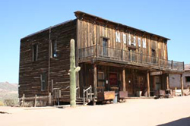
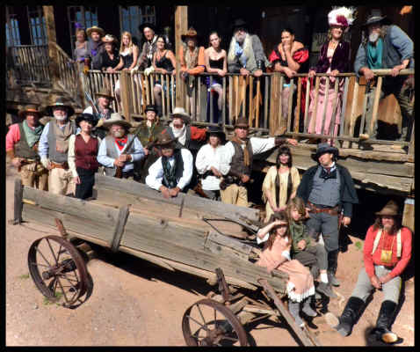
Complete with restored buildings and a whole crew of gunfighters and saloon ladies

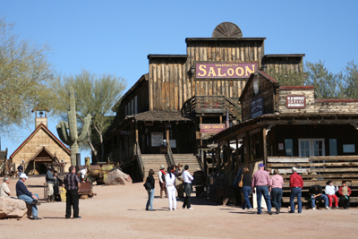

It is believed that there is still 175 Million in Gold in this ground.

You Are Beautiful!

For years now, I have been working in my own recovery. Prior to my real work starting, I was a part of what is called “religious addiction” for over 20 years. During that time, I look back on those years as a blessing because at least I was more safe than when I was in the substance abuse/relationship addiction period. But, what I have learned over these last years is that religious addiction or spiritual abuse can be just as damaging to our hearts and our emotions as any other type of abuse.
Recently, a couple of things have happened that reminded me of just how serious a subject this is to write about and consider what God’s truth tells us about this matter. Many have been hurt by the “organized religions.” You could be one of them. You may be a person who has not been directly hurt, but maybe you’ve seen others be hurt by the things that take place in this world. Just because a building has a cross on it or the name of Jesus on it, does not make it immune from the pulls and distortions of this world (Matthew 15: 8-14). This world is hard and keeping the things of this world out of the church is a battle that has gone on since Jesus noted it with the Pharisees. That struggle has not gone anywhere (Matthew 23). I recently had a friend who is a Christian be discouraged for her own unique views instead of being embraced for being special and beautiful in the Lord. We all have different gifts. We are supposed to. Even in scriptures, there is an example of two of Christ’s disciples going their separate ways because their gifts were not the same. We are not supposed to all think exactly alike. I believe when God talks to his church about being of one mind, he’s speaking of love, the unity that ties us together beyond mere ideas or opinions that we carry (Mark 9:35). Love covers a multitude of sins. The unity we carry is that we should be willing to do anything that we can for one another out of the love that we share (John 13:12-15).
I simply want to encourage you and tell you that you are beautiful in Christ Jesus and share some scriptures that help you to keep your chin held high in being a child of God. We may see hypocrisy in places of worship, but it’s because people make up the Church (Ecclesiastes 1:9). The Church truly is not within the walls, it is free and flowing throughout this world. Sometimes certain places of worship have very specific rules or guidelines they ask you to adhere to in order to be a member. I personally don’t ever apply to join any fellowship. I am a part of the Church, the very bride of Christ. How you join that real place of fellowship is by accepting Jesus as your Lord and Savior and doing your very best to live as Jesus lived and allow the blood of our Savior to cover your sins.
There is no condemnation in Christ Jesus. There are no rules or regulations to follow. The governing guideline from Jesus is that we love our neighbor as ourselves. There are many scriptures that tell us exactly what our focus should be (Romans 12: 9-18). We should be loving and watching over the orphans and the widows and visiting and loving those in jail and prison (James 1:27). We should be loving our enemy and reaching out to serve those who are lonely hurting and lost.
I love worship. I love to sing and praise our mighty God. He is worthy of all praise. I believe we need to meet together and the scriptures teach us to not forsake getting together. I also feel it’s fine to look for and be a part of a place to worship that builds you up. God did not come to this earth to beat us down. This world has quite enough of that capacity through Satan’s influence and that is not from God. We are one in Christ Jesus (John 10: 14-18). There are no barriers or rules that can divide us if we don’t allow it. We can stand strong in our faith, knowing we are not perfect and we never will be perfect on this earth, none of us will be. In that we are in agreement, that we all need Jesus, we all need love, we all need acceptance just as we are and let God be the one to heal and move in our lives. Leadership can be so, so good…………to guide us into a deeper understanding of the truth. To teach us and allow us to hear God’s word. Our faith is built up from hearing the word of God (Romans 10:17).
Fellowship can be wonderful. I look at the early church and how they cared for one another (Acts 4:32). I encourage you to not get discouraged by things of the past, if someone has hurt you in an organized religious setting. Look to Jesus (John 13: 13-15). He will heal those old pains. Fellowship is good. Allow God to minister to you and find a place of fellowship that speaks to you and encourages you. It’s OK to be a little picky about your family in God. You did not get to be picky about your biological family, but it’s alright to look for a place to worship that lifts up your soul and allows you to soar like an eagle. It’s out there. I’ve worshiped in many fellowships just as I described. We are free in Christ Jesus (Galatians 5: 1-6). Free to express ourselves, free to be a little or a lot different, but of one mind when it comes to love (Galatians 5:13-15).
You are beautiful in Christ Jesus and we were made to love. Let others build you up in love. We were made for this very purpose, to fellowship with our Lord, fellowship with one another, learn to live in the fruits of the spirit (Galatians 5: 22-26) and persevere in doing our best to follow the example of Jesus and His love.
Carol Ann
Write her at her P.O. Box

The Passing of Shadow – May 30, 2011


Shadow (Left) and blind Dodger (Right) Shadow for his last few days on Earth

Many of you may remember the tribute story in Volume 11 of M.O.M. of our dog Rigger that had gotten out of the yard and hit by a car (07/07/05 10:11PM). Recently our Dog “Shadow” had his health take a turn for the worst after approximately 16 years (112 Dog years). The same thoughts went thru Bob & Linda’s minds as he passed away.

This situation brings to mind a true story I heard from an individual
The individual telling the story had raised dogs for the military and the police departments. He said that these large dogs scared him.
He was now part of a family high wire act traveling with the circus. He, his wife, and daughter were continually on the move. He decided that he would not have a large dog since he could not keep it in the house (a travel trailer actually). He also did not want one of the small dogs because he felt that it could not do any protection.
Well the daughter started asking him for a dog. He would tell her no. Then one day, his wife found a middle-sized dog that had been abused. The dog was under nourished, had fur missing, and needed a bath. The topside of his tail was bald. This was one of those dogs that as you looked at it, you would think to yourself, “stay away.” The wife cleaned it up, fed it, and gave it loving care. The daughter fell in love with the dog.
However, the dog had one problem. Because of abuse in his past life, anytime he was cornered, he would growl and bite at whatever was cornering him, even family members.
One day the dog was in the trailer and under the small dining table. He refused to come out. The daughter decided to crawl under the table to get him out. The dog lunged and caught the girls face, requiring about 30 stitches. The friends and relatives of the family said to destroy the dog. The father stated that the dog was known to do this type of action when cornered. The people continued to say the dog needed to be killed. The father said that he would not do it and would protect the dog from the friends and relatives. The relatives went further to say that the next time the father was out of town for a crusade or performance; they would dispose of the dog.
Well as time went on the family continued to love the dog, even the daughter as she stated that she understood the dog’s actions. Then one-day the dog started to have seizures. They would start off with one every few days, then daily, and soon they were happening multiple times per day. The wife loving the dog, laid a blanket on the floor beside the dog’s bed and placed the dog on it where she would curl up with the dog, petting it and trying to sooth it during it’s time of seizures.
As the seizures got closer and closer together, soon the dog died. The friends and relatives of the family were relieved and rejoiced that finally the dog was dead. However, the family was filled with sadness. For you see, no matter what the dog had done, these people loved that dog as if it was a member of the family, and truly it was!

All of Bob and Linda’s dogs have been rescued from the SPCA. Yes we even go into “Doggie Prison” and save lives.

Now as we look at those individuals that are incarcerated, we often see them much as the friends and family saw the dog – worthless and needing to be disposed of. However, the family members had learned much from the dog in caring for it. They had gained much love in their lives from the dog being a part of the family. Worthless was a word that just did not fit in this family’s vocabulary. We need to think of these individuals the same way as the family that loved the dog. We need to do it before we might come to that point in life that we ask questions such as “Did I really present the plan of salvation to him?”, “Did I show her love?”, ”Was he living his lifestyle because of past abuse or unhappiness?”, and “Was there something I could have done different?”
Also realize that as we restrict these loved ones, they will desire “getting free”, much as Rigger did from the yard. They do not understand the dangers out there and our trying to protect them. Having to watch the passing of Shadow brought sadness to Bob and Linda as we thought of all the Joy he had put in our lives and the love he devoted unconditionally. Then we think of how Christ did the same for us with unlimited love and actually died for us. Yes, when individuals reject Christ, it also brings sadness to our hearts.

Lighter Side

************************************************************************
Actual Advertisement Ads
TOMBSTONE: Standard Gray.
A good buy for someone
Named Grady.
HUMAN SKULL USED ONCE only. Not Plastic. $200 OBO
Dr. Scott Tyler.

Get
50% off
Or half price
Whichever is less.
Statistics show that teen pregnancy drops off significantly after age 25
One-armed man applauds the kindness of strangers

County to pay $25,000 to advertise lack of funds

************************************************************************
“Am I a Christian? On Path?”

I really don’t know where to begin. I guess I can start with a “Thank You” for caring enough to reach out through M.O.M. it really means a lot to me, that I have befriended two such people. Believe me, I truly know what its like to sit in here, with doubts and pains that no one knows you exist.
But I’m getting off the path. I’m suppose to be writing a testimony. I will begin with a little about myself. I’m forty years old, and I’ve always made bad choices my whole life. I come from a big family, two brothers and two sisters, a very poor family. I was born in New Jersey, moved to the south at a very young age. My father was an alcoholic, beer of any kind. That left little or no money for even food on the table, let alone things like birthday presents and such. We moved around so much, at times I found myself starting different schools in the same year. There was no Christmas, no birthdays ever; I didn’t even know simple things like people celebrated anniversaries, Easter, even no Halloween. There was never any new clothes for school. I never slept over at a friends house. No Sunday school, no church and dad promoted fighting among us boys. I can clearly recall a memory at an early age, where dad took two belts, gave them to my older brother and me, then told us to hit each other. Of course he was drunk at the time. Another memory of dad handing us a carton of Pal Mall cigarettes, telling me to stick them in my waistband and walk out of the store. I was seven or eight at the time. Words will not begin to describe my childhood.
Then, one at a time, dad drove his kids away. My older sister married at the age of 15 to get away. Then my older brother left at 16. I ran away at the age of 16, to go live in Sanford, FL. Things were alright for a while. I lied about my age, found a job and rented an apartment. But I had the need to be liked so badly, I fell in with the wrong crowd. Then came the lying, boosting cars, shoplifting, different women, and stealing from my employer. Chaos ruled my life. (However, one good turn, I was never into doing the drug thing)
Then at 18, the night that changed my life forever. I was with a man that murdered another man. We were both charged with first degree murder, first degree arson, and use of a firearm. Hardly knowing anything about the system, I pleaded out to 30 and 15 years running wild, giving me 45 years to do.
I faired no better I prison. Since 1990, the date I was shipped from the county jail, I’ve learned to fight, smoke, lie better, and gamble. Over the last 21 years, I have been moved from prison to prison because of my problems. I lost all my gain time, backing my date up. I have stole from friends, lied to anyone I could, just to turn a gambling dollar.
In late 2004, I tried to kill myself. Wrapped a sheet around my neck, tied the other end to a second floor rail and jumped. The sheet broke and I injured my back and broke my arm. I was put in the nut ward, where it was a nightmare. Then released and spent the next few years going from prison to prison. Always trying my best to hustle a buck.
My father died in 2001, my mother passed away in 2002. my little brother followed me to prison. Lost contact with both my sisters, and my older brother doesn’t write.
So, you see, things I needed, like deodorant, soap, snacks, smokes, I had to get it off the land, so to speak. I was never one of the lucky ones, that received money orders. I can’t begin to describe what it feels like to have mail call and never hear your name called. We tough guys act like it’s no big deal, we just went on with our poker games and football bets.
Then Oct. 30, 2009, I was sent to Gainsville. A private prison, with more of the same. Almost 4 ½ months later, I was involved in an incident, or theysay I was involved, where an inmate was killed. They sent me to Max in F.S.P., charging me with second degree murder (the charges are still pending). I spent almost 11 months on Max, then moved CMI, which is only a lower level of Max.
But for the first time in my life, I can say, I’ve grown up. I got back in contact with a friend that I had written on and off for 15 years. She is a Christian, she doesn’t do any writing now, just accepts my one call a month. I have completed one Bible study and am currently working on another. The Salvation Army study (however I lack the stamps to send in the first 11 lessons. But I’m confident something will come up). It is a very in depth study. I exercise in my room daily, read a lot, and feel I’ve truly found peace. I wish I could have done this years ago. I would be out of prison now, instead of facing more time. I have stopped cussing and quit smoking cigarettes.
OK, do I call myself a Christian? No I don’t. Because I’m not really sure of the definition, even though I’ve completed a Bible study. Do I pray? I’m not sure of that either. I do believe in God and that Jesus died for us. I talk to both all the time. Do I want to be strong in faith like you and Linda? Absolutely! Can I is another question. I have to take baby steps and never look back. There is no road into the past.
Jason R.
************************************************************************
Graphic Truth

I’d write out my testimony, but truthfully I don’t believe it would ever be published, because it involves blood drinking, animal sacrifices, digging up graves for items like its wooden caskets, nails, human ash, different plants and roots in and on the grave, and the spirit of some graves, orgies, drinking, and calling the demons to do different stuff. I used to be a high priest of the Pagan Witches of the Dragon.
Believe it or not, I married a Christian lady in 1983. after we were married, she learned I was in the occult. She told me “oh well, I married you for better or worse, and we cannot get any worse than this.” For 21 years she prayed for me (I went to prison in 1990-92). Still stayed with me on parole 6 years 7 months. Stayed with me 1999-2004 stayed with me. When I got a letter from her in 2004 she begged me in a to give her God a chance, and that I could not write to her because she would never receive it because she said she’ll be with the Lord Jesus Christ. When the hurricane hit Honduras, she left me. Kairo’s Sept 12004. I accepted Jesus Christ as my Lord and Savior. God’s given me a whole new life. I’ve never had a nightmare, dream, or desire to return backto where I once was. God has given me the ability to discern spirits, see angels, interpret some dreams, speak in tongues, lay on hands for different things, and prayer warrior. And God has given me back my family, mom, dad, sister, 2 brothers, 2 daughters, 1 son, 12 grandkids, and 3 great grandchildren. I guess in a way, I did give you my testimony.
Larry S.

Cell Grateful
Today as I sit in my cell here at Corcoran, I am so grateful! Some may say how can I be grateful to be in a cell? See, only I (well, besides God) knows exactly how I was living my life out there. Because of our prideful nature, we never tell the whole truth on what we were really doing, or not doing. Fearing how the next man might think of us. But “nothing” is hidden from the eyes of God.
Each day is a battle in here, to not go off doing my own way. Only by the strength of the Holy Spirit, do I make it each day. Only by the love of God, am I able to stay full of joy, regardless of the situation in a place like this. Only by the wisdom & guidance of our sovereign God, am I able to stay away from situations or places I should not be. No matter where you are at this moment in your life, whether in a prison cell, or on the streets, please know and believe that God loves you so much and has a plan and purpose for your life that you could never bring yourself. No matter how many times you have let go, and turned away from God, God has never let go of you, and He is waiting for you. In those moments that you need that comfort, that a mother gives her newborn, God wants and will help you in his arms, and comfort you, and give you the peace and love that you are so desperately seeking. Only look up with your eyes and an open heart and receive His love & grace. Don’t let your pas mistakes dictate your future. God will forgive all our mistakes we once “lived,” because He is calling you to start “living” a life filled with blessings, you never imagined possible! Let’s start living for God.
Nelson P.

God's Wings
One day in the forest, a little sparrow just gave birth to 3 babies. Because of how happy and proud she was, she began to sing. She sang so loud for all the animals of the forest to come and see what she had done. So here came running towards her were all the animals of the forest, almost like a stampede. But they didn't stop at the nest to see her babies. They just kept running. The little mamma bird was so sad that no one had noticed so she cried. What was going on was that there was a horrible forest fire coming her way. An animal’s first instinct at the presence of danger or peril is to fly or run away. Well, the mamma did not fly away. She prayed to God for help. God told the little bird, just as He has spread His wings during her life for protection, now she must spread her wings over her children and protect them. So she listened to God and spread her wings. She noticed that the fire was not only coming her way, but that it was rising up each tree. So she decided to take each of her babies out of the tree one at a time. She placed them at the bottom of the tree and prayed to God again. God again said, "Spread your wings over your children and they will be fine." She did what God told her and here came the fire, but she did not move. Well, the sad part of the story and life is that the mother bird was killed in the forest fire. The next day as the fire was being put out, 3 forest rangers noticed a little bird at the base of the tree with her wings spread like she was trying to get away but was caught in the fire. They saw a perfect statue of the mother bird, with her wings spread wide open. The forest rangers said a prayer for the little bird and gently picked her up with a shovel and to their surprise all three babies started chirping. They survived because of the unselfish care and love of their mamma. If you just believe, anyone can have refuge under God's wings. Charles Ochlech
In the Spotlight – God’s Shining Light

Bob and Linda have been treated like they are celebrities in the jails and prisons.

While doing ministry in one of the units Bob goes to, one individual while looking at the newsletter “Letter From M.O.M.” asked Bob if he knew the people of M.O.M. Bob replied that he and Linda were M.O.M. The individual replied "You know these people?" Bob said "We are those people." The inmate said, you mean you are Chaplain Bob? Bob said “yes.” The individual grabbed Bob's hand and started shaking it with joy. The individual said, “I Finally get to meet you, I have been reading your Newsletters.”

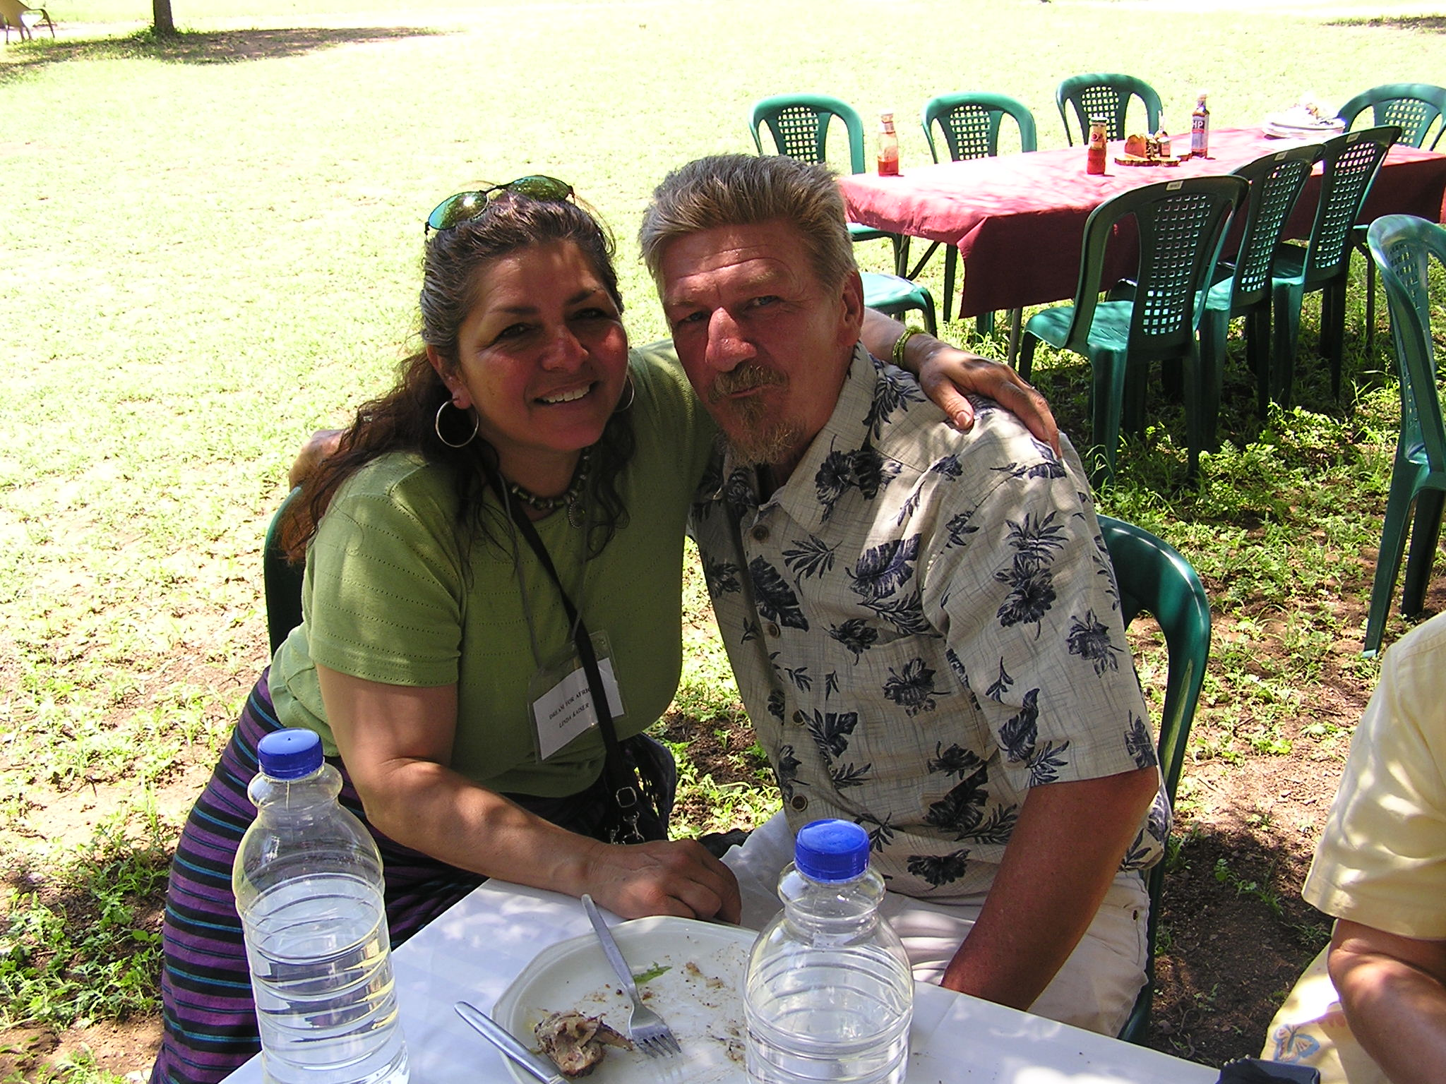
Linda usually goes into unit 12 at Bob Wiley Detention Facility, but due to two other ladies going into unit 12, Linda went into unit 11. Linda had a lady in unit 11 of Bob Wiley Detention Facility that kept motioning for her to make sure she stopped at her cell. When Linda got there, the lady said "I know you." Linda said "have I talked to you before?" The lady said "No, but I have something to show you." She produced a 'Letter From M.O.M.' and showed Linda's testimony and her picture. She said "that is you!" Linda responded "yes."

The lady said "wait a minute, I have something else to show you," and produced a picture of Linda and the movie star Branscomb Richmond of Rennegade fame. She said "that is you too!" Linda replied, "yes." The lady said "I have so wanted to meet you."
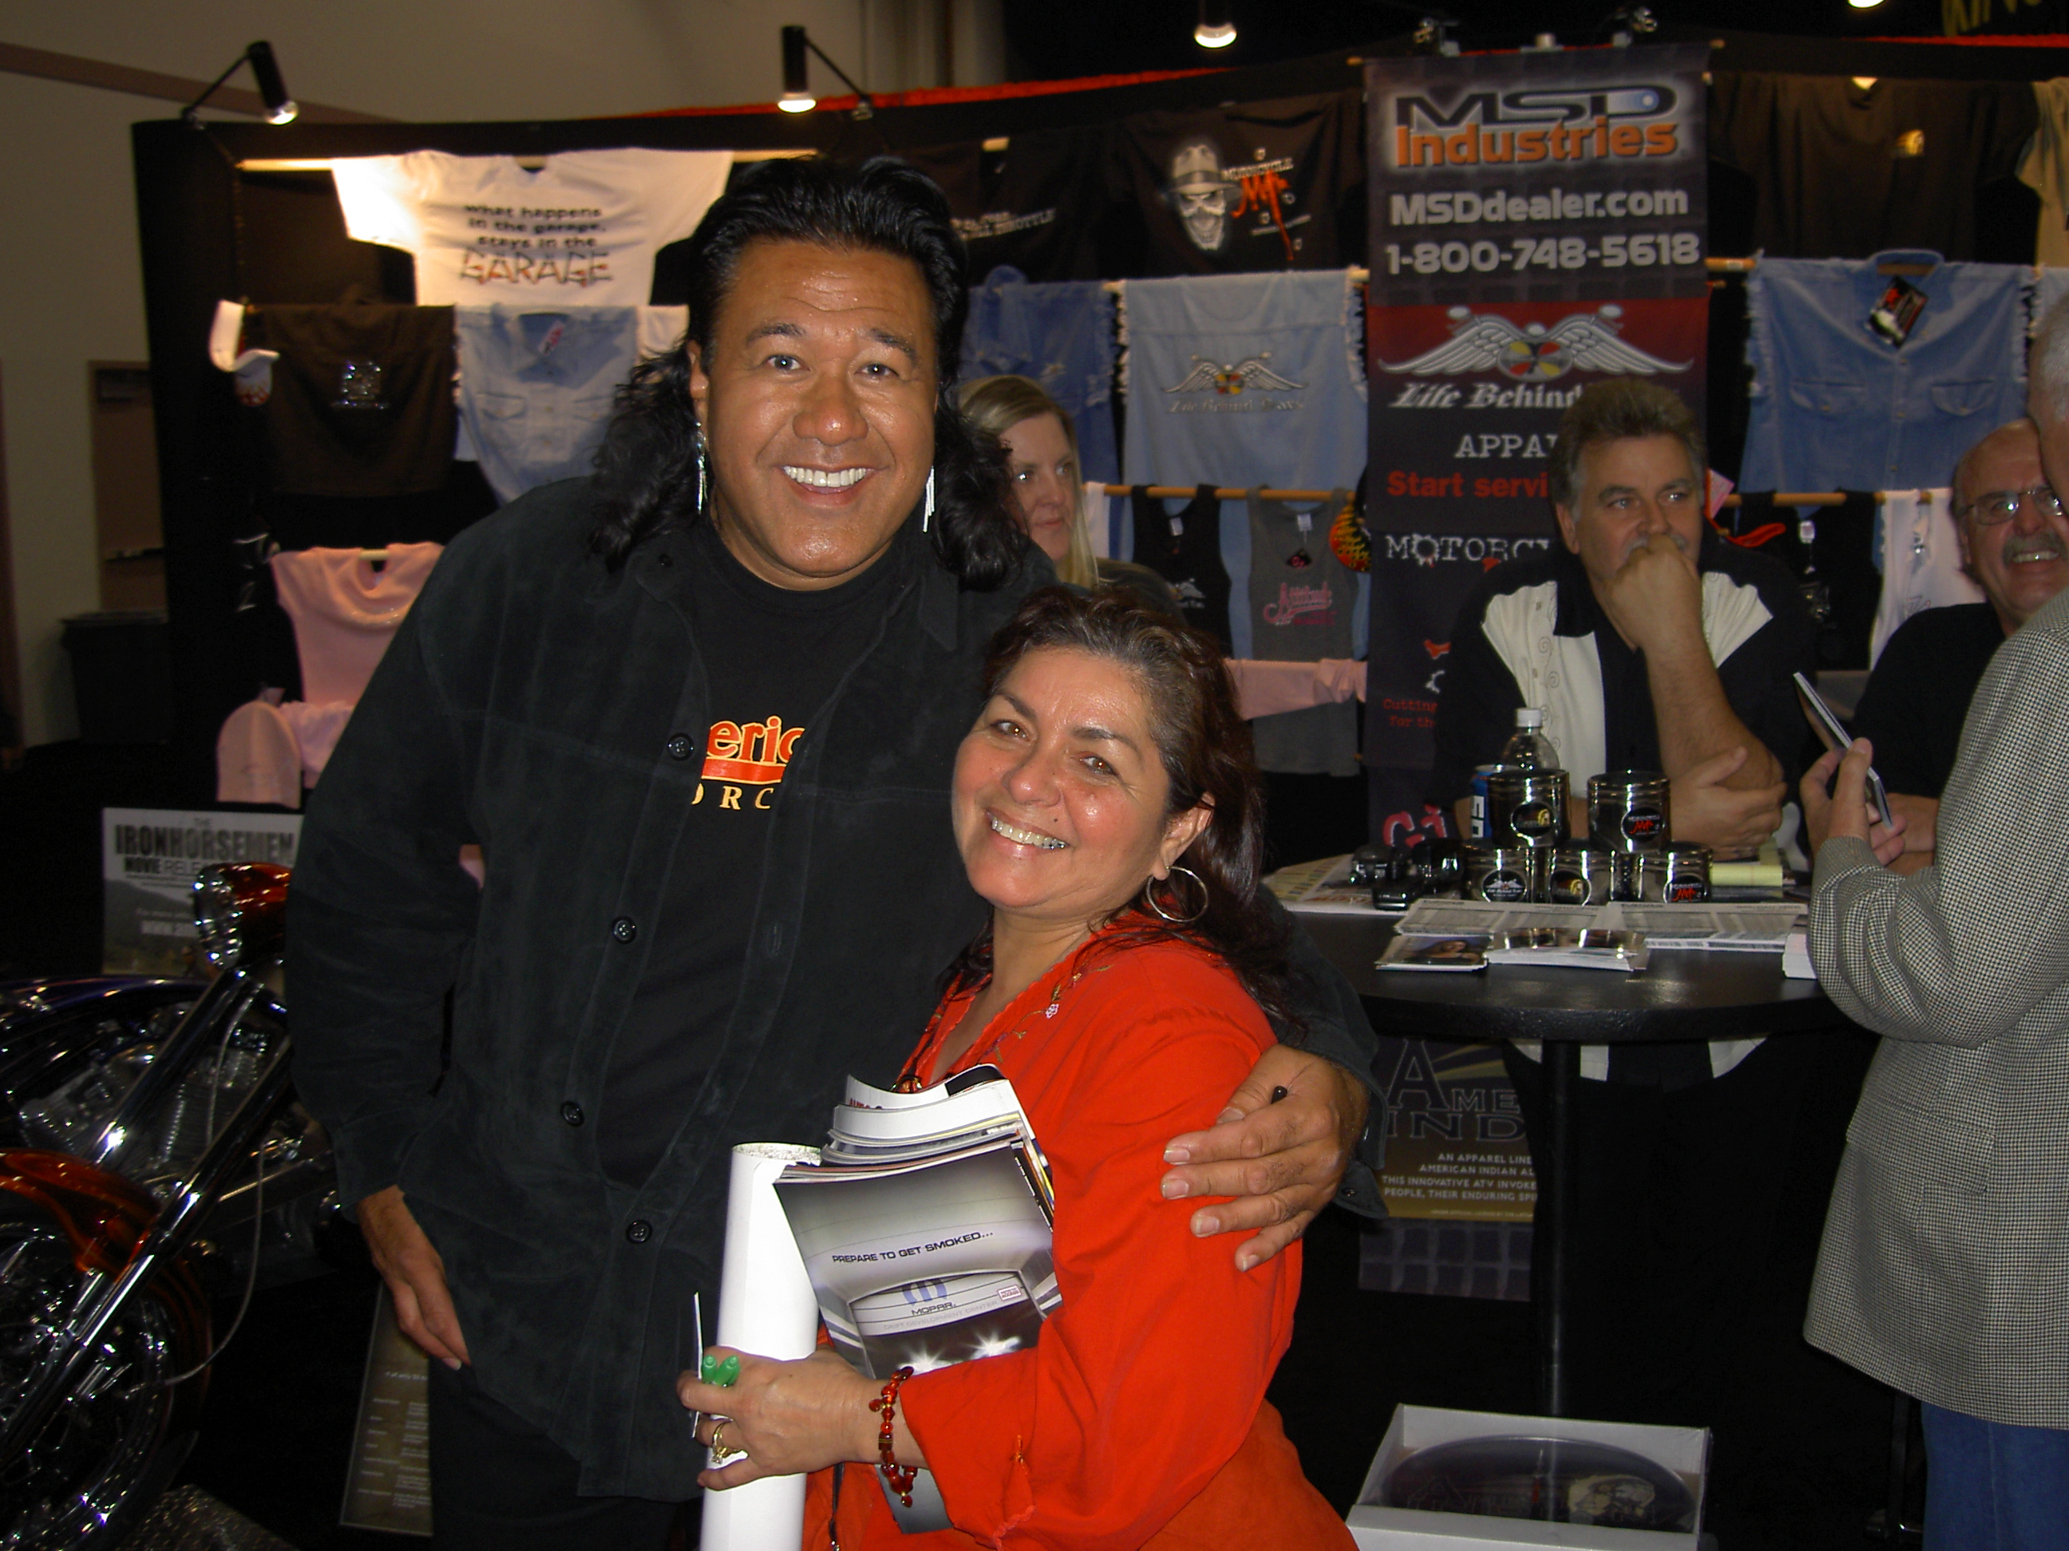

Guess there was a reason why God had Linda go into unit 11 that night instead of unit 12.

Truly Bob and Linda get to meet some great men and women serving God.

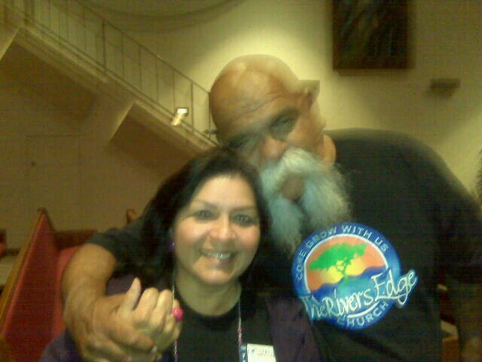
Big Al , originator of the Mongol Nation, but now serving Christ full time. Those that have read of Al’s pre-Christ days, are glad he is now a Christian.

Linda & Big Al of Mongol Nation

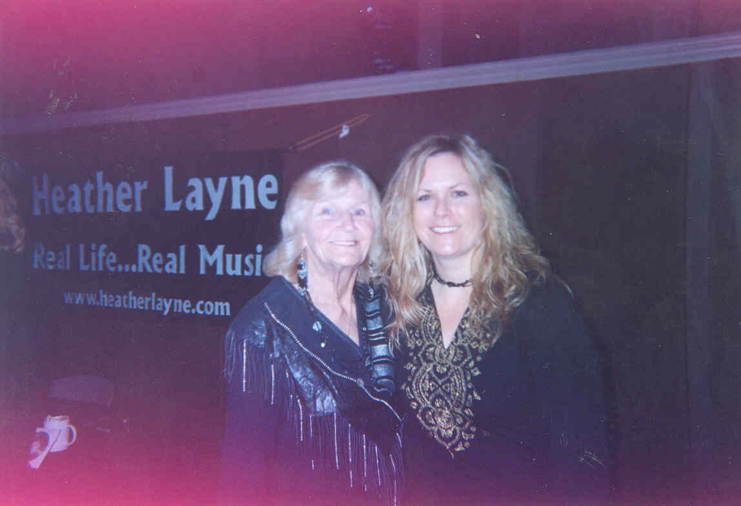
Jeanne (Mom of M.O.M.) with Heather Layne at concert.

Heather is now a national recording artist with 6 albums. Heather and Denny have dedicated themselves to reaching out to inmates.

Heather has done 4 concerts at Corcoran Prison with Moving On Ministry.

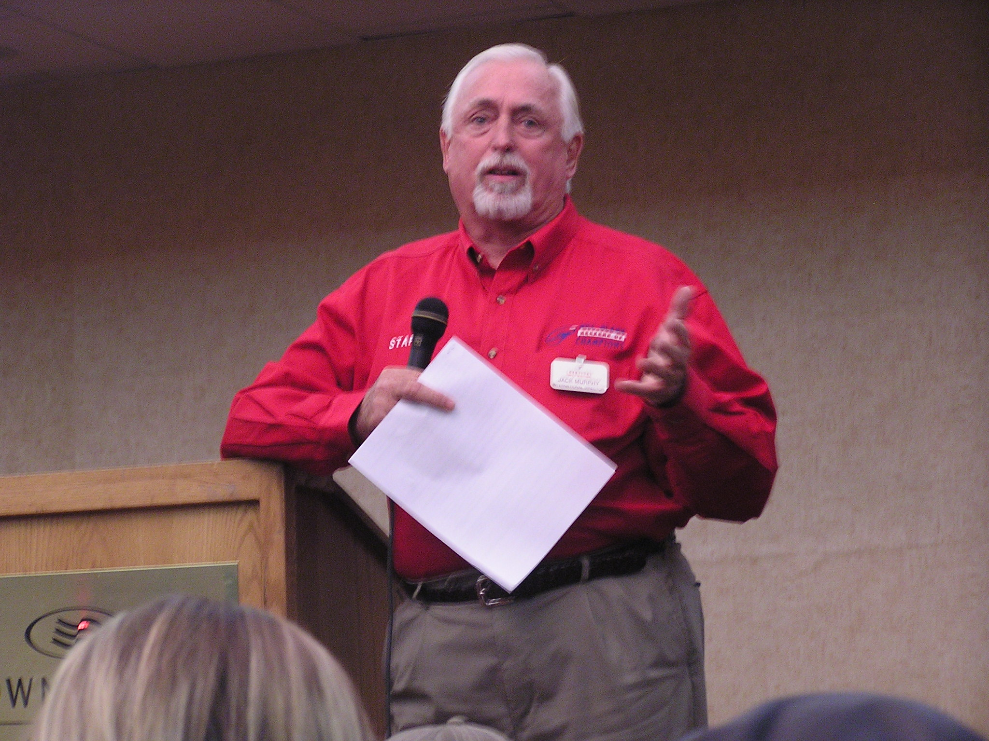

Jack (Murph the Surf) Murphy

Notorious Jewel thief that went from death row, to double life (EPRD 2144) to Servig Christ in the Bill Glass Ministry.

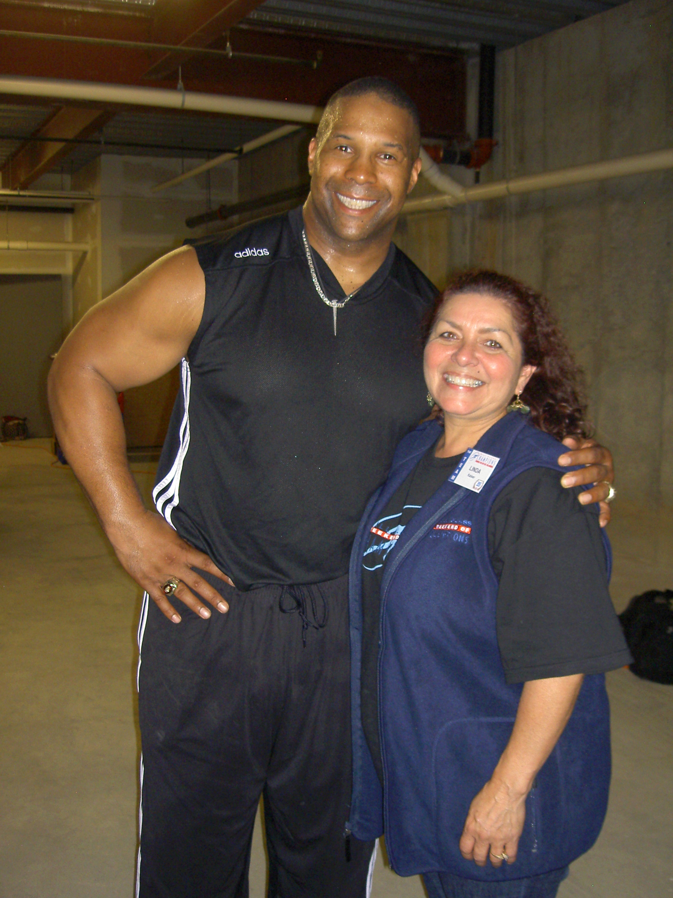
Keith Davis and Linda

As Linda and Bob did many of the Bill Glass Weekend of Champions prison ministries, they had the privilege of working with many great men and women of God.

Keith Davis was one of these great people. Keith would do strength displays by breaking an oak bat over his knee, tearing a phonebook in half, rolling a cooking pan into a burrito, and bending a steel bar in his mouth.

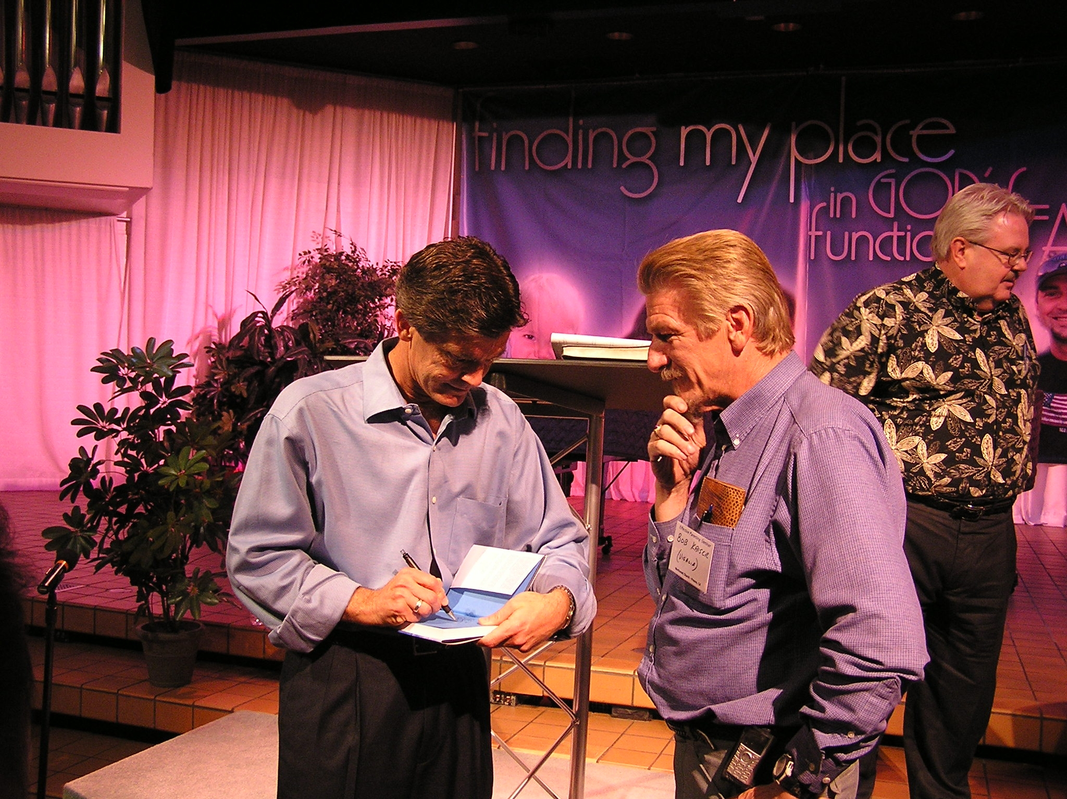

Pastor Chip Ingram with Chaplain Bob.
Pastor Chip is well known for his programs of “Walk Through the Bible” and “Living on the Edge.”

What Do We Offer, and What Do We REALLY Have to Give?

Thank you for enclosing “The Apple of God’s Eye” printout. It lifted me, as I’ve been under a lot of crazy stresses lately. Somehow, it seems that my last year in prison is destined to be my hardest. Funny how that works, huh?
Bob, I tried looking for you at the Bill Glass Crusade when you were here. They (volunteers) were on our yard for one day, and so I walked right into the mix to look for you, and immediately realized that wasn’t the greatest idea. I felt like I was a chicken that walked into KFC. Eeep! Everyone started looking at me and my yamaka, like I was the prime rib for potential “saving” and I bolted outta there right quick when I saw you were nowhere to be found. A shame, because I would have seen you and caught up on yours and Linda’s life.
I’ve noticed that there are now a few people on my yard (and in my building) that now get your newsletter, but none of these guys really talk to me, except one. They’re too busy telling me that I’m going to hell for not believing in Jesus, to become friend with me. They’d probably be really surprised to find out that not only do I know you (Chaplain Bob), but I have been to your home, the one in all the pictures from your newsletters. I don’t understand the hostility that a lot of Christians have towards me. I personally ascribe to the viewpoint of Rabbi Abraham of Kook, who was the chief Rabbi of Palestine before World War II. He said; “The diversity of religion is a legitimate and permanent expression of the human spirit. The different religions are not meant to compete, but to collaborate. Each is a path through which God is seeking to raise man to Himself.”
He also said; “The holy are, praised be He, bestowed mercy on His world by not confining His endowments to one place, one person, one people, one land, one generation, or one world, but His endowments are diffused, and His quest for perfection, which is the most idealistic striving of our nature, directs to seek the higher unity that must finally come in the world. In that day – God will be one, and His name One.”
If only we as people could emulate this to bring unity of God, and peace to earth. But I shant be deterred, it’s my responsibility to be a light unto the nations and to spread the unity of God the Father. Aaron B.

NOTES FROM BOB: During the Bill Glass Ministry, Bob and Linda were assigned to Madera County Jail and did not get to be on Avenal Prison yard. With Aaron’s statement, ”my last year in prison is destined to be my hardest,” may be to see a subtle reminder that this is not the place to be. Realizing what we don’t want; sometimes helps us to realize what we do want.
Chaplain Hollowell of Avenal State Prison in California said, “You volunteers come from many different faiths, Buddhist, Pentecost, Jehovah’s Witness, Mormon, Lutheran, Baptist, and such. What you have to offer these individuals is better than what they had.” I had to stop and look at my past life as I searched for the “True God” and realize that many of the processes and steps I took were actually something that helped me to seek out the relationship I now have with God. Pastor Bob Oakley once told me, “You cannot tear out the bad foundation on a house, until you have shored it up with a better one first.”
Poetry
************************************************************************

THE PROMISED LAND

Love me, Lord, and share the moment
You will set me free,
I can’t wait to share your glory
When rapture comes for me

Love me, Lord, though I’m not worthy
I am he who tries
To seek your blessing, read your story
Of He who lived, and dies

Love me, Lord, and rise again
To take your place, and lead
Lead me to the Promised Land
You are the one I need

Love me, Lord, bestow your blessing
In glory you’ll return
Impatiently, I look to heaven
Come, Dear Lord, I yearn

Love me, Lord, and save my soul
As only, Lord, you can
I see, Dear Lord, just as you said
I see the Promised Land

David Marsh
4-27-11

HE PROVIDES

No matter how many tears are shed
His promises are true.
No mater how long it takes
His timing is set for you.
No matter how alone you feel
His arms are there to comfort you.
No matter how down you are
His glory chases away the blue.
No matter how small our faith
God always provides for me and you.

Melinda Seitz

THANK YOU LORD

Thank you Lord for rescuing me
Thank you Lord for the blessings
I cannot yet see.
Thank you Lord for setting me free
Thank you Lord for taking control
Of my destiny

Melinda Seitz

************************************************************************

DELIVER ME

Deliver me Lord. Deliver me oh Father. I really don’t mean to be such a bother. But I have lost my way. I feel my heart going astray. Sin has broken thru my wall. No longer am I standing tall. The pleasures of this world have caught my eye. The freedom I once had; has passed me by. Tears fall like the winter rain. My body is in two with so much pain. Do you have the answer to my lonely strife? Cause Lord, I really need you back in my life.
Bobby Rodriguez

************************************************************************

Drawing by Melinda Seitz



