“Letter From M.O.M.”
The Monthly newsletter of Moving On Ministry

WWW.MovingOnMinistry.com
www.PrisonMinistry.net/MovingOn
Volume 52 – December 2009

“I Can Only Imagine”

As you receive this volume of Letter From M.O.M., we have many new writers of articles, we are putting some more of the testimonies of “How God Changes Lives” as well as some of our own written articles. We can truly say that the “high” that many of our inmates have been trying to get through the wrong methods, is being surpassed by those putting God in ownership of their lives.
Watch our website www.MovingOnMinistry.com

We are affiliated with International Prison Fellowship
http.//PrisonMinistry.net/movingon

and Good News Jail & Prison Ministry Volunteer
www.GoodNewsJail.com


Intentions & Wishes

The intentions of this newsletter are to allow an understanding of jail & prison ministries. It is our intentions to get input from those incarcerated as well as those “free” to visit. Life experiences of the faith and fellowship from those locked up in the facilities are always desired to let others know of the value of “visitation”. I am certain that each of us have many stories of the miracles God has done in our lives.
Our wishes are that we would have a list of supportive churches that individuals might look forward to attending once released.
A list of services, such as housing, employment, and counseling services, as well as some individuals available for friendly fellowship are also much needed items.
God’s Word says if a man stumbles, how can he continue lest there be another to help him up. Ecc. 4:10 “For if they fall, the one will lift up his fellow: but woe to him [that is] alone when he falleth; for [he hath] not another to help him up.” Proverbs 24:17 “Rejoice not when thy enemy falleth, and let not thy heart be glad when he stumbleth:” John 11:10 “But if a man walketh in the night, he stumbleth, because there is no light in him.”
Please help us with input for this newsletter as we strive to serve God. We appreciate any articles or input.

Addresses to contact Ministry Volunteers

Moving On Ministry
Chaplain Bob
P.O. Box 6667

Visalia, CA. 93290

Moving On Ministry
Spanish Ministry - Linda
P.O. Box 6667

Visalia, CA. 93290

Moving On Ministry
Volunteer Bryon
P.O. Box 6667
Visalia, CA. 93290

Jesus Prayer Ministry
Sis Denise
P.O. Box 7925
Chula Vista, CA 91912

Andrea Shannon
P.O. Box 553
Dover, NH 03812

For 2009, Bob is doing Bible study at BWDF on Mondays.
The Sunday after the 2nd Saturday of each month is Moving On Ministry’s assigned day for 3 to 4 chapel Services at Corcoran State Prison (“Old” Corcoran).
Bob was rechecking for CMC clearance & Bob is doing Wasco 1 or 2 Saturdays a month
We have stopped doing the Miramonte Conservation Camp #5 chapel services every other Friday, due to lack of attendance.
Bob and Linda have also applied to do services at SATF Corcoran prison.
We are now a part of “Awaken Church” with the prison/jail ministry.

M.O.M. Needs
- Pen-pals to write inmates
- Finances
- Testimonies
- Possible sale of Squaw Valley Property (Camp Clarius)
- Development of Nevada property
- Development of Arizona property
- Graphics artist for books
- Drawings to publish and share
*********************************
Thoughts from Bob;
As we have just come out of the day we celebrate as “Thanksgiving,” we now approach “Christmas.”
Many celebrated Thanksgiving, but did they do it to God or do it to man? We see those that celebrate, and yet continue in sexual sin, drug addiction, materialism, and putting other things as gods before the God. We see people professing to give thanks without enabling the respect and relationship with God. I often look at these relationships as the bride that might profess with her mouth of her love for her husband, yet tries to live her secret (and now days even openly) life of disrespect to the husband. How often are we guilty of doing the same as the ‘Bride of Christ’?
As we go into the Christmas season, do we recognize why Christ was born, and came to die for our sins, that we might have life more abundantly? Or do we continue in sin, and deny Christ? I believe that God must be respected all times as with Christmas, Easter, and Thanksgiving
*********************************
Ask for a copy of our complete “Resource Supplemental Letter”

What is "Jail Ministry?"

(1) It is "out-reach that goes beyond in-come"
(2) It is God making House-calls to inmates
(3) It is Dedication and not just Convenience
(4) It is saying "yes" to something, you previously told God "no"
(5) It is gleaning from fields already picked.
(6) Realizing that but for the Love of God, there am I
(7) Providing God's Grace and Mercy when needed (always)
(8) Putting God as a priority, instead of a choice.
(9) Treating inmates with the same dignity and priority we would treat family.
(10) Taking God to those that feel they are not worthy to come to Him
(11) Knowing our God is able to deliver us from harm, but if He chooses not to, we still choose to go.
(12) Showing up to where God has chosen you to do His work
(13) Being part of a 'team'
(14) Being a light shining in the darkness
(15) Just being there for 'whatever'
(16) Being a Fortress of Truth, in a World of Lies
(17) Reading an individual's mail to him, who can just barely read or write
(18) Going in to share God's Word, when it is not normally convenient for you.
(19) Often just pointing the way, without saying anything
(20) It is realizing that God does just as we do, keeps His valuables behind lock and key with armed guards.
(21) Realizing God does not have vacations or Holidays, and keeping the coverage.
(22) Displaying a life that is desirous.
(23) Realizing it is more of Him, and less of me
(24) Not taking credit for God's Ministry

Send us some ideas of what you see as Jail and Prison Ministry and perhaps some examples of how these things have been displayed. We have individuals that do not volunteer because they do not really understand what the ministry is.

Letters that Express it All

We like to post real life situations, because God works in real lives and He is the one that gives “Eternal Life.” Every week we get many letters that state “I love hearing the testimonies.” There are so many, we cannot publish them all, and the sad part is – people not involved in jail / prison ministry do not get to read the many letters we receive daily (average 2 to 11 each day) and try to keep up with and answer.
********************************
Chaplain Bob,
Good day sir. First and foremost I hope all is well with you, your family, and the church through our Lord & Savior Jesus Christ. Well I read the monthly “Moving On Ministry” and I just want to let you know we appreciate the things you put together. We, meaning the Brothers in Christ on this yard 3C. We also want to thank you for putting together that little concert (Heather Layne). It was truly a blessing from God. After the service, the Brothers went out and told all the other Brothers how they missed out. It was a surprise, last minute, unexpected service. The Brothers who missed, wanted to know if that musician lady can maybe come back and perform again, if it is possible. But, it be announced next time if possible. Also, Chaplain Bob, I wanted to let you know how blessed it was to see you. I met you at Bob Wiley Detention Facility (BWDF) in unit 42, then unit 22, and now here at Corcoran. I’m Matthew, that youngster that talked to you before the service. I look forward to your next appearance. Well, Chaplain Bob, I just wanted to share with you these thoughts. May God bless you and your loved ones. You are appreciated chaplain.
Matthew R.

NOTE: Heather will be doing more concerts;
CCWF Chowchilla – Dec. 19, 2009
Corcoran State - - - – Apr 11, 2010
VCPW Chowchilla - Oct. 9, 2010

********************************
Dear Bob & Linda, things are going well. Yes, I did get a job with Bekins Moving Co. I’ve been working for 2 weeks.
My license has been released & I took the test today and passed. Now I have a license too. The feeling is so good & strong, I almost can’t contain it! I just want to yell so loud! I just get the jitters!!
I want to thank you for your support and prayers. I know it was God working in my life. I thank Him every moment. Oh, thank you for the letters that come from other people & their testimonies. Well that’s all for now. Thank you & God bless you both.
Joaquin S.
********************************
Bringing Life to Death Row
Chaplain Bob & Linda,
Thank you for this newsletter this month. It’s nice to receive the Word of God through the mail, when your having a tuff day in a grumpy mood. At the end of the day (like today), it changes everything. Thank you guys for caring.
I’m enclosing a poem (When I say I’m a Christian . . . published in this issue) a friend sent to me. I hope you guys find people to share it with. Here on the ‘Row’ we had a copy hanging up.
Cathy S.
********************************

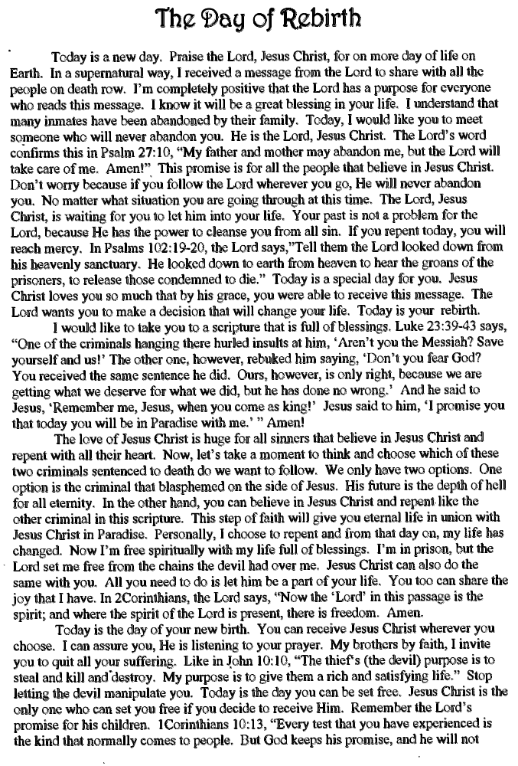

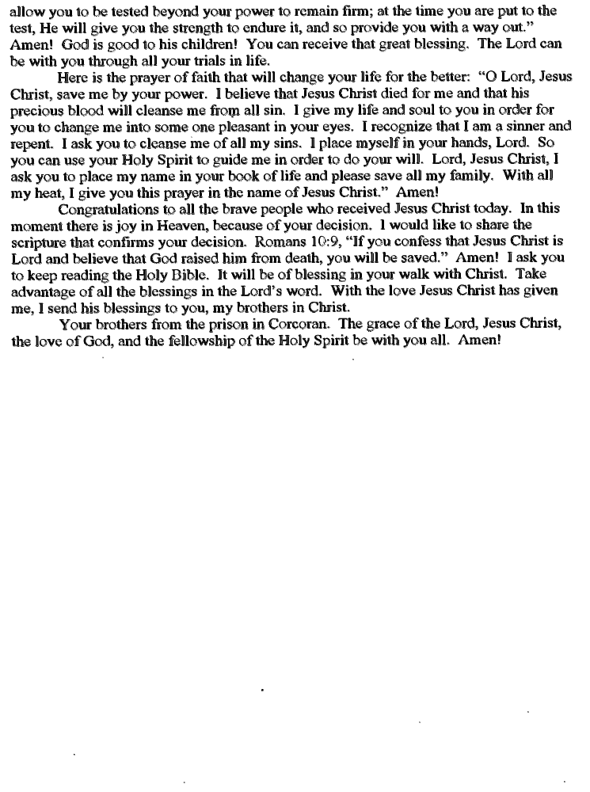
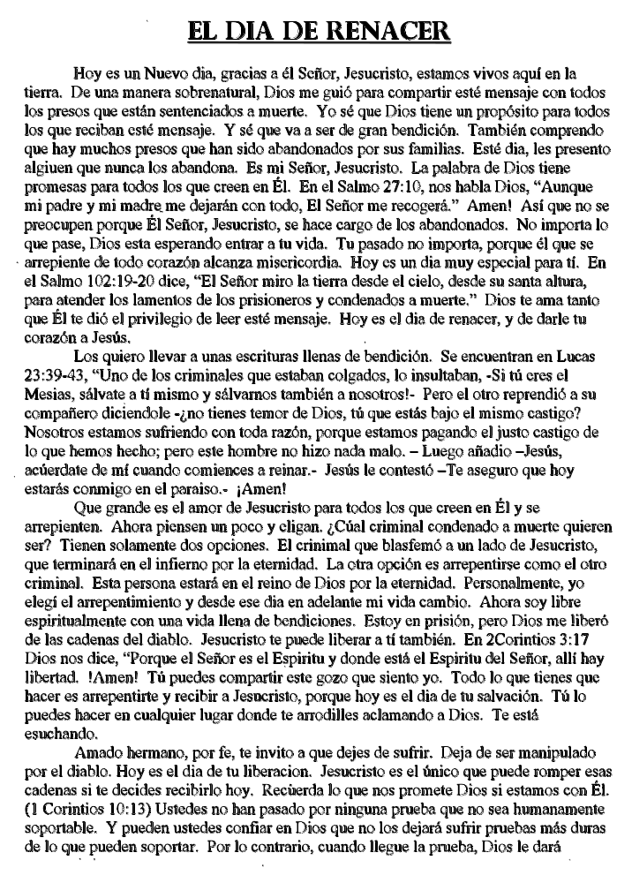

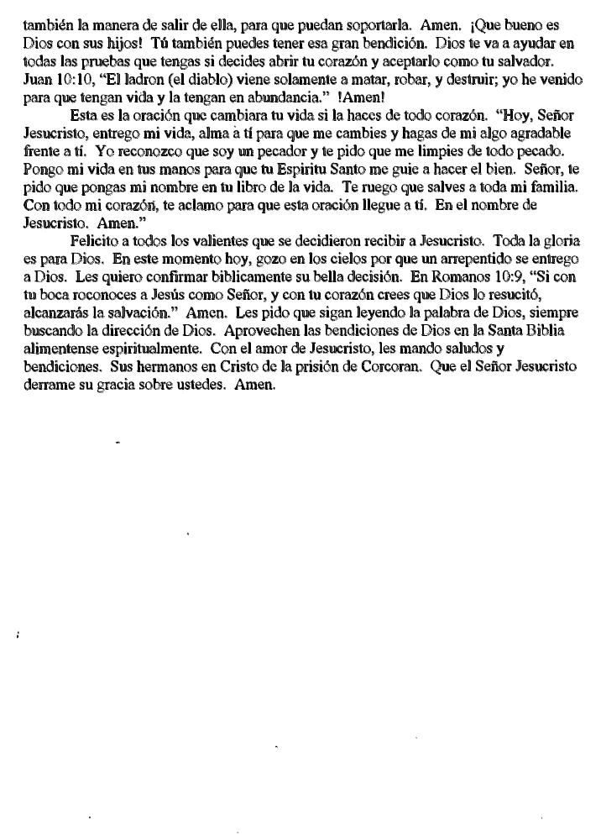
*************************************************************

The Foundation We Build On;
Giving vs. Getting
By Chaplain Bob

Does your life description describe “the Savior.” If the description points to something else, you might be serving a different god.

Some Thoughts for Growth

“As you give, so shall you receive.” Luke 3:38 How often do we hear “God if you will do this, I will serve you the rest of my life.” We are changing it to “as God gives, He will receive.”

“Where God guides, He provides.”

Prosperity ministries – Take of thy (own) first fruits.

Coming out of the starting blocks vs. finishing the course

How far can I go vs. how close can I stay.

Are we doing more for the Lord than just rearranging the deck chairs on the Titanic?

Be in the world, but not of it.

Have no fellowship with . . .

Step away if a professing believer profanes the way of Christ.

Ephesians 5:11 And have no fellowship with the unfruitful works of darkness, but rather reprove [them].

The bible said that, they came out from us that it might be made manifest that they were not of us. For had they been of us, no doubt they would have continued with us. [1 John 2:19]

There are three questions/answers that we must clarify.
- Salvation – How to
- Assurance - Knowing
- Eternal security - Keeping
Salvation / Eternal Life
Last newsletter, we mentioned that Eternal life is the gift of God to those who come to Him in repentance and faith. (Mark 1:15, Acts 11:18, 17:30, 20:21, 26:20 II Timothy 2:25) By repentance, we mean acknowledging our guilt before God of breaking His Law and turning from sin to submit to the Lordship of Jesus Christ. By faith, we mean a total reliance on the finished work of Jesus Christ on the cross to take away the sins of all those who believe. (John 8:24, Acts 16:31, Romans 1:16, 4:5, II Corinthians 5:21, I John 5:13)

Salvation
Salvation is by grace through faith not of works. (Ephesians 2:8-9) The source is God’s grace and there is always a conversion story.

Repentance – Turning from sin, turning from bad habitual habits.

Faith – Total reliance, believing God and His Word.

Finished work – Being ‘finished,’ leaves no openings for ‘works to get into heaven’ or for ‘purgatory’ to finish what Christ did not fulfill paying for. Christ said “It is finished.”
Are we really saved? We hear individuals say “I remember feeling the excitement” or “I remember praying a prayer.” I wonder if what they felt was the confirmation that the covenant with Christ was entered. Have they first given their lives TOTALLY to Christ, before they are expecting to receive the gift of salvation? Is there true repentance?
I meet lots of people that say “I gave my life to God at a very young age, but then backslid later in life.” Let’s further break down the steps of giving our life.

So, if these types of sins keep people out of Heaven as stated “shall not inherit the kingdom of God,” there are now some questions. Did this person backslide? Did this person loose his salvation? Was this person never really saved?
God saves, hears, and restores His own.
1 Thes. 4:1-12

Perhaps we need to go back and fully understand what salvation is.

Hebrews 6:1 Therefore leaving the principles of the doctrine of Christ, let us go on unto perfection; not laying again the foundation of repentance from dead works, and of faith toward God,
Hebrews 6:2 Of the doctrine of baptisms, and of laying on of hands, and of resurrection of the dead, and of eternal judgment.
Hebrews 6:3 And this will we do, if God permit.
Hebrews 6:4 For [it is] impossible for those who were once enlightened, and have tasted of the heavenly gift, and were made partakers of the Holy Ghost,
Hebrews 6:5 And have tasted the good word of God, and the powers of the world to come,
Hebrews 6:6 If they shall fall away, to renew them again unto repentance; seeing they crucify to themselves the Son of God afresh, and put [him] to an open shame.
Hebrews 6:7 For the earth which drinketh in the rain that cometh oft upon it, and bringeth forth herbs meet for them by whom it is dressed, receiveth blessing from God:
Hebrews 6:8 But that which beareth thorns and briers [is] rejected, and [is] nigh unto cursing; whose end [is] to be burned.
Hebrews 6:9 But, beloved, we are persuaded better things of you, and things that accompany salvation, though we thus speak.
Hebrews 6:10 For God [is] not unrighteous to forget your work and labour of love, which ye have showed toward his name, in that ye have ministered to the saints, and do minister.
Hebrews 6:11 And we desire that every one of you do show the same diligence to the full assurance of hope unto the end:
Hebrews 6:12 That ye be not slothful, but followers of them who through faith and patience inherit the promises.

We will not have the situation of turning away and ‘backsliding’ (a term not found or implied in the Bible) if there is true repentance. Repentance is:

- Stop doing what you are doing
- Turn around
- Follow Christ

And if there is true repentance, there will not be the problem of turning away. There can not be just 2 of the parts of repentance, but must be all 3 of them. Let’s look at each one and the combinations.

(1) & (2)
If we stop doing what we were doing and turn around (away from previous activities), but do not follow Christ, we will find new things we should not be doing.

(2) & (3)
If we do not stop doing the things of sin, and turn around and follow Christ, we are trying to bring the things with us, and there is no repentance. It is much as trying to ‘serve two masters.’

(1) & (3)
If we stop doing the things of sin, and try to follow Christ, without turning away from the sin, and turning to the way of Christ, we are still on the wrong path looking for something that will not be found on that path.

Assurance of Salvation
Assurance of salvation requires ‘marks.” Do we bear these marks increasingly. This is being kept by the “power of God” and the source is the “Spirit of God.” As we follow Christ, we will often run into confrontation and trials. How we bear these times, shows if we are truly following and bearing the marks. Assurance is not just something that is displayed in times of non-conflict, but rather is more so displayed in times of conflict.
Remember that the whole relationship is built on following thru ‘faith.’ Works is the outward expression of the inward faith.
James 2:18 Yea, a man may say, Thou hast faith, and I have works: shew me thy faith without thy works, and I will shew thee my faith by my works.

James 2:20 But wilt thou know, O vain man, that faith without works is dead?

James 2:26 For as the body without the spirit is dead, so faith without works is dead also.

Eternal Security
Eternal Security’s source is the “Power of God.”
Do not confuse the answers to the questions. Often an individual will ask “Am I really saved?” A church member will give an answer of assurance of “Of course you are saved, God keeps His own.” The answer is one of eternal security, but the question was one of salvation. The answer should not relate to “God keeps his own,” but should answer “Are you one of His own?” The answer should be an answer of “Do I bear the marks?”
John 10: gives the difference of the questions. “My sheep hear my voice and I know them” shows the salvation doctrine. “And I give to them eternal life and they will never parish” is eternal security. In the middle is the often overlooked “and they follow me,” and that is the doctrine of assurance.
God hears His children and they hear Him (John 10:3,16,27). John 14:13 “If you ask anything in my name (according to His will) I will do it.”

Balance

*************************************************************

God was missing for six days. Eventually, Michael, the archangel, found him, resting on the seventh day.
He inquired, "Where have you been?"
God smiled deeply and proudly pointed downwards through the clouds, "Look, Michael.. Look what I've made."
Archangel Michael looked puzzled, and said. "What is it?"
"It's a planet," replied God, "and I've put life on it. I'm going to call it Earth and it's going to be a place to test Balance."
"Balance?" inquired Michael, "I'm still confused."
God explained, pointing to different parts of earth. "For example, Northern Europe will be a place of great opportunity and wealth, while Southern Europe is going to be poor. Over here I've placed a continent of white people, and over there is a continent of black people. Balance in all things."
God continued pointing to different countries. "This one will be extremely hot, while this one will be very cold and covered in ice."
The Archangel, impressed by God's work, then pointed to a land area and said, "What's that one?"
"That's Washington State, the most glorious place on earth. There are beautiful mountains, rivers and streams, lakes, forests, hills, and plains. The people from Washington State are going to be handsome, modest, intelligent, and humorous, and they are going to travel the world. They will be extremely sociable, hardworking, high achieving, carriers of peace, and producers of software."
Michael gasped in wonder and admiration, but then asked, "But what about balance, God? You said there would be balance."
God smiled, "There's another Washington. Wait till you see the idiots I put there."

*************************************************************

Lesson in Lying
A minister told his congregation, "Next week I plan to preach about the sin of lying. To help you understand my sermon, I want you all to read Mark 17."
The following Sunday, as he prepared to deliver his sermon, the minister asked for a show of hands. He wanted to know how many had read Mark 17. Every hand went up. The minister smiled and said, "Mark has only sixteen chapters. I will now proceed with my sermon on the sin of lying."

Sermon
A pastor, known for his lengthy sermons, noticed a man get up and leave during the middle of his message. The man returned just before the conclusion of the service. Afterwards the pastor asked the man where he had gone.
"I went to get a haircut," was the reply.
"But," said the pastor, "why didn't you do that before the service?"
"Because," the gentleman said, "I didn't need one then."

Poetry Section
************************************************************************

Heaven
No poverty there,
Riches beyond compare.
No pain or distress,
Only eternal bliss.
No crying there,
God dried up each tear.
No sorrow can be found,
Rejoicing all around.
Thank you Lord for Eternity,
Peace, Joy and serenity.
Faith, hope and Love,
Eternally lived above.
The completed message:
A Heavenly marriage!
---Selah---
To God be the glory!!!
Alex
*********************************
God My Master
As God is my master,
So Satan is my foe.
Love is the greatest,
Thing we can show

God gave us His Son,
So that we might live.
He gave us the greatest
Gift He could give.

Jesus has the keys,
To hell and death.
He has the keys,
To life in His breath.

He that liveth,
Though he were dead,
Unto us,
He is our bread.
Jeffrey P.

*********************************
Praying for a Sign
In my prison cell,
I’m praying for a sign.,
Hoping to get into Heaven,
And not be left behind.
I’ve done a lot of wrong,
That I can’t deny.
Other than my sins,
I’m not a bad guy.
I’m praying for a sign.
So I’ll know I’m forgiven.
Maybe my sign fron God,
Is to go on livin’
I took a lot of chances,
Chances I shouldn’t have took.
When I should have been serving God,
I was out there being a crook.
Praying for a sign,
That could only come from God.
Maybe it’s the newsletter,
From Sister Linda and Chaplain Bob

Jonathan M.
Sept 1, 2009
*********************************
Jesus, let me not neglect Your great salvation,
Fill my heart with pure and holy conversation.
Lord, live in my heart, walk by my side,
My communication in
You alone abide.
Help me live my life
for You, no other,
Jesus, my best friend
…my Brother.
Alex
July 31, 2009
*********************************

*********************************
Our Path to Heaven

Hell is full of Fire,
God can raise the dead.
The devil is going to retire,
We have eternal life ahead.

Remember that the devil
Has only one big ploy,
To take away from us,
Our one true inner joy

The joy built upon love,
Seasoned with God’s grace.
Eternal life through Jesus Christ,
In Heaven our resting place.

Our spirit walking with our Father,
His love making us whole.
God gave us our life,
Jesus can truly save your soul.

I’ll follow in Christ Jesus’ footsteps
In His example I will abide.
Letting the Lord be my compass, as I feel His great love inside.

God will protect our soul,
Our future He will defend.
If we will remain faithful,
In Jesus Christ till the end.

What matters most in life,
Are the souls we have won.
And to hear in the end,
our Father say, “Well done !”

Jeffrey P.
Aug. 6, 2009

*********************************

*********************************
When I say that I’m a Christian

When I say that I’m a Christian
I’m not shouting that I’m saved.
I’m whispering “I was lost,”
That’s why I chose this way.

When I say that I’m a Christian,
I don’t speak of this with pride.
I’m confessing that I stumble,
And need someone to be my guide.

When I say that I’m a Christian,
I’m not trying to be strong.
I’m professing that I’m week,
And pray for strength to carry on.

When I say that I’m a Christian,
I’m not bragging of success.
I’m admitting that I’ve failed,
And cannot ever pay the debt.

When I say that I’m a Christian,
I’m not claiming to be perfect,
My flaws are too visible,
And God believes I’m worth it.

When I say that I’m a Christian,
I still feel the sting of pain.
I have my share of headaches,
Which is why I speak his name.

When I say that I’m a Christian,
I do not wish to judge.
For I do not have authority,
I’m only here to love.
Received from Cathy S.

*********************************

*********************************
Some Days, Lord

Some days Lord, I see for miles
Some days I’m so blind
Some days I can be so cruel
And some days oh, so kind.

Some days Lord are beautiful
Bright sun and deep blue skies
Some days, Lord, the birds don’t sing
Some days the magic dies.

Some days, Lord, I know you well
So close, and always there.
Some days, Lord, I’m all alone
And have no love to share.

Some day, Lord, I’ll be with you
You’ve told me, and I believe.
I know you hear me now, dear Lord
Stay with me, never leave.
David M.
March 2009

*********************************
So Far to Go

Help me read the scriptures, Lord
These words I need to know
I’m learning, Lord, to know you
But I’ve sp far to go.

Often, Lord, I feel you close
So close to me through prayer
So easy, Lord, to reach you
For you are always there.

Comfort me when lonely, Lord
Guide me when I’m blind
The sure, true path to righteousness
Can be so hard to find.
David M.
March 2009

*********************************
*********************************
Your Love Has Set Me Free

Lord I feel yor presence
And, too, I hear your voice.
Helping me to make my way
And helping with each choice

Lord, I sometimes waver
And, too, I sometimes fail
I sometimes wander far astray
I sometimes lose the trail

Still you’re there to guide me
With patience, you are true
Knowing my transgressions, Lord
Won’t take me far from you

Lord, you are my sunshine
The blue sky in each day
The beauty that’s wuite plain to see
In a very special way

Lord, you are the answer
The warmth I feel inside
I know throughout eternity
You’ll be there at my side

Your love, Lord, my true blessing.
Your gift, from you to me.
No earthly chains can hold me, Lord
Your love has set me free.
David M.
Oct. 2009

*********************************

Inmate Art by
Richard Sanchez



