“Letter From M.O.M.”
The Monthly newsletter of Moving On Ministry

WWW.MovingOnMinistry.com
www.PrisonMinistry.net/movingon
Volume 48 – May / June 2009

“I Can Only Imagine”

As you receive this volume of Letter From M.O.M., we have many new writers of articles, we are putting some more of the testimonies of “How God Changes Lives” as well as some of our own written articles. We can truly say that the “high” that many of our inmates have been trying to get through the wrong methods, is being surpassed by those putting God in control of their lives.
Watch our website www.MovingOnMinistry.com

We are affiliated with International Prison Fellowship
http.//PrisonMinistry.net/movingon

and Good News Jail & Prison Ministry Volunteer
www.GoodNewsJail.com

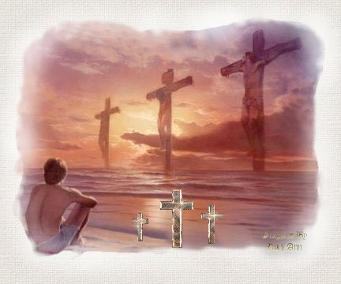
You can’t cut out the Middle Man, He has to be the Center
Intentions & Wishes

The intentions of this newsletter are to allow an understanding of jail & prison ministries. It is our intentions to get input from those incarcerated as well as those “free” to visit. Life experiences of the faith and fellowship from those locked up in the facilities are always desired to let others know of the value of “visitation”. I am certain that each of us have many stories of the miracles God has done in our lives.
Our wishes are that we would have a list of supportive churches that individuals might look forward to attending once released.
A list of services, such as housing, employment, and counseling services, as well as some individuals available for friendly fellowship are also much needed items.
God’s Word says if a man stumbles, how can he continue lest there be another to help him up. Ecc. 4:10 “For if they fall, the one will lift up his fellow: but woe to him [that is] alone when he falleth; for [he hath] not another to help him up.” Proverbs 24:17 “Rejoice not when thy enemy falleth, and let not thy heart be glad when he stumbleth:” John 11:10 “But if a man walketh in the night, he stumbleth, because there is no light in him.”
Please help us with input for this newsletter as we strive to serve God. We appreciate any articles or input.

Addresses to contact Ministry Volunteers

Moving On Ministry
Chaplain Bob
P.O. Box 6667

Visalia, CA. 93290

Moving On Ministry
Spanish Ministry - Linda
P.O. Box 6667

Visalia, CA. 93290

Jesus Prayer Ministry
Sis Denise
P.O. Box 7925
Chula Vista, CA 91912

Armor in Ministry (A.I.M.)
Brother Rocky
P.O. Box 7032
Visalia, CA. 93290

Ask for a copy of our complete “Resource Supplemental Letter”

For 2009, Bob is doing Bible study at BWDF on Mondays, MCF on Wednesdays, Pretrial on Thursdays.
The Sunday after the 2nd Saturday of each month is Bob, Rocky and Linda’s assigned day for 3 to 4 chapel Services at Corcoran State Prison (“Old” Corcoran). Brother Rocky has been cleared and did his first Corcoran services with M.O.M. on 12/27/2008 and 1/11/2009.
Bob and Rocky have also been doing the Miramonte Conservation Camp #5 chapel services every other Friday.
Bob and Linda were scheduled for the Bill Glass Ministry in Fresno, CA (4/30-5/2) and Bob went to SATF & “old” Corcoran and Linda went to Chowchilla. Then (9/17-9/19) the No. Calif. Event, then (10/22-10/24) the So. Calif. Event.

M.O.M. Needs
- New Tractor has arrived for Camp Clarius development (with problems).
- Pen-pals to write inmates
- Finances & stability
- Testimonies
- Development of Squaw Valley Property (Camp Clarius)
- Development of Nevada property
- Development of Arizona property
- Volunteers for ministry
- Drawings to publish and share
- Praise for Bob’s mom’s surgery
- Praise for Bob’s hernia surgeries

*********************************
Prayer Praise
The Mom of M.O.M. (Jeanne) has recovered well from her neck surgery. She had been cut off all pain medication before the surgery and was suffering with the pain, but now since the surgery, is predominately med free and little or no pain from the neck.
She went to the doctor for her checkup and the doctor was totally amazed with the speed in which her bones are healing. She just said, “I have lots of men and women in prisons praying for me.” The doctor said, “It must work.” He was calling in some of the other doctors to look at the miracle in the x-rays. Please pray for her continued recovery, and the miracle of prayer can be shared with other individuals.

*********************************
Heavy Load / Expense
We have combined May & June for Volume 48 of Letter From M.O.M.

Letters that Express it All

We like to post real life situations, because God works in real lives and He is the one that gives “Eternal Life.” Every week we get many letters that state “I love hearing the testimonies.” There are so many, we cannot publish them all, and the sad part is – people not involved in jail / prison ministry do not get to read the many letters we receive daily (average 2 to 11 each day) and try to keep up with and answer.

*********************************

Letter on the Yard
Matthew was the individual’s name that came up to me and handed me the homemade track, and I thought it worth sharing. I was doing Bill Glass Champions for Life ministry on D-Yard at SATF Corcoran Prison. Matthew introduced himself and handed me a hand written tract that had the title of;

“From 85 to Life - - To: Eternal Life”

The tract went like this;
Hello. My name is Matthew. The reason I am giving you this tract is to share with you, what Jesus Christ has done for me and what Jesus Christ can do for you.
I was a hopeless drug addict from 15 years old till the judge sentenced me to three 25-to-life terms, plus ten years. My crimes were for burglaries to support my drug addiction, I was 37 years old. In prison I cried out to God to deliver me from drugs and to give me peace. I was tired of always wanting to get high. Well, God heard that prayer. The Bible says in Romans 10:9 “That if you confess with your mouth the Lord Jesus and believe in your heart that God has raised Him from the dead, you will be saved.” That is exactly what I did. God saved me! I got a Bible and asked for help to understand it. I reached out to real Christians on the yard and they embraced me. I made a prayer list and took my petitions to the Lord and God heard my prayers and I developed a relationship with Jesus Christ. Now, I would like to help you find Jesus. The Bible says, “All have sinned and fallen short of the Glory of God” (Romans 3:23) and continues “The wages of sin is death, but the gift of God is eternal life.” So, in order for you to have a relationship with Jesus Christ, you must confess your sins and turn from them and ask Jesus to come into your life and show you His love and mercy. That is what God did for me. By the way, three years after I got sentenced, the judge brought me back and took all of the life sentences off of me. So, if you would like to talk to me or go to church, I would like to help you find the peace that I found. May God bless you and save you. Matthew

*********************************

You are Me, part 2

To those youngsters out there, who are caught up in that web of pain, hurt & hate. Believe me, I feel you.
I know exactly what you are going through. And what you are feeling. Please, give me a minute of your time, and allow me to reach out to you. I will speak no lies to you. You’ve got my utmost respect to speak the truth to you. I know you’re tired of being lied to. I’m going to be up front with you. No tricks are going to be played on you. For these words could very well save you from a life of pain and misery. I don’t know if anyone has ever told you that there is a better life out there for you? A life free of the pain and hurt we are going thru. But this life I speak of does not come to us. We have to go to it. Let me be straight out with you. There’s two roads in life. And we alone are free to choose which road we are to follow. One road goes right (the good life) and the other road goes the wrong way. There is no one there standing between this road of choice, with a gun to your head, telling you which road to choose. Me, myself, I made the worst mistake of my life, for I chose the wrong road. No I wasn’t blind, and yes, I could read, and I was smart enough to know what wrong meant. So I alone made a free choice to live in a life of pain and misery for the wrongs I was to commit in my life. There was a price to pay for this. For one minute do you think I am writing you from the peaceful home, sipping on a cold soda? Hearing the birds sing? Well, I’m not! For my house is a cold, lonely prison cell. Stuck in a place where misery lives 24/7. Where the pain and hurt never rest. Where only the strong will survive. Where I’m stripped of my freedom and of what little fight I have left, I can’t even hear a bird sing. But I can hear men speak madness. I can’t sip on a cold soda. I can only wish on waking up tomorrow. This is my reward for my choices I made. I didn’t step up to no podium to receive this reward, but I did have to stand up when the judge handed me my sentence. At night I lay in the dark and I wonder what happened? Where did I go wrong? Where are my true friends now? What happened to the party? You see, my little brothers. I was lied to! Those friends don’t last. They forget about you once you’re gone. Their party continues, but yours has ended. It doesn’t have to be like this for you. Life can give you so much (love & peace) by doing what is right. You’ll be able to enjoy a life of freedom. Let me give you a short list on how you can accomplish . Obey and listen to your parents. Go to school and get your education. Stay away from drugs and gangs. And most important, obey and love God. For with God’s grace and help, you will be able to find the strength to pull it off. You see, God won’t lie to you. He loves you too much to do something like that (with God it is impossible to lie), and I won’t do it cause I am trying to save you from a place like this. I’m not saying to you it is going to be easy. Yes, it’s going to be hard. It’s hard even for grown ups. But it’s the choice you make that counts. There is a saying that goes like this, “we make the bed we lay in.” Now you know my little brothers. I care for you. If I didn’t, I would go back to my world and forget about you. But the good Lord tells us, regardless of race or color or what side if town we are from, we are all one family in God’s eyes. Be a true champion. Believe in yourself and love yourself. Cause when you can, you’ll do what is right for you. In my prayers you all will stay. God loves you.

A little food for thought.

Some of your friends will not want you to go on.

They will want you to stay where they are.

Friends that don’t help you climb, will want you to crawl.

Your friends will stretch your vision or choke your dreams.

Those that don’t increase you, will eventually decrease you.

Rudy U.

*************************************************************

Camp Clarius Development

Many have asked on the progress of Camp Clarius. Well here is a quick summary

Tractor for Camp Clarius

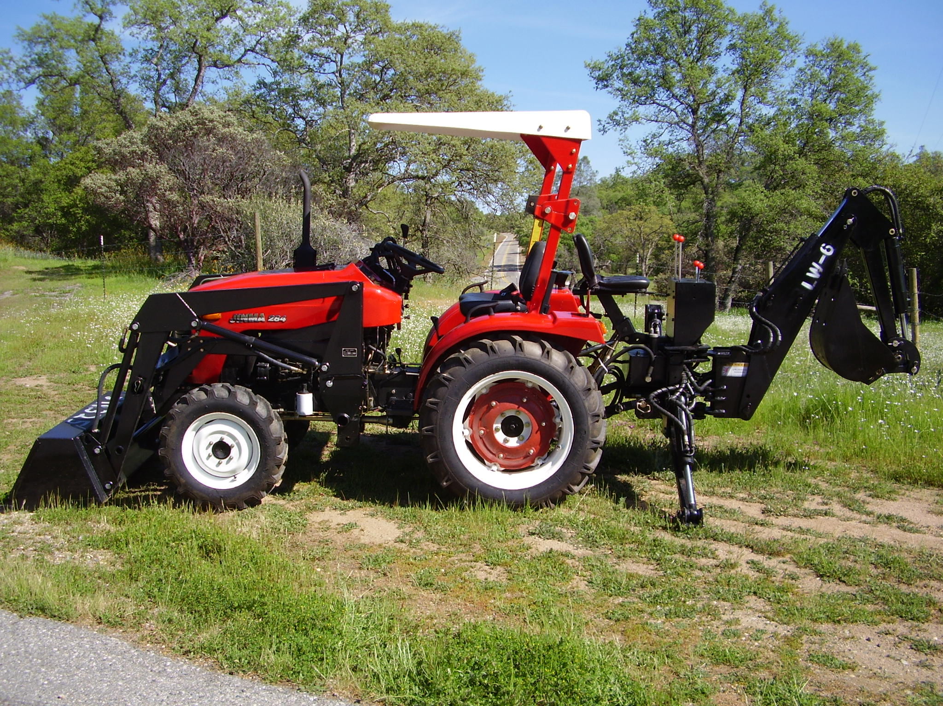
We purchased a new tractor for use on the property. We now have a bucket loader and a backhoe.
This was the result of Bob liquidating all his retirement money, for support of the ministry.

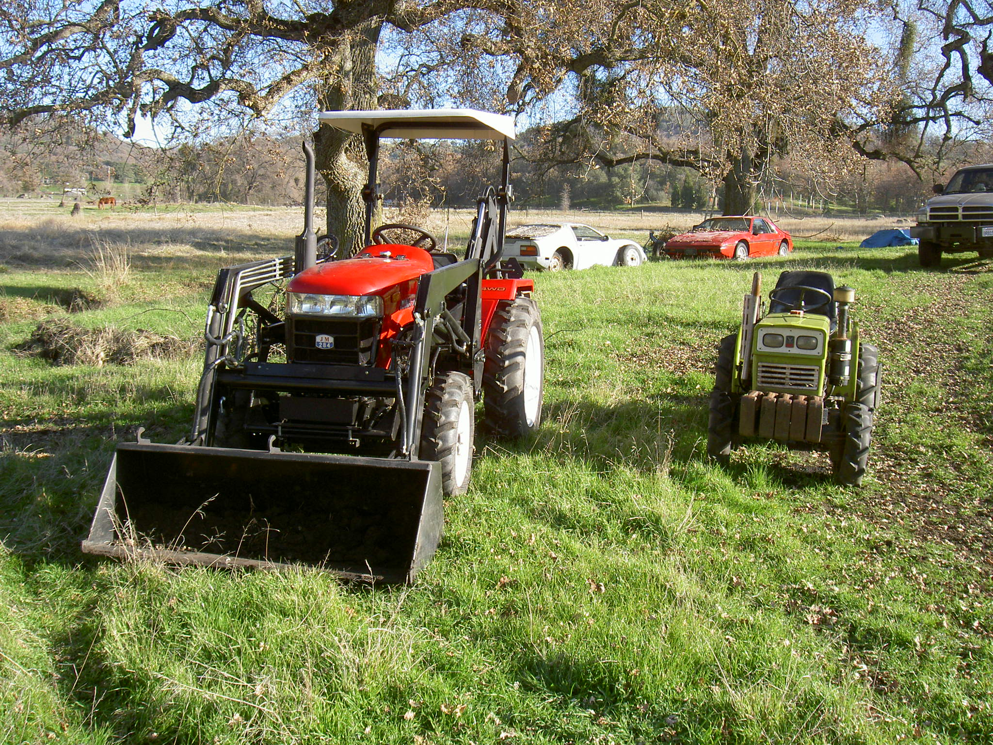
The Jinma 284 (28 HP) is larger compared to the Yanmar 155D (15 HP)

The property is progressing slowly due to lack of finances, but still headed in a positive direction.
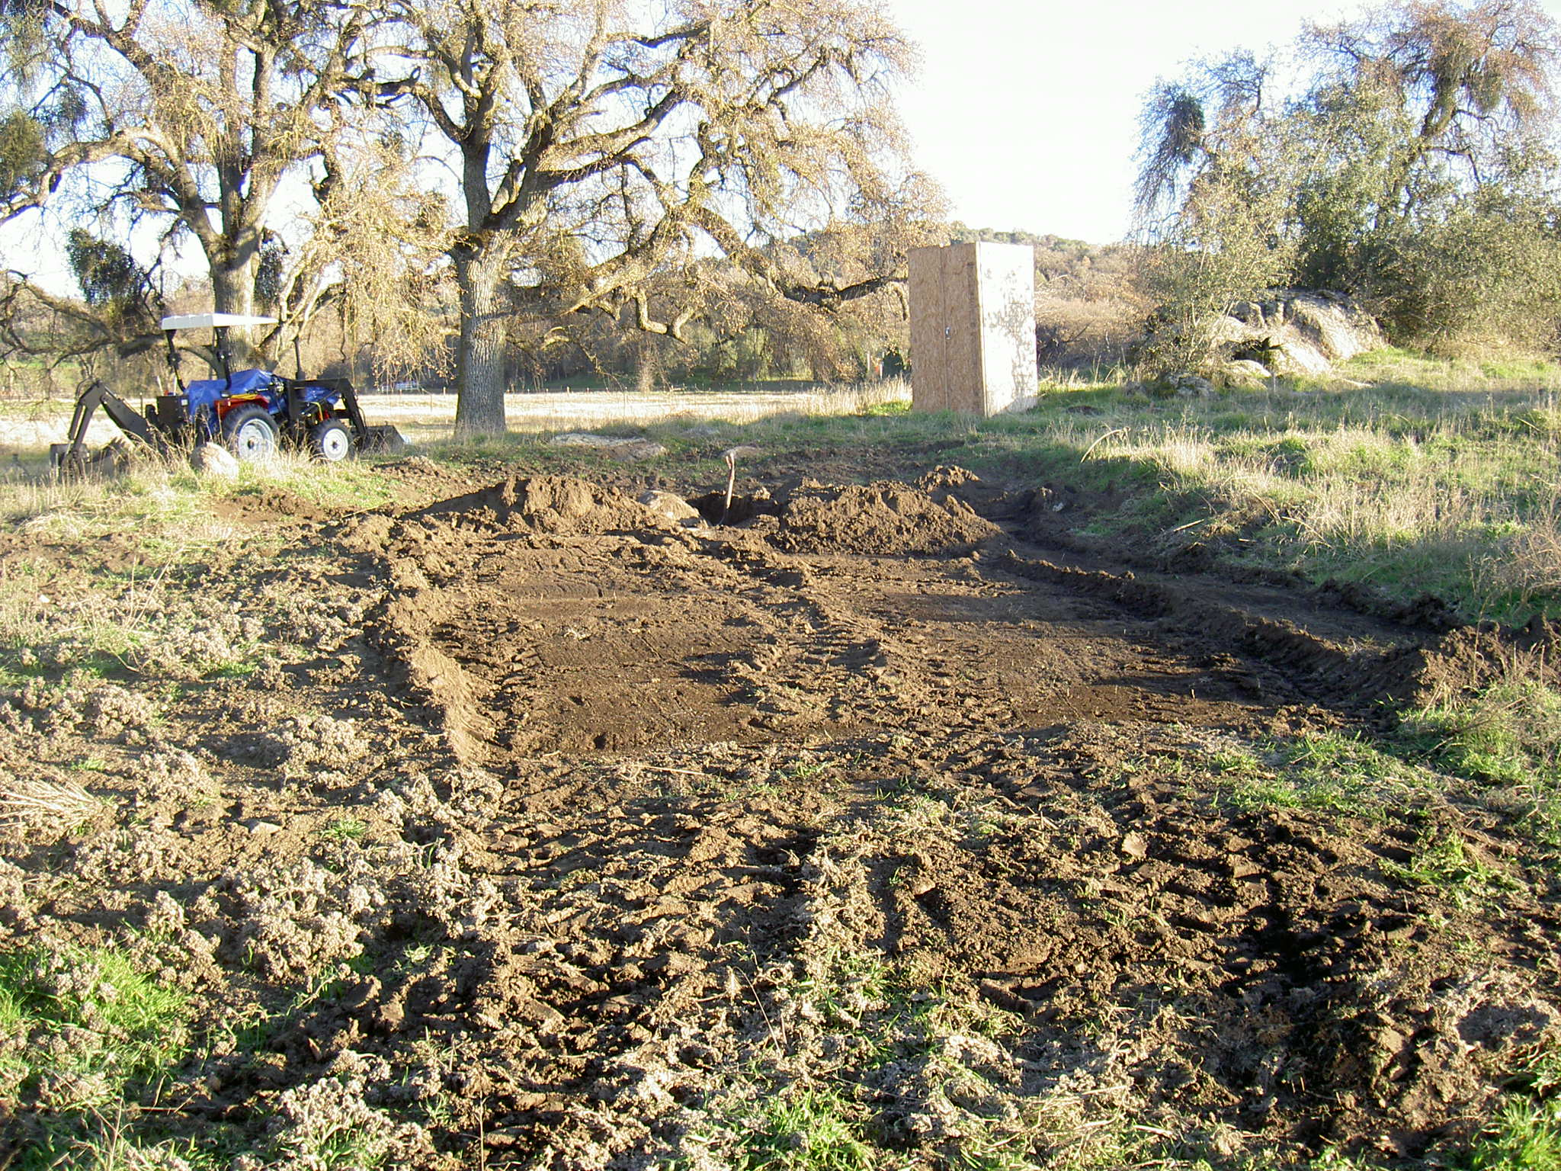
Clearing and leveling for concrete pad

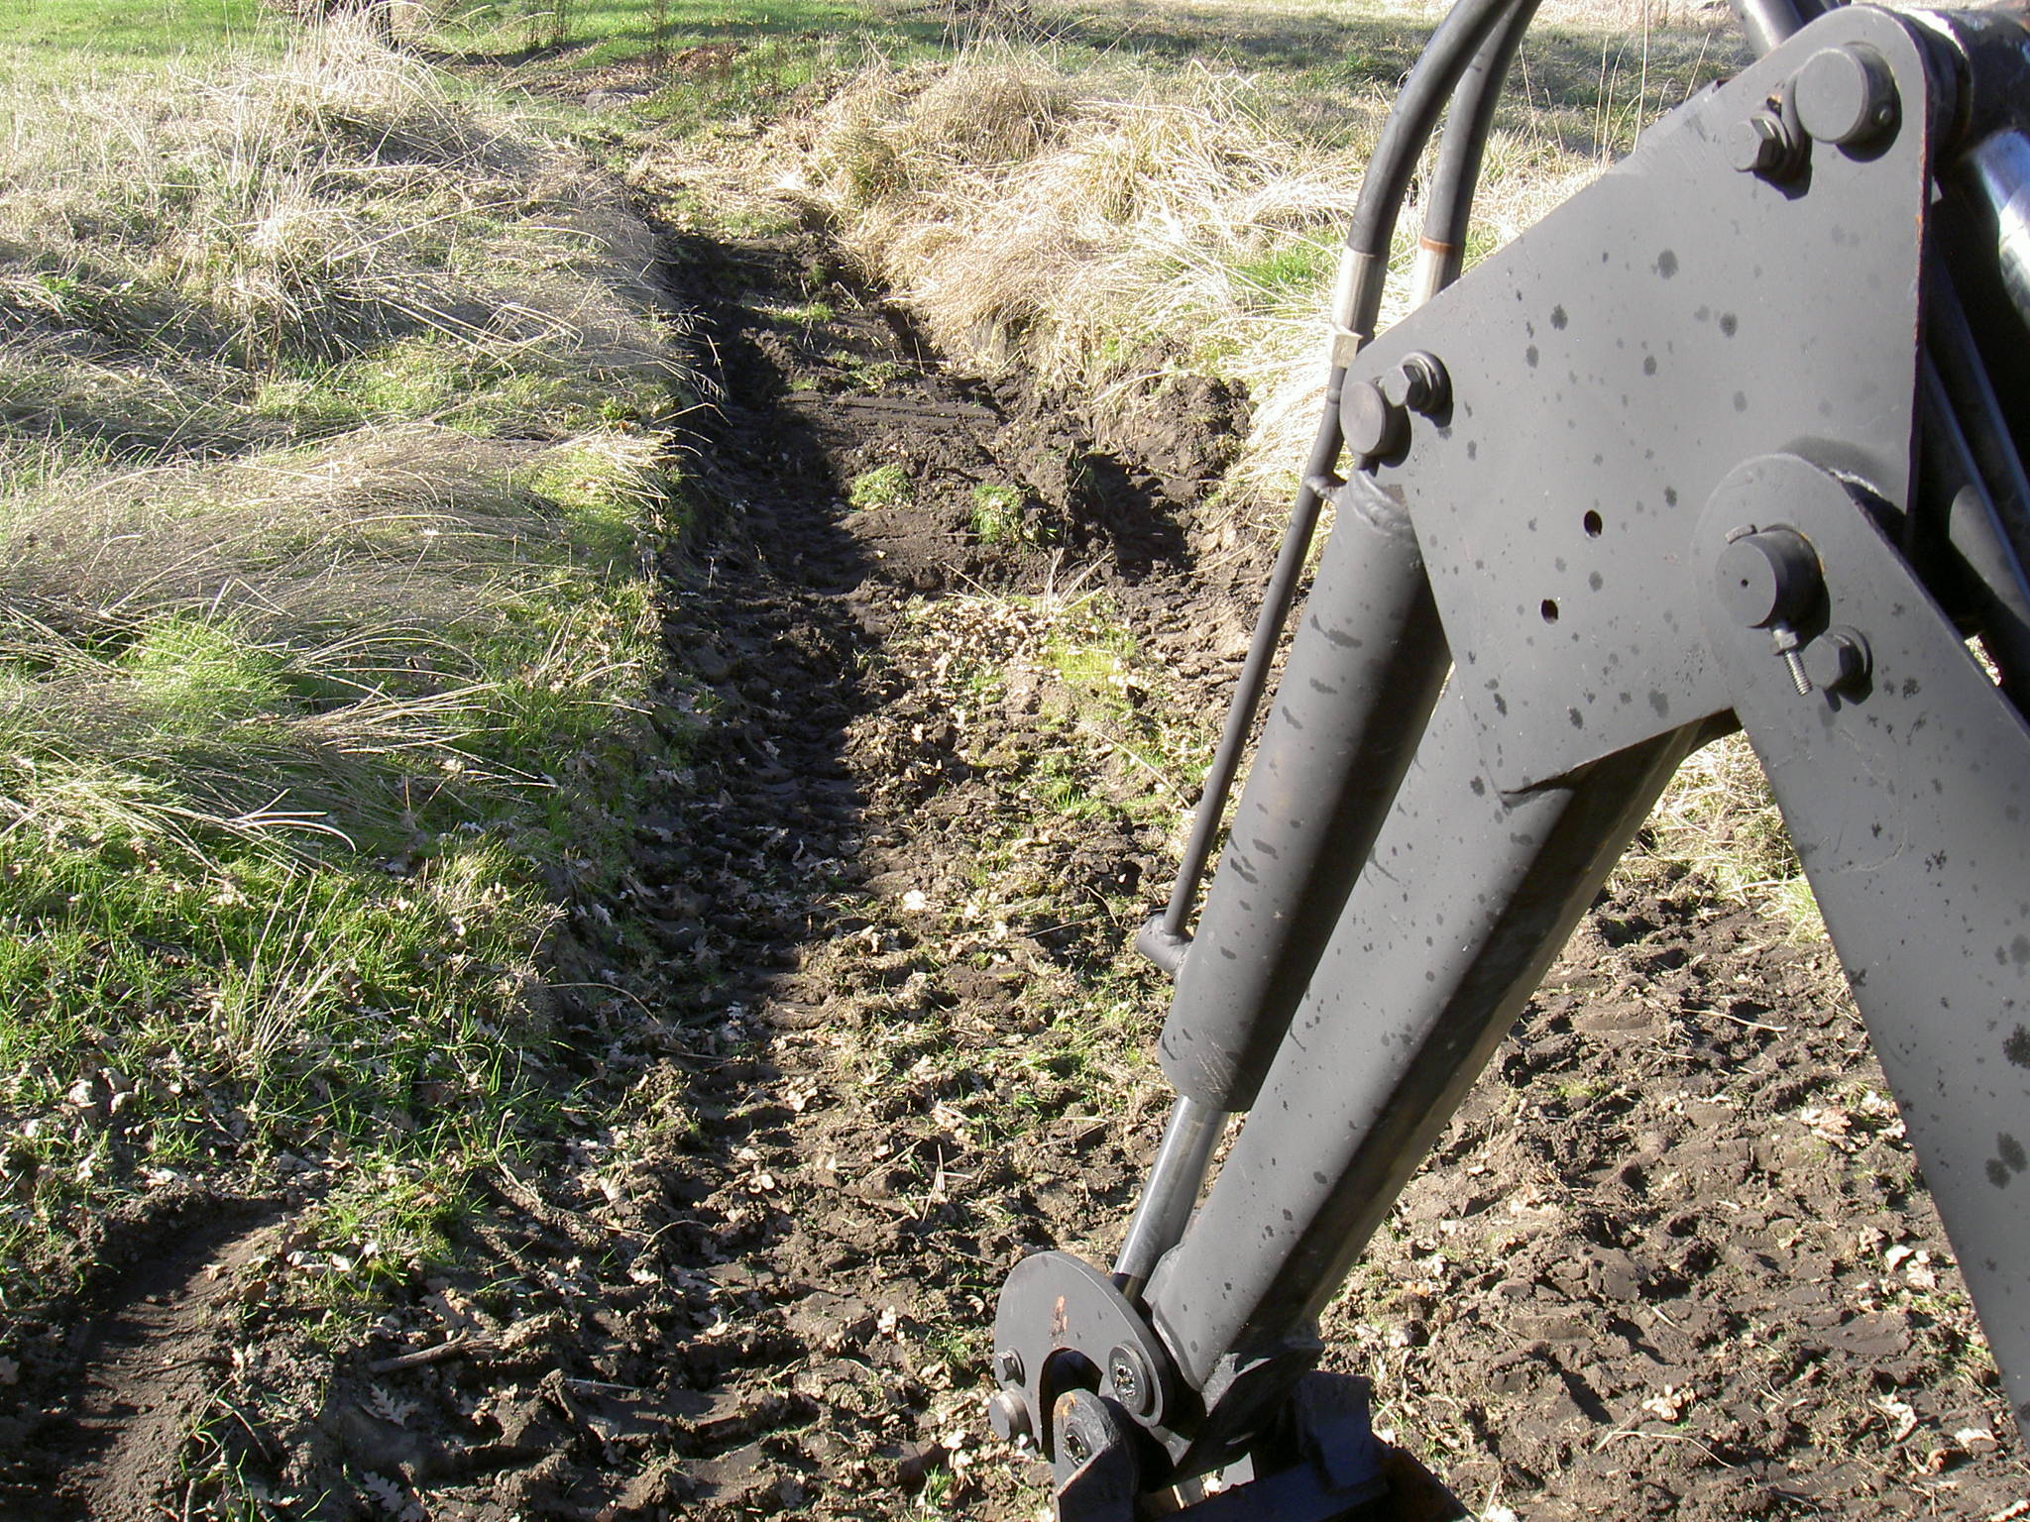
Clearing the creeks

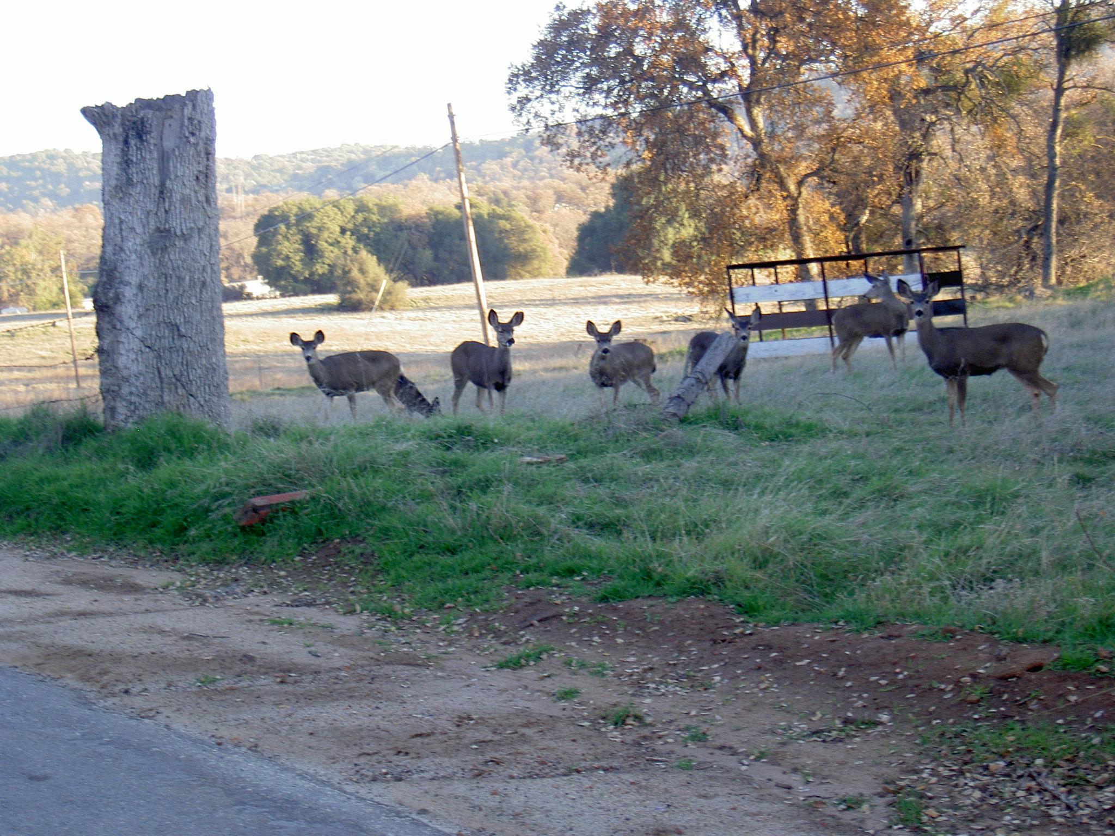
Local “wild” livestock watching activities. 7 deer in this picture.

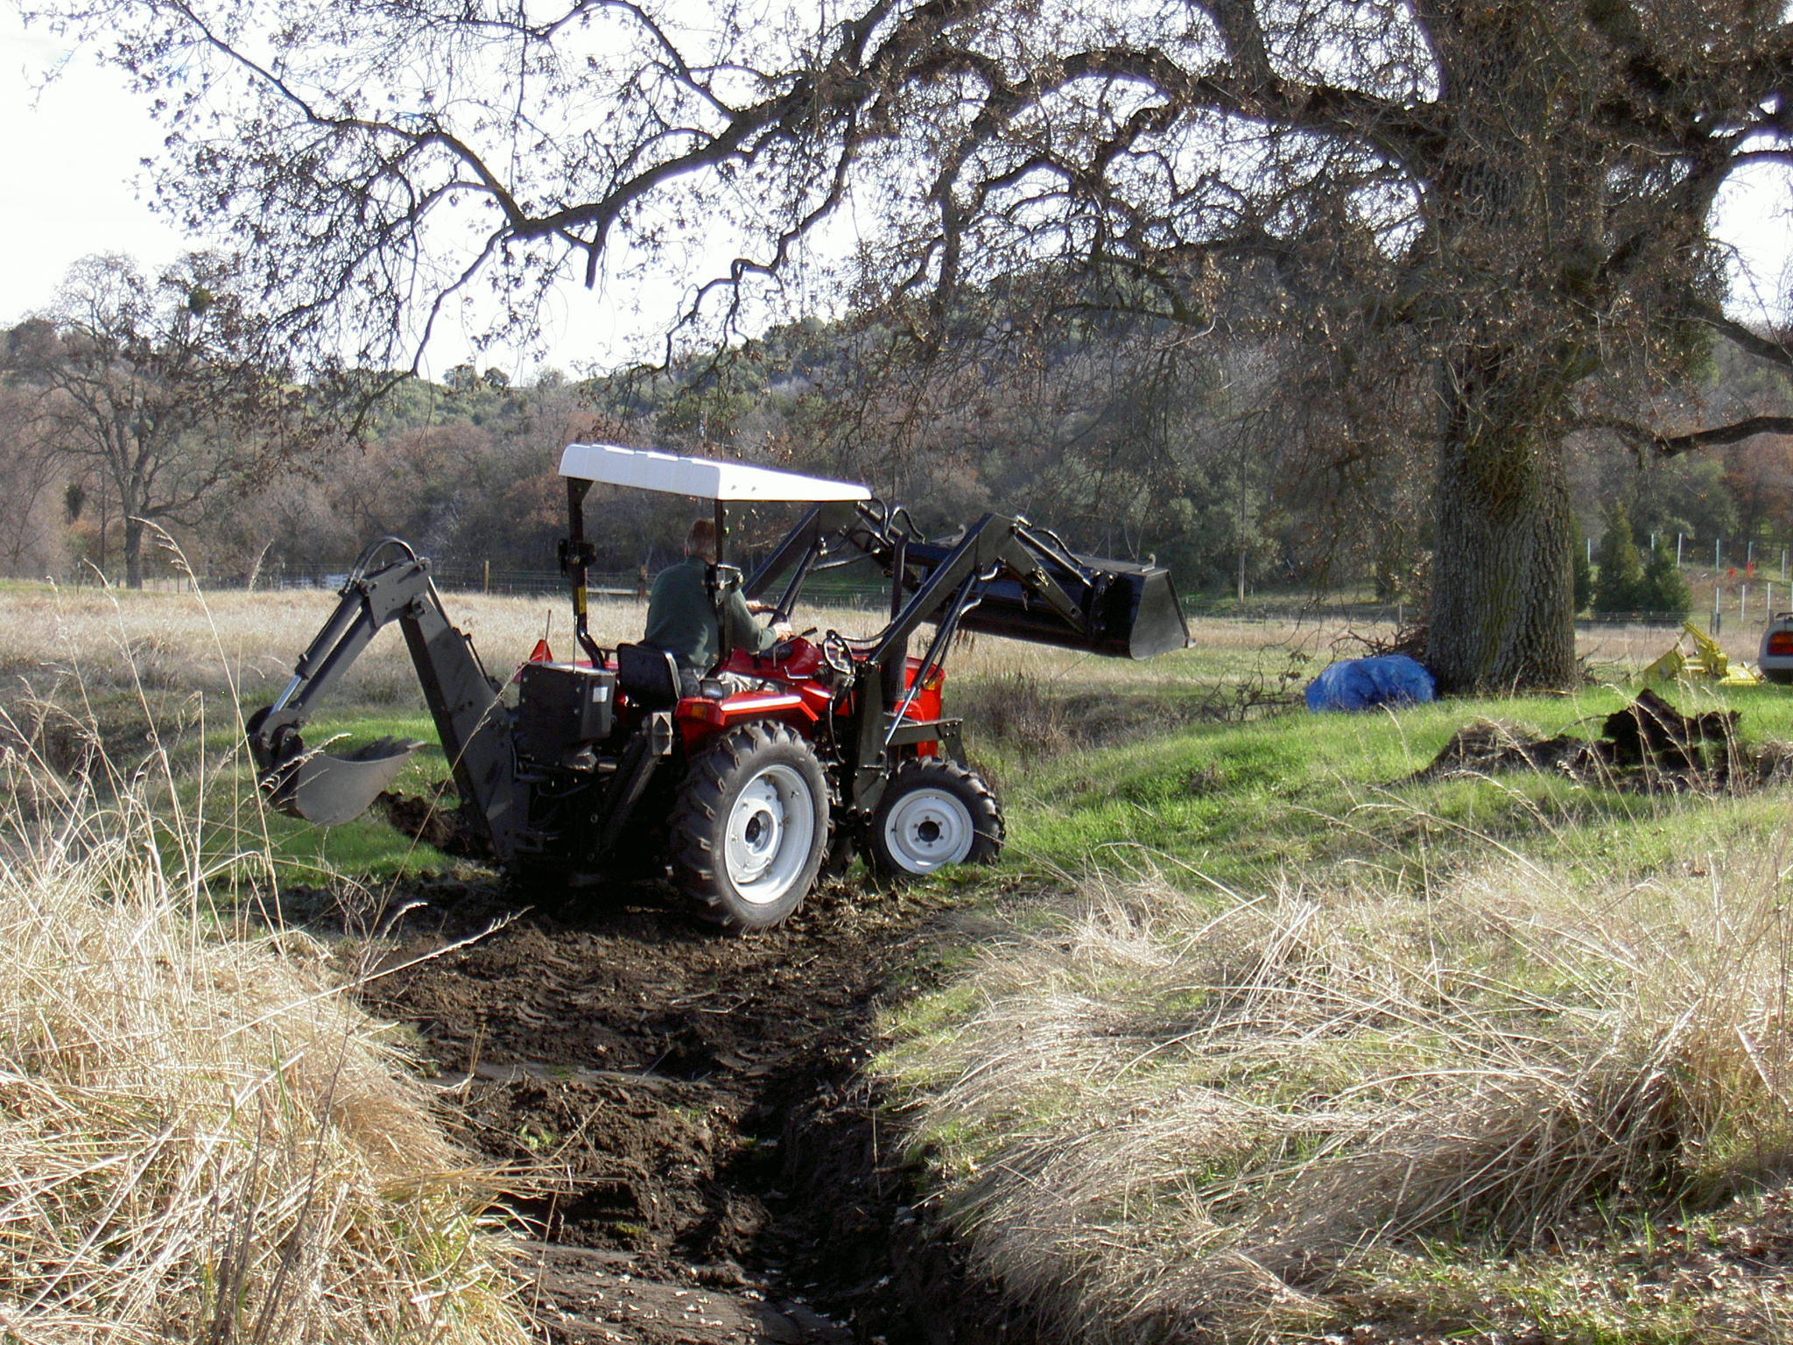
Clearing the creek and doing swimming hole.
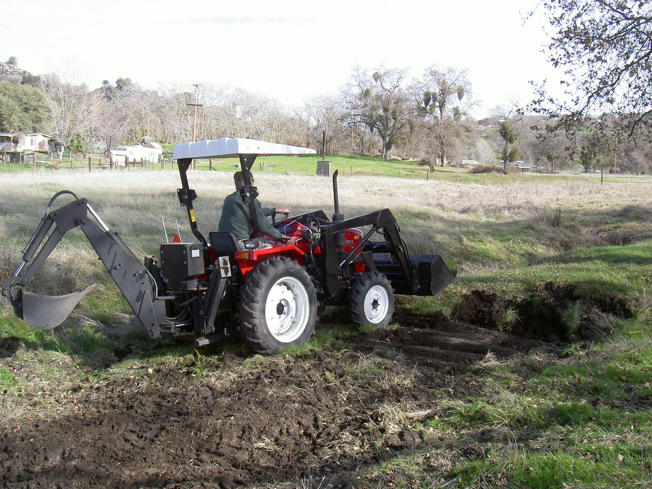
Start of digging swimming pond.
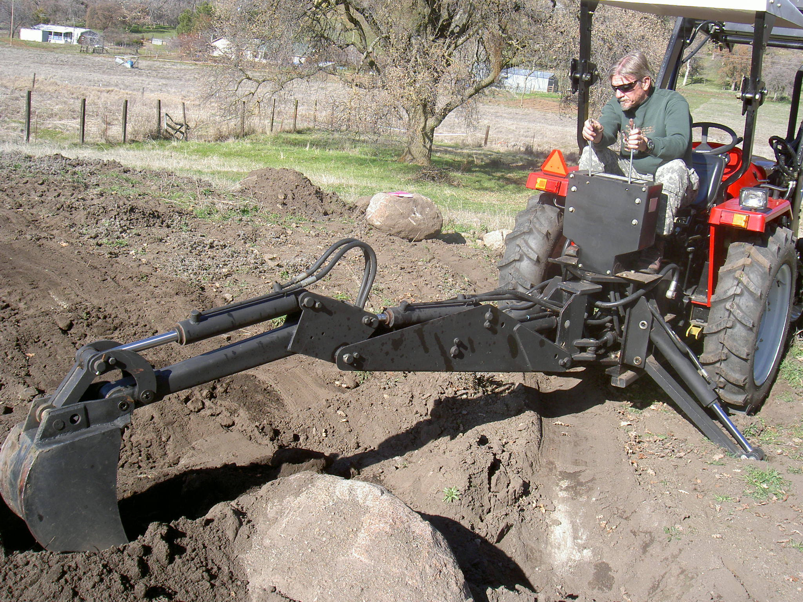
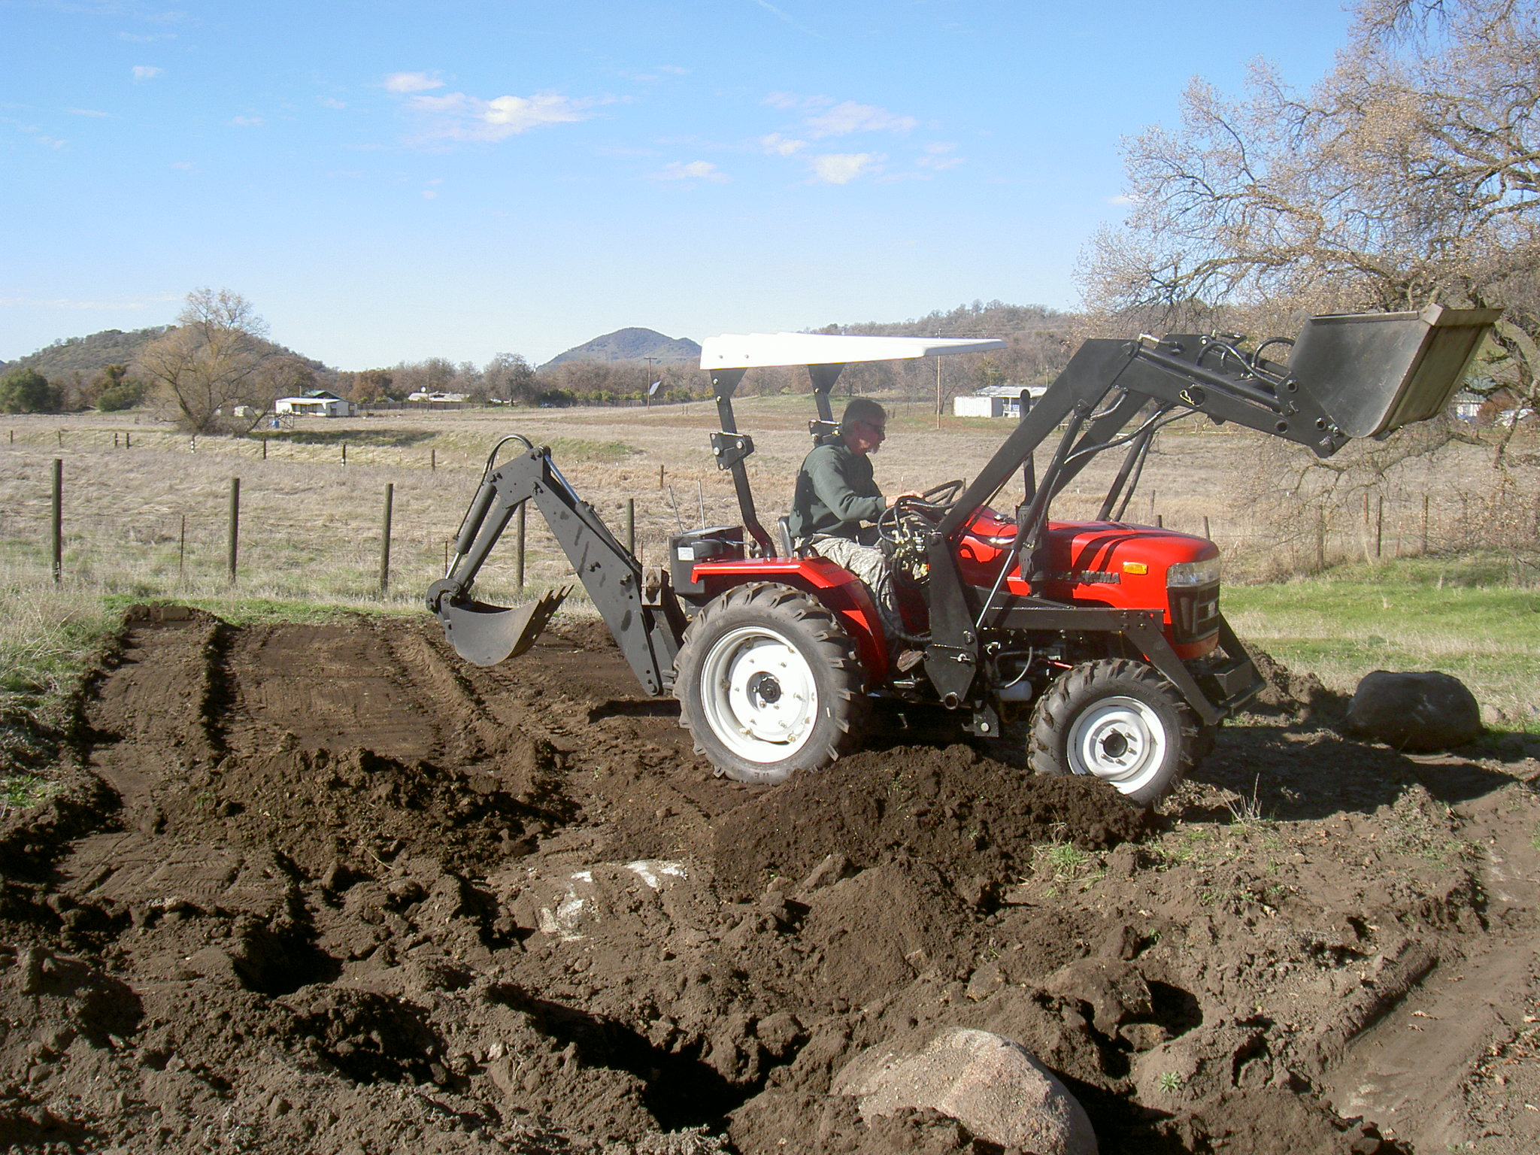
Still working on rock removal. We refer to these as “potato rocks” because you do not see them until you start to dig.
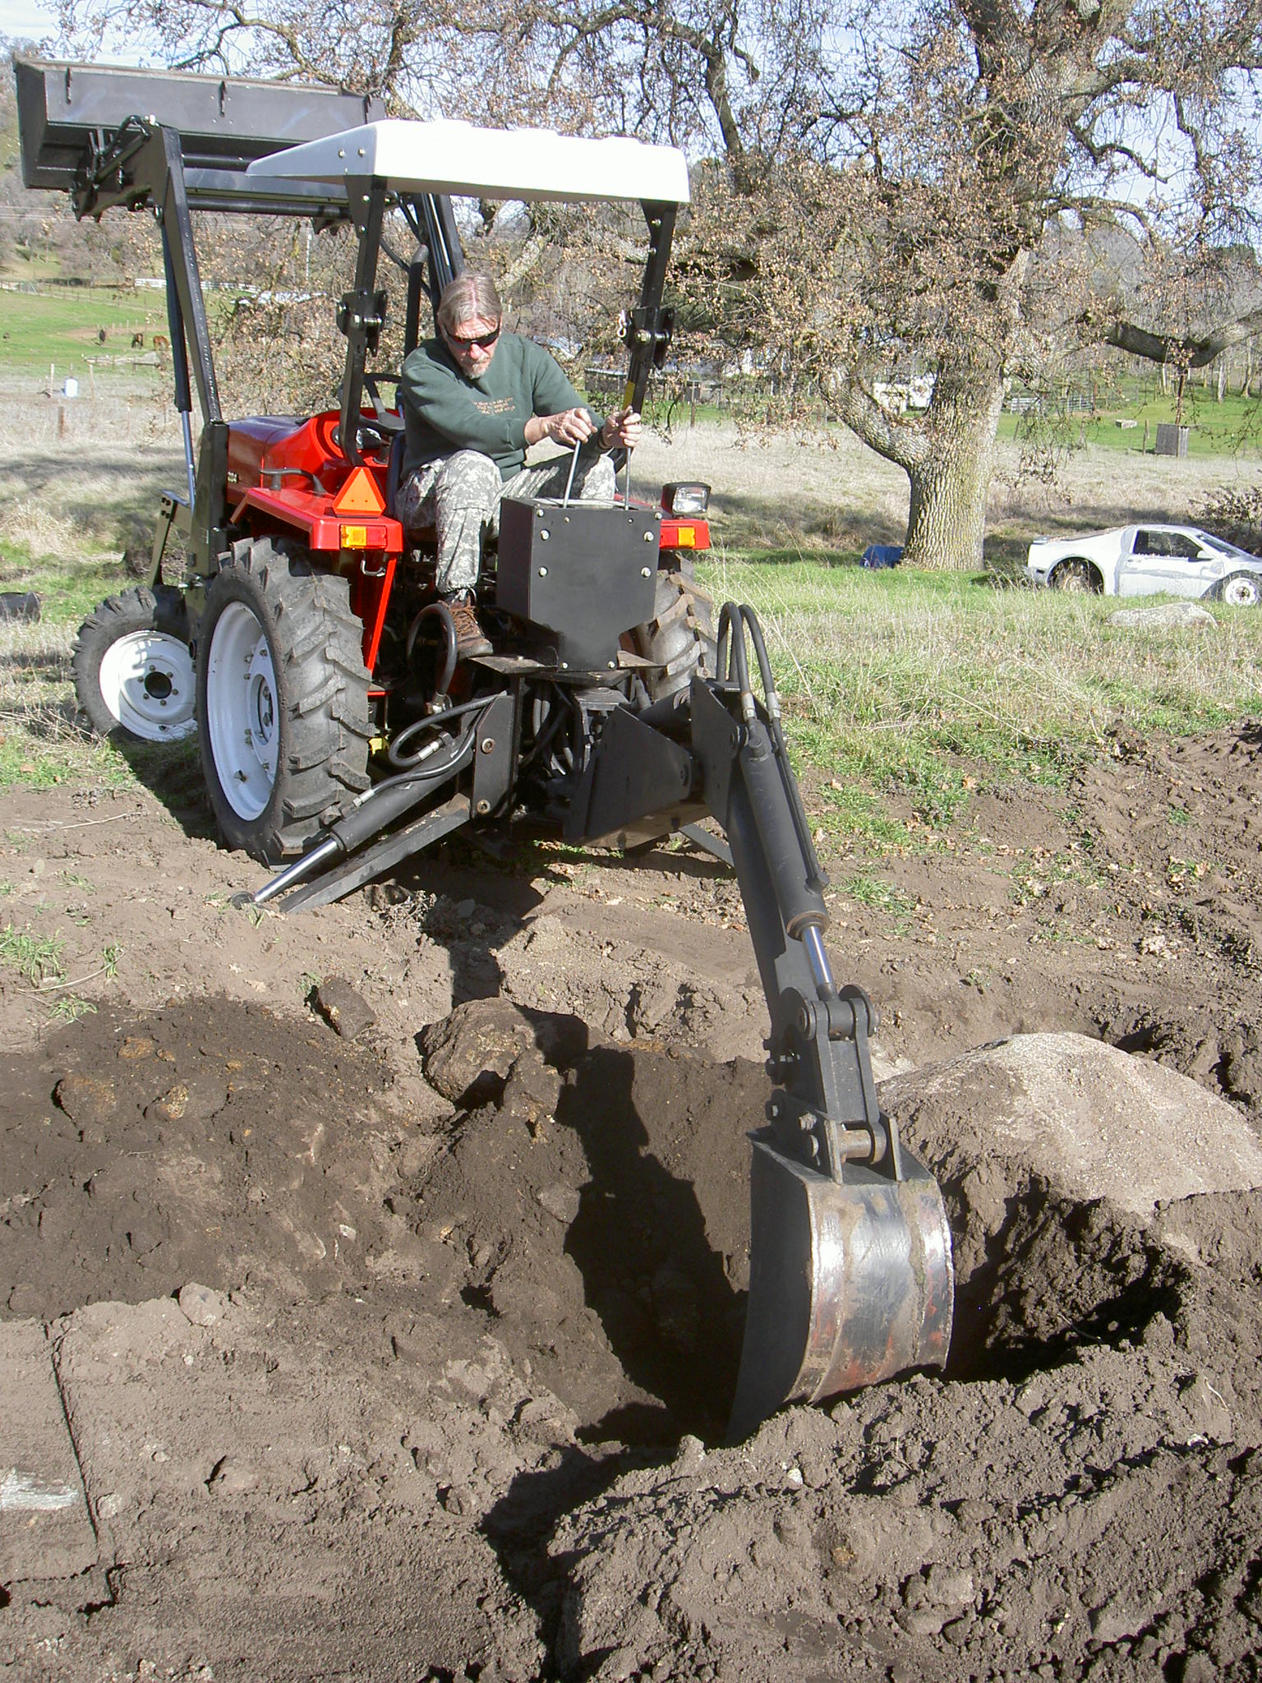

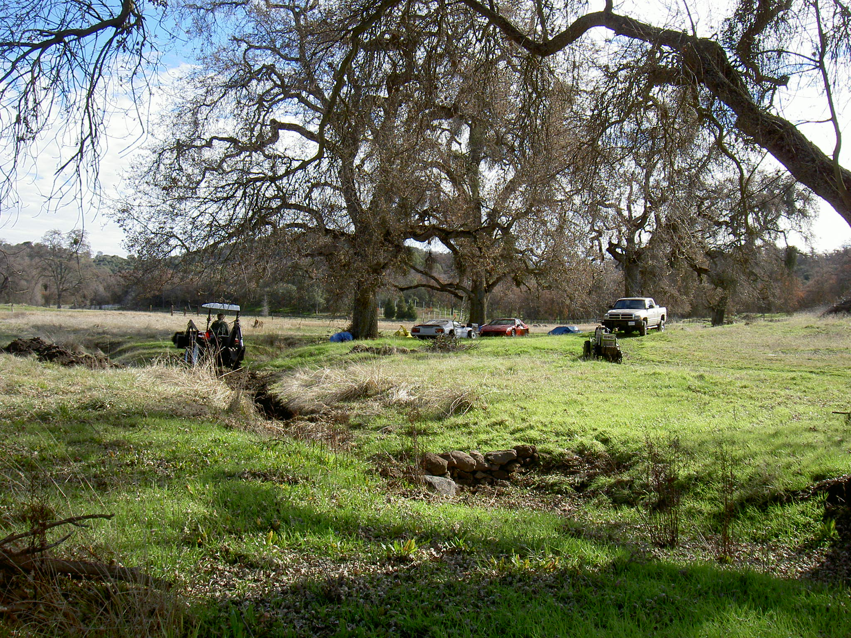

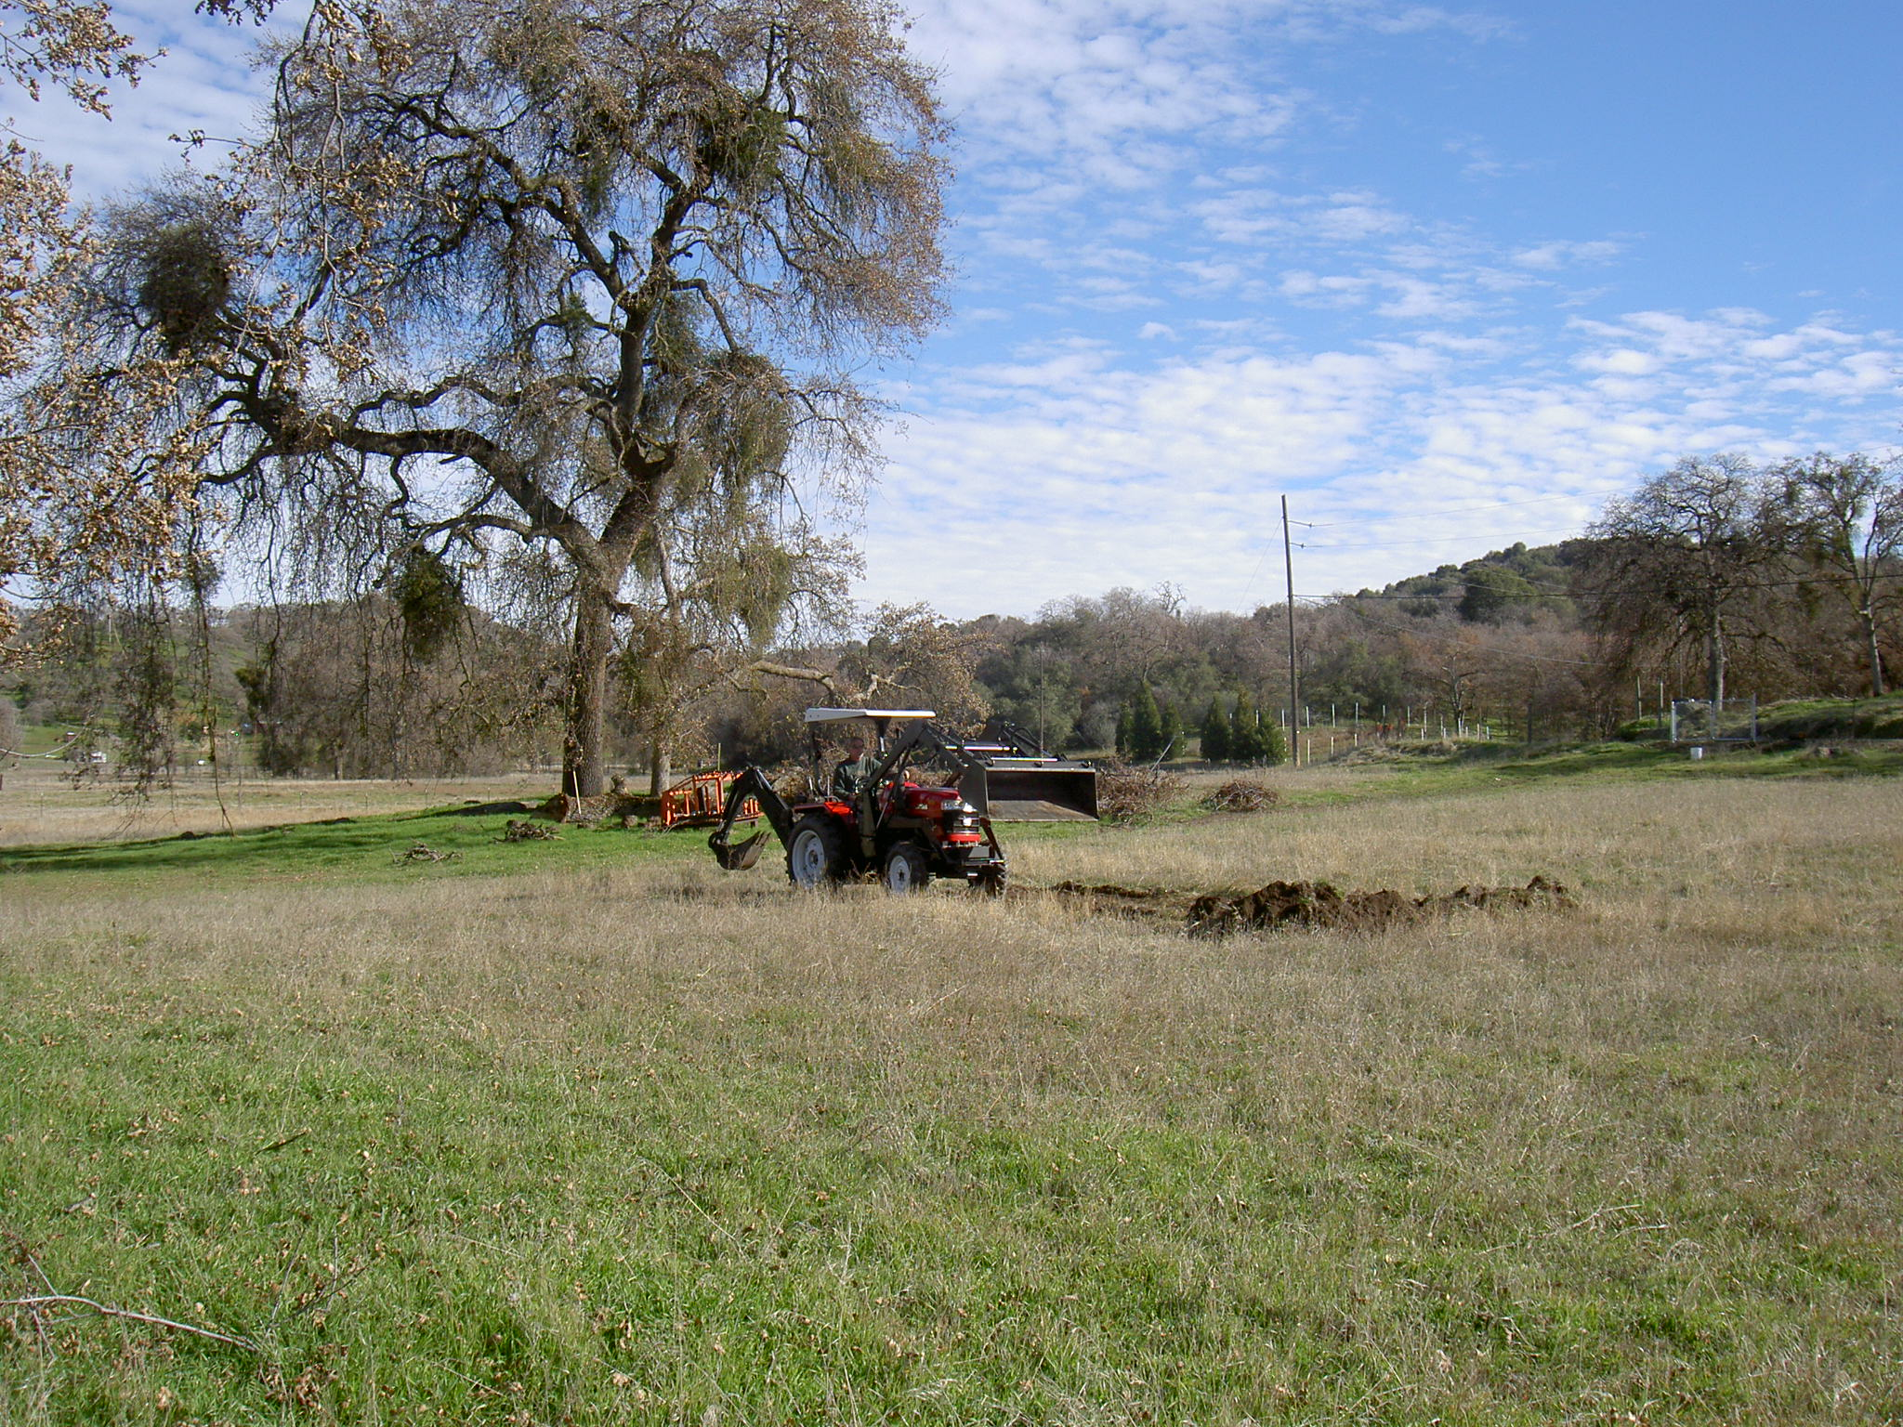
Here we were clearing an area where we had a controlled burn of the tree trimmings.

Poetry Section

*********************************
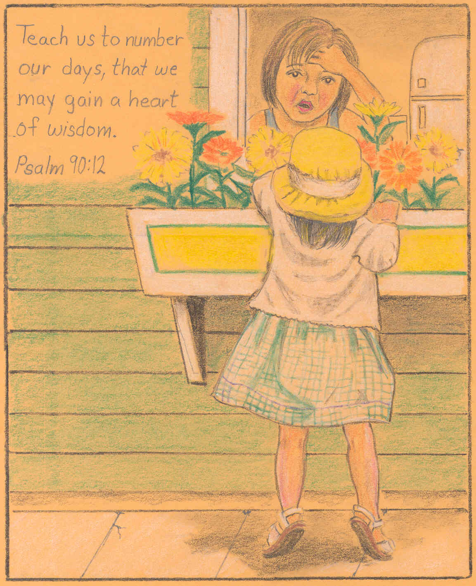
Drawing by Richard Sanchez
*********************************

I See . . . . Me
I look unto myself and see
An empty soul, at best
A failure, true, quite sim-pi-ly
And things I’ve not confessed.

A man quite irresponsible
A father, failed, I be
All these things, and much, much more
In the mirror I do see.

All the things I’ll never be
And promises unkept
And goals perhaps I’ll only see
In dreams on nights I’ve slept.

So much wasted, so much lost
In prison I reside
In spite of lies, I tell myself
The truth can’t be denied.

Yet, somehow. Hope has not died
For what I might yet be.
These dreams I have with lofty heights
Someday, might yet, be me . . .

David Marsh
*********************************

Basket of Water

The story is told of an old man who lived on a farm in the mountains of eastern Kentucky with his young grandson. Each morning, Grandpa was up early sitting at the kitchen table reading from his old worn-out Bible. His grandson, who wanted to be just like him, tried to imitate him in any way he could.
One day the grandson asked, "Papa, I try to read the Bible just like you but I don't understand it, and what I do understand I forget as soon as I close the book. What good does reading the Bible do?"
The Grandfather quietly turned from putting coal in the stove and said, "Take this coal basket down to the river and bring back a basket of water." The boy did as he was told, even though all the water leaked out before he could get back to the house. The grandfather laughed and said, "You will have to move a little faster next time," and sent him back to the river with the basket to try again.
This time the boy ran faster, but again the basket was empty before he returned home. Out of breath, he told his grandfather that it was "impossible to carry water in a basket," and he went to get a bucket instead. The old man said, "I don't want a bucket of water; I want a basket of water. You can do this. You're just not trying hard enough," and he went out the door to watch the boy try again.
At this point, the boy knew it was impossible, but he wanted to show his grandfather that even if he ran as fast as he could, the water would leak out before he got far at all. The boy scooped the water and ran hard, but when he reached his grandfather the basket was again empty. Out of breath, he said, "See Papa, it's useless!"
"So you think it is useless?" The old man said, "Look at the basket." The boy looked at the basket and for the first time he realized that the basket looked different. Instead of a dirty old coal basket, it was clean. "Son, that's what happens when you read the Bible. You might not understand or remember everything, but when you read it, it will change you from the inside out.
That is the work of God in our lives, to change us from the inside out and to slowly transform us into the image of His Son. Take time to read a portion of God's word each day, and remind a friend by sharing this article.

Trivia Answers:
1. Weathering 2. Cerebellum 3. Orange 4. Nine 5. African
The Lighter Side

- Nothing ever gets built on schedule or within budget.

- There are two rules for success: 1) Don’t tell all you know

- The more urgent the need for a decision to be made, the less apparent becomes the identity of the decision maker.

- Birthdays are good for you. The more you have, the longer you live.

- In an argument, the woman always has the last word. Anything a man says after that is the start of a new argument.

- Failure is not an option. It is bundled with your software.

Quotable Quotes

Enjoy the little things, for one day you may look back and realize they were the big things. Robert Brault

The best and most beautiful things in life cannot be seen, not touched, but felt in the heart. Helen Keller

You can go your whole life and not need math or physics, but the ability to tell a joke is always handy. Garrison Keillor

Trivia

- Rocks are broken down by the elements by what gradual process?

- Which part of the brain deals with voluntary movement – forebrain, cerebellum, brain stem?

- What flavor is Grand Marnier?

- In the English alphabet, how many letters are there before “J”?

- Which elephants have bigger ears, Indian or African?

[ Answers on bottom of page 9 ]

What is the Plan?

Our plan - change
We look for things to change. We say that “times have changed,” “Now that is not so bad,” “everyone’s living together,” “We should legalize that,” and the list (excuses) goes on.

God’s Plan – same as always
God’s plan was expressed over 2000 years ago with His sermon on the mount. (Matt. 5-7)

Matt. 5:3-12 – Beatitudes . . . Blessed are . . .
Matt 5:13-16 – Simillitudes . . . Ye are the salt . . . Ye are the light
Matt. 5:17-19 – Jesus fulfills the law
Matt. 5:20-26 – Jesus compares anger with murder
Matt. 5:27-30 – Jesus compares looking with adultery
Matt. 5:31-32 – Divorce
Matt. 5:33-37 – Making an oath, is it a covenant?
Matt. 5:38-42 – Retaliation
Matt. 5:43-48 – Love (5:48 – be perfect)
Matt. 6:1-4 – Alms/Giving (not for our glory)
Matt. 6:5-15 – Prayer (5:7 – no vain repetitions, do in secret like pattern used)
Matt. 6:16-18 – Fasting
Matt. 6:19-34 – Wealth
Matt. 7:1-6 – Judging, first remove own beam
Matt. 7:7-11 – Asking
Matt. 7:13-14 – 2 paths available
Matt. 7:15-20 – Speak the truth loud and bold
Matt. 7:21-23 – Not all that profess will enter Heaven
Matt. 7:24-27 – Build on rock, not on sand

God expects us to pursue Him in all we do. To keep his commandments, and “continue” in His will.

---------------

Our plan – I’ll be “Big, Popular & Powerful”
We put our effort into developing our life so that we will be recognized a success, by what we have accomplished.
We workout with the weights, to grow bigger, for show. We display indications of our knowledge, to impress.
We decide to magnify and display our positive points and cover or not mention our negative points.
We think we are “OK” in life as compared with others.

God’s Plan – We are small to show how “Big” God is
“What shall it profit a man if he gains the whole world and looses his own soul” (Mark 8:31).
God wants us to do a Spiritual workout. God designed us to be balanced; body, spirit, mind.
Our development of body, spirit and mind should be to God’s glory. Our lives should radiate the presence of God.
God is faithful to point out the flaws in our lives. We confront them and change them.
II Tim. 3:17 -

---------------

Our plan – I’ll open the doors, or there were some doors shut to me.
We figure on ways of getting doors open to us. We hear it said,”It’s not what you know, it is who you know.”

God’s Plan –They are open and shut by God.
Rev. 3:7 “…He that openeth and no man shutteth, and shutteth and no man can openeth.
Matt. 19:26 “…with men this is impossible, but with God all things are possible.”
Imagine having “Christ” as your reference on your resume.

---------------

Our plan – “I love you God”
We express verbally of knowing God and loving Him. We tell others of the importance of recognizing God. With the mouth we profess love for God, but with our life, we do not show it.

God’s Plan – “If you loved Me, you would NOT do these things.”
God says “if you love me, keep my commandments.”
God says;
I Corinthians 6:9 “Know ye not that the unrighteous shall not inherit the kingdom of God? Be not deceived: neither fornicators, nor idolaters, nor adulterers, nor effeminate, nor abusers of themselves with mankind,
I Corinthians 6:10 Nor thieves, nor covetous, nor drunkards, nor revilers, nor extortioners, shall inherit the kingdom of God.”
God is VERY explicit in saying these “shall not” inherit the kingdom of God. He then goes on to say “and such were some of you.” It is only by putting these things in the “past tense” that we can inherit the Kingdom of God. It is ONLY by giving our life to Christ for COMPLETE ownership.

---------------

Our plan – Do things to control God
I will pray for ½ hour every day if you will do this for me God.
I will walk up 100 steps on my knees if you will do my requests God.
I have fasted for 3 days God, and you have not granted my prayer request.
I go to church every week and I still have troubles and trials.

God’s Plan – Ownership of us
John 10:27 – My sheep hear my voice and they follow. We are to “just do as God tells us to do.”
God does not get influenced by our trying to please Him to get control of His actions. He wants total ownership of our lives.

---------------

Our plan – Fear of the unknown
As the child when you tell him to go to bed and his reply is “I’m afraid.” You again say, “Go to bed.” The child again says “I’m afraid of the dark.” The child then takes hold of the father’s arm and the father walks him in and safely tucks him in bed.

God’s Plan – God says 365 times “Do not fear.”
God as our Heavenly Father, offers us his “arm” to safely guide us thru the dark and keep us safely.

---------------

Our plan – Ask for a wall of protection
We ask God to protect us. We ask God to put a wall of protection around us and our family. We continually request a wall around our entire family, and we wait. We try to “Break Down” the walls that restrict or restrict.

God’s Plan – Each builds his part of the wall
God does not expect us to build a wall of protection for everyone. Neither does He expect us to tear down the walls that are contrary to his doctrine. “They wondered around and then watched the walls fall down.” It was God’s victory at Jericho, man did not break down the walls.

In constructing the wall around the city, each individual built the wall in front of his own house and as they joined the walls in agreement, great was the wall. We are each part of a bigger picture, part of a larger team. We each need to take care of the wall around our house and do our part.

---------------

Cost of Incarceration

Back in 2005 with volume 12 of Letter From M.O.M., we published an article on the Cost of Incarceration.” The article went as follows;

The numbers and figures quoted will be for the California state prisons, the nation’s largest state prison system only. Although California is #1 of the states in cost, realize that there are another 49 states with the same dilemma. The LA Times reported in March 13, 2005 that “the number of men and women in state lockups soared to 165,000 – a record number that jammed prisons to twice their intended capacity.”
On February 23, 2005, the number of inmates was 162,276. At CSP Solano, a system designed for 2,600, was housing nearly 6,000. Mule Creek State Prison in Ione, California houses about 10,000 inmates.
July 2005 saw the opening in Kern County of prison #33, for the state of California with the dedication of Delano II, designed to house 5,000 inmates with a construction cost of $380 million.
So, what makes up the residents of the nations largest prison system? Note the following figures

Sex Race/ethnicity

Males: 93% Hispanics: 37%
Females: 7% Whites: 29%
Blacks: 29%
Other: 6%

Average age – 36

Average sentence – 53 months

Average time served – 26 months

And with these 165,000 +/- individuals, what is the real expense of their “stay?”

Annual Budget (2004-2005) $6.25 Billion
(2006-2007) $8.75 billion - 40% increase in 2 years
(2008-2009) $

Average yearly inmate cost – (2005) $30,929 - (2006) $34,000 - (2008) $ ???

Number of State Prisons – 33

Number of firefighter camps – 40

# of community correction facilities – 12

We would like to note that California’s prison population is growing at a pace that could fill two new prisons every year. These prisons had a cost on an average of $280 million to build and $80 million a year to operate (Little Hoover Commission Report, Jan. 1998).
In June 1996, it was predicted that 17 new prisons will be needed by the year 2006 with the projected prison population growing to 240,000 inmates. Realize that the projected cost of incarcerating offenders with a minimum 20 year sentence is $500,000. $25,000 operational cost to house a prisoner in California for a year, not taking into account the fixed costs. A county jail bed in 2005 costs $19,700 per year. Elderly inmates typically cost up to $65,000 annually, primarily because of their greater medical needs.

NOW, LET ME BRING SOME OF THOSE FIGURES UP TO DATE.

One out of every 100 people in the USA is behind bars. Tulare County Jail facilities house about 1500 inmates in the 4 facilities. Cost for each inmate is $60/day. Cost for the 1500 inmates is $90,000/day. Cost for all inmates is $33,850,000/year for Tulare County alone.

Inmate Art
Titled “Satan Paints a Pretty Picture”
by
“One that is Released”


