“Letter From M.O.M.”
The Bi-Monthly newsletter of Moving On Ministry

WWW.MovingOnMinistry.com
www.PrisonMinistry.net/movingon
Volume 13 – Jan. 2006 / Feb. 2006

“I Can Only Imagine”

As you receive this volume of Letter From M.O.M., we should be doing or have done our Africa mission trip. In this 13th Volume issue, we are putting some more of the testimonies of “How God Changes Lives.” We can truly say that the “high” that many of our inmates have been trying to get through the wrong methods, is being surpassed by those putting God in control of their lives.

Watch our website www.MovingOnMinistry.com

We have also become affiliated with International Prison Fellowship
www.PrisonMinistry.net/movingon

Fellowship

We would like to keep a listing of locations for fellowship that welcomes previous incarcerated individuals. We previously listed 51 churches that are supportive. Please feel free to let us know of those available. We also cherish letters from inmates or relatives to the churches to let us know how we are doing

Intentions & Wishes

The intentions of this newsletter are to allow an understanding of jail & prison ministries. It is our intentions to get input from those incarcerated as well as those “free” to visit. Life experiences of the faith and fellowship from those locked up in the facilities are always desired to let others know of the value of “visitation”. I am certain that each of us have many stories of the miracles God has done in our lives.
Our wishes are that we would have a list of supportive churches that individuals might look forward to attending once released.
A list of services, such as housing, employment, and counseling services, as well as some individuals available for friendly fellowship are also much needed items.
God’s Word says if a man stumbles, how can he continue lest there be another to help him up. Ecc. 4:10 “For if they fall, the one will lift up his fellow: but woe to him [that is] alone when he falleth; for [he hath] not another to help him up.” Proverbs 24:17 “Rejoice not when thy enemy falleth, and let not thy heart be glad when he stumbleth:” John 11:10 “But if a man walketh in the night, he stumbleth, because there is no light in him.”
Please help us with input for this newsletter as we strive to serve God. We appreciate any articles or input.

Letters that Express it All
Those of you that received Volume 11, our 2nd anniversary issue, noticed about 4 pages of letter excerpts from letters actually received. We like to post real life situation, because God works in real lives and He is the one that gives “Eternal Life.”
***********************************************************
“In the last part of your letter you said that you see anger and hurt . Well you hit the nail on the head, but let me explain to you why, maybe you’ll understand. My father left me when I was one, so I never met him. My mom left me for four years when I was five. I remember feeling unwanted and alone, and to make matters worse, the neighbors sexually molested me during the four years mom was gone. When I was nine, I went to live with my mom who would beat me everyday and sometimes lock me up in a closet all day. At school, the teachers would take me to the principle’s office to show him the marks on my arms left by extension cords. When he would ask, I always denied my mom was hitting me. When I was eleven, all my friends at school approached me to ask me if my mom was a prostitute? I have never felt so ashamed in my life, because I knew it was true, so at fourteen I started with the drugs. You said that I have to shape and mold my daughter, well these are the things that shaped and molded me. So, yes there is anger, bitterness, fear, shame, and a lot of other negative emotions. But I don’t want to live like this chaplain, it’s a miserable existence. I want to have love, joy and peace in my life. I want to be free of these negative emotions that bind me. Why won’t God help me and why can’t I get free? I have prayed for deliverance, I have prayed for healing for years and nothing. JU
***********************************************************
Prayer and Promises
I’d like to thank you for the prayer. It truly helped me . . .(Oh) I would also like to let you know I could still hear you out there talking to the guys. I find you are an inspiration to me, for I respect the fact that when you say, “I’ll come by to see you,” you actually do . . . and for that I truly thank you, you are a man of his word. And what a good word it is. . . . you’re truly a good man Bob, I wish God would make more like you sir, for this world truly, truly needs more men just like you. OZ
***********************************************************
LANDING ON GOOD SOIL
I pray when this letter reaches you it finds you in the best of health and spirit. Upon receiving your letter it brings hope and joy to me to hear your ministry on how God blessed you and continues on blessing you. It brings hope to me and others here, who turn our life over to God and are comforted on God blessing us as he blessed you.
So it gives me great honor to give to you one of God’s gifts He gave me, and that is the drawing on the front of this card. Brother Bob, I have no one on earth who writes me. So it is just me and God and as it said in Psalms 23:1, “The Lord is my shepherd; I shall not want.” So I only have 2 months left before I go home and I just want to take this moment to say “Thank You” for the joy you bring to me, and “yes” your “SEED DID LAND ON GOOD SOIL.” Bless you Brother Bob.
So I’m closing this letter, but I will never close my love, have blessed days. JD
***********************************************************

NOTE From Bob; Let us each pray for God’s glory in situations like these
***********************************************************
Addresses to contact our Ministry Volunteers

Bob
P.O. Box 6667

Visalia, CA. 93290

Church Behind the Wall
3737 W. Walnut

Visalia, CA. 93277

This space available
P.O. Box
Your Town,

This space available
P.O. Box
Your Town,

When Satan reminds you of your past, remind him of his future.

God accepts you where you are, but loves you too much to leave you there.

Need for Change
. . . Keep doing what you have been doing, and you will get what you have been getting.

Conversion
Conversion is the wiping of the slate clean so a new process can “start.”

Replenishing

God’s Word promises to restore the years of the locust, or more simply the years previously lost.

Joel 2:25 And I will restore to you the years that the locust hath eaten, the cankerworm, and the caterpillar, and the palmerworm, my great army which I sent among you.

Our life Left
As we look at the wasted life we have lived, we can only say, “Lord, be the Lord of what is left.”

When you get down to nothin’
Then God is up to somethin’

Psalms 37:21
The wicked borroweth, and payeth not again: but the righteous showeth mercy, and giveth.

EXTRA CREDIT QUESTION

Methuselah was the oldest living man (969 years), yet he died before his father. Can you explain this? Answer coming in Volume 14 of Letter From M.O.M.

Recommended Reading

For the new Christian, or the individual desiring to know God, we would like to recommend the following reading:

The Gospel of John – This is a great introduction of Christ’s walk on Earth.

The Book of Romans – This gives an introduction of many of the Bible stories shared and helps build familiarity of Christ’s plan for our lives.

The Purpose Driven Life by Rick Warren – 40 chapters will change your life in 40 days

Book of Proverbs – Read one chapter a day with the chapter read being the day of the month. This will allow the book to be read almost 12 times thru the year.

Ephesians 4 – 6 – This gives the pattern for life that we should live. All 7 S’s are displayed in these 3 chapters. We are given the purpose of the gifts, changing our character, husband/wife/family relationships, and the type of life we are to live and display.

Men’s Relational Toolbox – Another fine work by Gary Smalley with both of his sons adding to this book. This book avoids “male bashing” but rather teaches men to use and modify the inner tools they have to improve their relationships.

Prayer of Jabez – A truly fine first book from Bruce Wilkerson. This short book will change your mind about being disobedient to God by not taking care of people in need

Sharing Your Testimony
There are 4 parts to an individual’s testimony;
- What my life was like before I met Jesus
- How I realized I needed Jesus
- How I committed my life to Jesus
- The difference Jesus has made in my life.
But in reality, those who believe in Jesus have the testimony of God in them; each of us needs to periodically share our testimony with others. The importance is not what you have done, but what God is doing.
- Your testimony;
- Your life lessons
- Your godly passions
- The Good News

Rent to Own Salvation?
Many are familiar with the “Rent to Own” process of furniture purchase. This is actually a “try it before you buy it” process. The individual gets immediately delivery and just starts making payments. If the payments quit, the items are sacrificed and sometimes there are penalty costs. If the items are what the individual wants, there is a payoff and they are actually purchased. It is unfortunate that this concept has flowed over into the salvation theme. Individuals think that they can try a small piece of a relationship with Christ. They believe that if they try it and don’t like it, they can just let it go and no harm done. Salvation is an eternal and full commitment to Christ.

Turning ‘Life” to Eternal Life
This is how the Lord had changed my life. I was out on the street living with my girlfriend and one day I started drinking and getting crazy with my girlfriend. She called me a bad name and I didn’t like what she called me, so I pushed her down. She called the cops, knowing I had two strikes, and the cops came and took me to jail. So when I got there, I was too drunk for them to book me in, so they put me in the drunk-tank and I went to sleep.
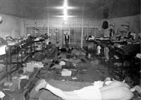When I woke up, I couldn’t believe where I was and what I had done to get there, so they let me call to lock me in and I asked them “What am I in here for,” and they told me spouse abuse, and I am looking at my third strike. Right there and then I started going crazy and I started crying because I didn’t know what to do because I was looking at ‘Life in prison’, and never getting out. The pain was too hard and I wanted to give up and end my life. So, I called my friend on the phone and told her what happened and she told me “Allen, get on your knees and pray and ask the Lord to take off that ‘life’.” So, I hung up the phone and I laid on my bunk just thinking about what she told me to do. I didn’t do it, because I didn’t think nothing would happen. Three days later I went to court and still was looking at ‘life,’ they wouldn’t drop it. I went back to my cell and laid on my bunk again and couldn’t eat at dinnertime. My world was gone. I would never see the streets again.
About 6:00 o’clock some young guy came in and I didn’t know him. He asked me my name and I told him. He told me his name was Jonathan and he was from Tulare. He asked me how much time I am looking at and I told him ‘life’ and I started crying again because I didn’t know what to do. He told me “Allen, do you know the Lord?” I told him “Not really, not that much,” and he told me that the Lord will take off that ‘life’ if you pray and ask him into your life. I asked Jonathon “How do I do it?” and he told me to get my brown Bible and go to the back of it and read with him “My Decision to Receive Christ as my Savior.” So, I did and he told me to read the word every day and get on my knees every night and ask him for forgiveness like my mom told me to. It was the best feeling I ever had in my life. It is like I am free at last. I don’t care if I get ‘life’ or not, I was free.
Three weeks later, I had to go back to court and before I went, I prayed and read Psalms 91. When I went, I walked in the courtroom and I could feel the Lord inside the courtroom. So they called me up there and they told me that I was looking at Four years in prison. I looked up in the courtroom and thanked Him right there. I was so happy that I jumped for joy. When I got back to my cell on the 3rd floor, people could see the love that God gave me, in my Face. Thank God, Bob, I am free again and then when I went to B.W.D.F., I met one of God’s Angels, and it was you! I called you over to my cell and told you the good news that the Lord had done for me. There was a big smile on your face.

It was like that car you showed in the pictures.
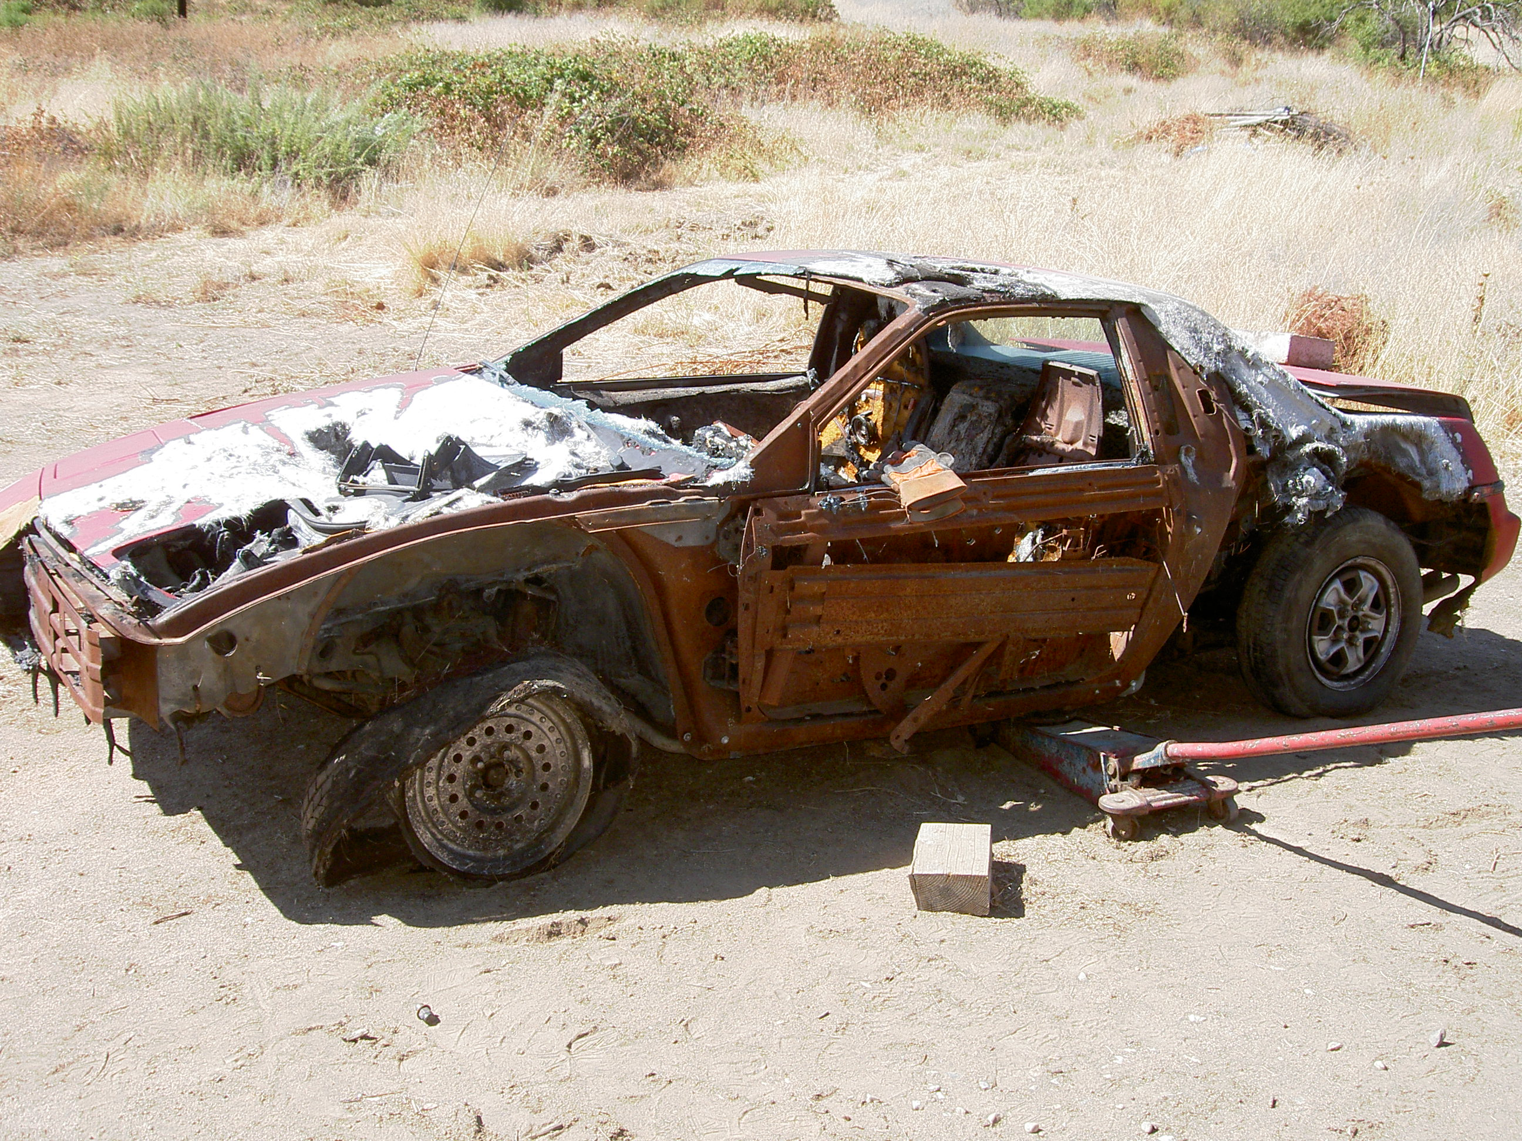
Not only my outside was messed up,

But my inside was also messed up.

Now I am new inside and out.


Now I am at Delano reading my Bible everyday.

God is so good. Well, right now I am reading the book of Proverbs. I love the Bible. If God could change my life, He could change anybody. All they have to do is ask Him to come in their heart, and He will. AF

“Someway and Something Better”
So I said last night, there were things I needed to say, now I’m gonna say them.
Bob, my life was going nowhere fast. I was on a down hill slide with no way of stopping!
Then one day a man comes to my cell (41-105) and began a conversation about God. All my life I believed in God, even went to church as a child, yet I never gave my life to Him and asked for forgiveness.
Every time you came to the unit, you came to my cell and we talked. At first you talked, I just listened, but what I was hearing was catching my attention making me wonder if I was truly living my life right. The more you talked about how God had helped you overcome your spiritual struggles and everyday living problems, I came to understand that there was someway and something better than doing it my way for it was not working.
I started reading my Bible more and more, trying to get an understanding on how to live my life (spiritual) better, so I finally prayed and I felt like a burden was lifted from my shoulders, but something was missing, I didn’t feel whole!
The last time you came was a Monday night, and then a Thursday night and here you came walking through the doors for Bible study. That was the night my life changed for the good and forever, for I accepted God as my personal Savior, it seemed as if my worries, all my problems, were lifted and I felt completely at ease, I felt whole!
Because of you my life has changed and it is for the good and best. I’m very grateful. I wish I had done it sooner, yet again I’m even pleased I did it with you, for you started me on a journey of a lifetime that is rewarding as well as fulfilling.
So I just sit back and remember my life before Christ. I was on my way to self-destruction. People always said; “Look for the silver lining in the dark cloud.” They never told me why! Well I found out, it was lightening getting ready to strike.
Now with God in my life, I don’t have many “dark days” and the few I do, I know God will help me through them and things will be better!
Again I thank you for everything you have done for me and all the other people. Please keep up the work of God, for it changes lives for the good!
Forever I in your debt, and grateful to be there, for it changed my life for the good! SW

A Woman’s Mission
I have been asked to write a portion of my testimony. Well, it all started May 2003. I had already been locked up 5 times. I was in lock down. I was strung out and mad. My veins were full of poison, all I could think about was what I was going to do to get high. Who could I rip off? My mission in life was to get what I wanted at any cost. I had no emotions. I did not care who I hurt. Then one Monday evening I had a woman come to my door. I was very bored, had nothing to do, so I started talking to her. I don't know what it was about her, but she made an impact on me. There were always people that talked to me about God but never impacted me. I don't know. When I get to heaven, I am going to ask God why she got thru to me? Maybe it was the light that she had. Or maybe she could relate to me like no one else could. I am not sure but I actually listened. I had always known God, but not Jesus. So I knew since I was young I was doomed to go to hell. Then this Caucasian woman came and told me there was hope for me of all people. I am not sure that I got it right there and then. So after that I started doing Bible studies with a chaplain. My thought was, okay I will do it. It will give me something to do. That is where I believe God started chipping away the ice. What started out to be entertainment, ended up being what changed my life. It is a process you don't change over night. But the closer and more knowledge of God you have, the faster you change. You get a vast hunger for Him. No matter how much you have read or heard, you want more.
When I got out, I went straight to a church, and I got connected. That is one of the things that have kept me sane and sober is the church body I was in. I left my hometown and moved to Tulare. God placed me in another good church that has been my home ever since then. They have picked me up when I fell. See, God places people in your life, but you have to be open. It is easy to serve God in jail, but what are you going to do when you go out? If you go back to the same life style, you will fall. When you get out, get connected to a church that is Bible based. Somewhere you will not wait to be called, but you will run to. Maybe it won't be the first one you go to, but ask God to show you where you belong. You will know it just feels right. I have been out for little over two years and life is not easier; on the contrary it is harder. But God is always there to pick me up when I can no longer walk. He has to be the one that keeps you strong. Only He can fill up the void in your heart that replaces the poison out of your veins. KN

Like a Dog - To and Fro
It’s like God said, there is nothing new under the sun, meaning to me in God’s eyes, God sees the same thing that goes on in people’s lives. Like crimes, gangs, drugs, adultery, abuse and other temptations. Like in the book of Job, when Satan appeared in front of God and God asked Satan “where did you come from” and he said back and forth the Earth seeking to devour someone like what he tried on Job.
Bringing someone back onto his leash like a dog tied up, and how I realize to myself, I was just that animal. But now that I’ve given my life to Jesus Christ, I feel much better as I’m “Moving On.”
As God has delivered me from a deep pit that I fell into, He has carried me in His arms for so many years. Even though I would fall off, He would lift me up as He waited patiently for me for so many years till I fell into prison. He’s opened my eyes and when He has spoken to me and said, “I have to punish you because your sins are many and your guilt is great and I believe that is very true and God has touched me to look back at the things I’ve done wrong to Him, myself, and family. And as God said to me once more in the book of Jeremiah 46:28, But I must discipline you; I can’t let you go unpunished. Amen. AC

Churches Filling The Gap
. . . thank you for finding time to write me. It really means a lot to me. Also I’d like to thank you for trying to find a program for my children to get X-mas gifts. I hope it’s a success. I read and enjoyed your newsletter. Keep them coming, please. As for myself, well, I’m a 36 yr. Old Mexican. I am Christian and I do believe in our Lord and Him taking our sins for us by dying on the cross. I used to attend Victory Outreach in Carson, CA. with Pastor Robert. Then I went to Calvary Chapel with Pastor Isaac in Torrance, CA., then back to Victory Outreach in Carson. I stopped going about 2 years ago. I started smoking weed and using cocaine cause I thought it was the answer to my problems. I’ve been married for 10 years to a good woman and three beautiful children and a 12 month old grandchild from my 17 year old. I’m a good dad and man. I just had a setback due to marital problems and was kicked out of the house and felt completely lost, and came back to the system. I blame no one but myself. I am responsible for my own actions and only God can save and help me. I need Him (God) in my life or I will end up in here forever. I don’t want that. I want to be saved and serve God with my wife and kids on my side. I’m tired of living wrong. Please pray for me to be strong and be saved. I need all the help of prayer I can get please. You asked me how I stumbled on your ministry. I was in Delano with a Puerto Rican Christian who shared your news letter with me and gave me your address. So now I find myself writing you seeking help from God. RG
NOTE: We wrote to 10 churches, and one (like the one that returned of the 10 lepers) replied and had provided.
Lighter But Serious Side
***********************************************************
GOD SAID 'NO'

I asked God to take away my habit.
God said, No.
It is not for me to take away, but for you to give it up.

I asked God to make my handicapped child whole.
God said, No.
His spirit is whole, his body is only temporary

I asked God to grant me patience.
God said, No.
Patience is a byproduct of tribulations; it isn't granted, it is learned.

I asked God to give me happiness.
God said, No.
I give you blessings; Happiness is up to you.

I asked God to spare me pain.
God said, No.
Suffering draws you apart from worldly cares and brings you closer to me.

I asked God to make my spirit grow.
God said, No.
You must grow on your own! but I will prune you to make you fruitful.

I asked God for all things that I might enjoy life.
God said, No.
I will give you life, so that you may enjoy all things.

I asked God to help me LOVE others, as much as He loves
me.
God said...Ahhhh, finally you have the idea.
***********************************************************
Frayed Friendship
Old Joe was dying. For years he had been at odds with Bill, formerly one of his best friends. Wanting to straighten things out, he sent word for Bill to come and see him.
When Bill arrived, Joe told him that he was afraid to go into eternity with such a bad feeling between them. Then, very reluctantly and with great effort, Joe apologized for things he had said and done. He also assured Bill that he forgave him for his offenses. Everything seemed fine until Bill turned to go. As he walked out of the room, Joe called out after him, “But, remember, if I get better, this doesn’t count!”
Our Daily Bread, June 18, 1994.
***********************************************************

A Father’s Love
There’s a Spanish story of a father and son who had become estranged. The son ran away, and the father set off to find him. He searched for months to no avail. Finally, in a last desperate effort to find him, the father put an ad in Madrid newspaper. The ad read: “Dear Paco, meet me in front of this newspaper office at noon on Saturday. All is forgiven. I love you. Your Father.”
On Saturday 800 Pacos showed up, looking for forgiveness and love from their fathers.
Bits & Pieces, October 15, 1992, p. 13
***********************************************************
Church Thoughts: Waking up for church one Sunday morning, a mother went in to wake her son and tell him it was time to get ready for church, to which he replied, "I'm not going."
"Why not?" she asked.
I'll give you two good reasons," he said. "One, they don't like me, and two, I don't like them."
His mother replied, "I'll give YOU two good reasons why YOU SHOULD go to church:
(1) You're 59 years old, ...and (2) you're the pastor!"
***********************************************************
The Picnic: A Jewish Rabbi and a Catholic Priest met at the town's annual 4th of July picnic. Old friends, they began their usual banter.
"This baked ham is really delicious," the priest teased the rabbi. You really ought to try it. I know it's against your religion, but I can't understand why such a wonderful food should be forbidden! You don't know what you're missing. You just haven't lived until you've tried Mrs. Hall's prized Virginia Baked Ham. Tell me, Rabbi, when are you
going to break down and try it?"
The rabbi looked at the priest with a big grin, and said, "At your wedding."
***********************************************************
The Usher: An elderly woman walked into the local country church. The friendly usher greeted her at the door and helped her up the flight of steps. "Where would you like to sit?" he asked politely.
"The front row please," she answered.
"You really don't want to do that," the usher said. "The pastor is really boring."
"Do you happen to know who I am?" the woman inquired.
"No." he said.
"I'm the pastor's mother," she replied indignantly.
"Do you know who I am?" he asked.
"No." she said.
"Good," he answered.
***********************************************************
Show and Tell: A kindergarten teacher gave her class a "show and
tell" assignment. Each student was instructed to bring in an object
to share with the class that represented their religion.
The first student got up in front of the class and said, "My name is Benjamin and I am Jewish and this is a Star of David."
The second student got up in front of the class and said, "My name is Mary. I'm a Catholic and this is a Rosary."
The third student got in up front of the class and said, "My name is Tommy. I am Methodist, and this is a casserole."
***********************************************************
The Best Way To Pray: A priest, a minister and a guru sat discussing
the best positions for prayer, while a telephone repairman worked
nearby.
"Kneeling is definitely the best way to pray," the priest said.
"No," said the minister. "I get the best results standing with my hands outstretched to Heaven."
"You're both wrong," the guru said. "The most effective prayer position is lying down on the floor."
The repairman could contain himself no longer. "Hey, fellas," he interrupted, "The best prayin' I ever did was when I was hangin' upside down from a telephone pole."
***********************************************************
The Twenty And The One: A well-worn one-dollar bill and a similarly distressed twenty-dollar bill arrived at a Federal Reserve Bank to be retired. As they moved along the conveyor belt to be burned, they
struck up a conversation.
The twenty-dollar bill reminisced about its travels all over the country: "I've had a pretty good life," the twenty proclaimed. Why I've been to Las Vegas and Atlantic City, the finest restaurants in New York, performances on Broadway, and even a cruise to the Caribbean."
"Wow!" said the one-dollar bill. "You've really had an exciting life!"
"So tell me," says the twenty, "where have you been throughout your lifetime?"
The one dollar bill replies, "Oh, I've been to the Methodist Church, the Baptist Church, the Lutheran Church..."
The twenty-dollar bill interrupts, "What's a church?"
***********************************************************
Goat for Dinner: The young couple invited their elderly pastor for Sunday dinner. While they were in the kitchen preparing the meal, the minister asked their son what they were having.
"Goat," the little boy replied.
"Goat?" replied the startled man of the cloth, "Are you sure about that?"
"Yep," said the youngster. "I heard Dad say to Mom just this morning, 'Today is just as good as any to have the old goat for dinner.'

***********************************************************
Why go to Church?
If you're spiritually alive, you're going to love this! If you're
spiritually dead, you won't want to read it. If you're spiritually
curious, there is still hope!
Why go To Church?
A Church goer wrote a letter to the editor of a newspaper and complained that it made no sense to go to church every Sunday.
"I've gone for 30 years now," he wrote, "and in that time I have heard something like 3,000 sermons. But for the life of me, I can't
remember a single one of them. So, I think I'm wasting my time and the
pastors are wasting theirs by giving sermons at all."
This started a real controversy in the "Letters to the Editor"
column, much to the delight of the editor. It went on for weeks until
someone wrote this clincher:
"I've been married for 30 years now. In that time my wife has
cooked some 32,000 meals. But, for the life of me, I cannot recall the
Entire menu for a single one of those meals. But I do know this... They all nourished me and gave me the strength I needed to do my work. If my wife had not given me these meals, I would be physically dead today.
Likewise, if I had not gone to church for nourishment, I would be spiritually dead today!"
When you are DOWN to nothing.... God is UP to something!
Faith sees the invisible, believes the incredible and receives the impossible! Thank God for our physical AND our spiritual nourishment!
"When Satan is knocking at your door, simply say, "Jesus, could you get that?"

***********************************************************

Dream For Africa
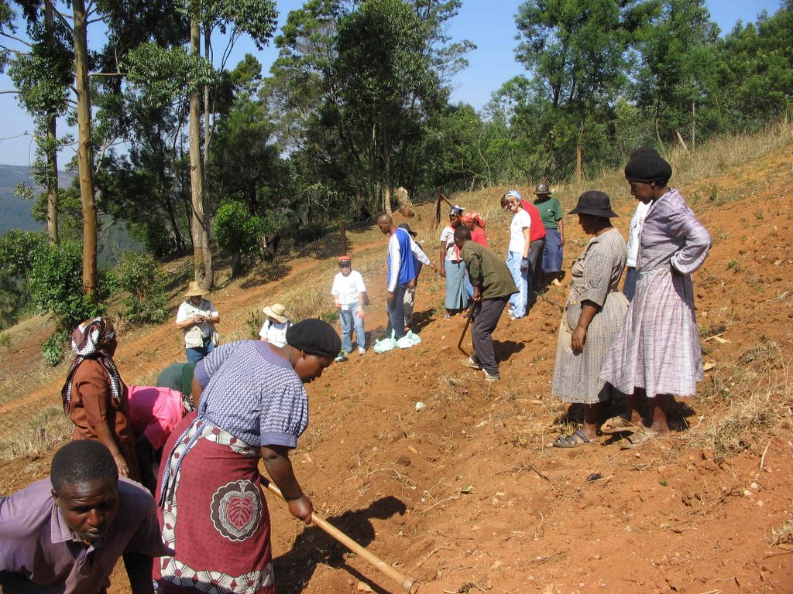
1 Chronicles 4:10 And Jabez called on the God of Israel, saying, Oh that thou wouldest bless me indeed, and enlarge my coast, and that thine hand might be with me, and that thou wouldest keep me from evil, that it may not grieve me! And God granted him that which he requested."

Four things Jabez prayed for.
1. That God would bless him indeed. Spiritual blessings are the best blessings: God's blessings are real things, and produce real effects.
2. That He would enlarge his coast. That God would enlarge our hearts, and so enlarge our portion in himself, and in the heavenly Canaan, ought to be our desire and prayer.
3. That God's hand might be with him. God's hand with us, to lead us, protect us, strengthen us, and to work all our works in us and for us, is a hand all-sufficient for us.
4. That he would keep him from evil, the evil of sin, the evil of trouble, all the evil designs of his enemies, that they might not hurt, nor make him a Jabez indeed, a man of sorrow. God granted that which he requested. God is ever ready to hear prayer: his ear is not now heavy.

Here am I Lord, Send Me . . .
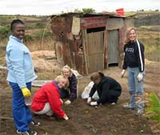
Many have read my testimony of “God I accept you but . . .” (Volume 10 - article on “The Path Inspired”) and asked about where I am with my Africa trip. Well, Praise God, the wife and I will be going for 10 days the beginning of 2006, and may be there or already have gone as you read this. We stepped out on faith and were raising support for the trip. Destination was Swaziland near the southern tip of Africa. The thoughts are joy, fear, love, release, faith, unknown, newness, commitment, release, following, calling, and a million others. I think the wife and I may feel much like Jonah did when asked to go to Nineveh. We also know that the only answer you can give is “Yes Lord, here am I.” Please pray that we raise support for our calling. We believe that “where God guides, He provides.”

So, what was Swaziland like?

Watch for Volume 14 for results of our trip.

The Cost of Incarceration

The numbers and figures quoted will be for the California state prisons, the nation’s largest state prison system only. Although California is #1 of the states in cost, realize that there are another 49 states with the same dilemma. The LA Times reported in March 13, 2005 that “the number of men and women in state lockups soared to 165,000 – a record number that jammed prisons to twice their intended capacity.”
On February 23, 2005, the number of inmates was 162,276. At CSP Solano, a system designed for 2,600, was housing nearly 6,000. Mule Creek State Prison in Ion, California houses about 10,000 inmates.
July 2005 saw the opening in Kern County of prison #33, for the state of California with the dedication of Delano II, designed to house 5,000 inmates with a construction cost of $380 million.
So, what makes up the residents of the nations largest prison system? Note the following figures

Sex
Males: 93%
Females: 7%

Race/ethnicity
Hispanics: 37%
Whites: 29%
Blacks: 29%
Other: 6%

Average age – 36

Average sentence – 53 months

Average time served – 26 months

And with these 165,000 +/- individuals, what is the real expense of their “stay?”

Annual Budget (2004-2005) $6.25 Billion

Average yearly inmate cost - $30,929

Number of State Prisons – 33

Number of firefighter camps – 40
# of community correction facilities – 12
We would like to note that California’s prison population is growing at a pace that could fill two new prisons every year. These prisons had a cost on an average of $280 million to build and $80 million a year to operate (Little Hoover Commission Report, Jan. 1998).
In June 1996, it was predicted that 17 new prisons will be needed by the year 2006 with the projected prison population growing to 240,000 inmates. Realize that the projected cost of incarcerating offenders with a minimum 20-year sentence is $500,000. $25,000 operational cost to house a prisoner in California for a year, not taking into account the fixed costs. A county jail bed costs $19,700 per year. Elderly inmates typically cost up to $65,000 annually, primarily because of their greater medical needs.

Cost of visitation of the inmates ?
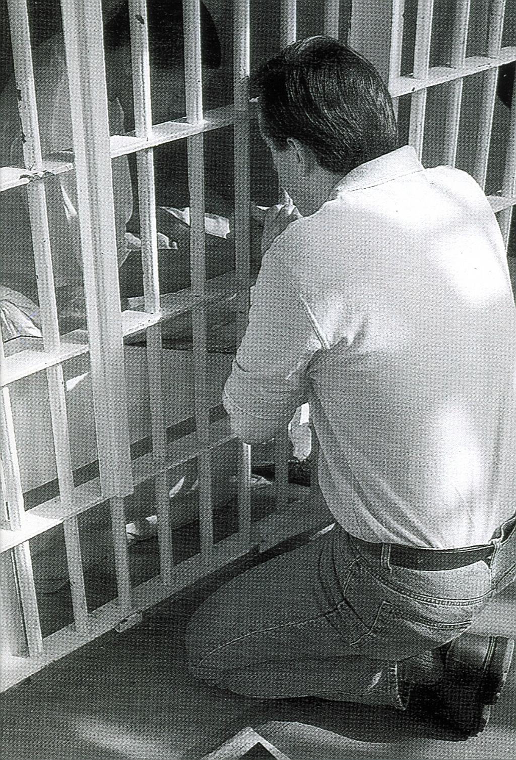
This cost was paid by Jesus Christ and is continually carried by volunteers. Help curb these expenses by showing these individuals the Love of Christ.

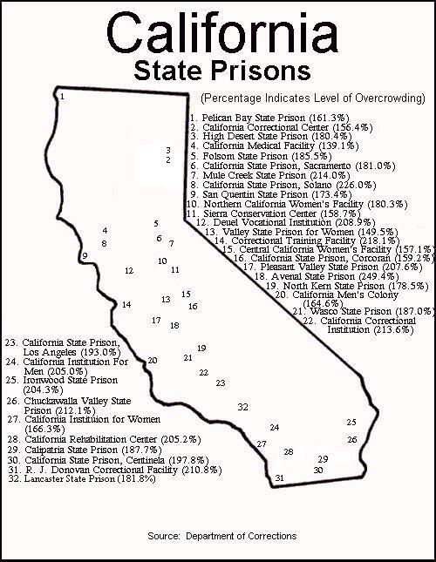

NOTE: 33. Delano II opened this year
The average overcrowding of the 32 listed facilities (#33 – Delano II of North Kern State Prison, not included) is 187.929%. The message needs to get to the inmates that we do not need returning customers, we get lots of new ones each day. Wouldn’t it be nice if churches were this overcrowded!! Prisons would then be down in business!!

