“Letter From M.O.M.”

Volume 95

The Quarterly newsletter of Moving On Ministry

WWW.MovingOnMinistry.com (Since April 2001)
www.PrisonMinistry.net/movingon

Volume 95 –Jan / Feb / Mar 2017 (Published since Oct. 2003)

************************************************************************

“I Can Only Imagine”

As you receive this volume of Letter From M.O.M., we are continuing with more of the testimonies of “How God Changes Lives” as well as some more of our own written articles. We can truly say that the “high” that many of our inmates have been trying to get through the wrong methods, is being surpassed by those putting God in ownership of their lives.

Watch our website www.MovingOnMinistry.com

We are also affiliated with International Prison Fellowship
www.PrisonMinistry.net/movingon

Fellowship

With the crashing of the computer, we are building a new mail list. We got behind on letter replies, and may occasionally miss one. Please write back if we do not answer, and write clearly so we can get the mailing information correct.

Intentions & Wishes

The intentions of this newsletter are to allow an understanding of jail & prison ministries. It is our intentions to get input from those incarcerated as well as those “free” to visit. Life experiences of the faith and fellowship from those locked up in the facilities are always desired to let others know of the value of “visitation”. I am certain that each of us have many stories of the miracles God has done in our lives.
Our wishes are that we would have a list of supportive churches and programs that individuals might look forward to attending, once released.
A list of services, such as housing, employment and counseling services, as well as some individuals available for friendly fellowship are also much needed items (Resource List).
God’s Word says if a man stumbles, how can he continue lest there be another to help him up. Ecc. 4:10 “For if they fall, the one will lift up his fellow: but woe to him [that is] alone when he falleth; for [he hath] not another to help him up.” Proverbs 24:17 “Rejoice not when thy enemy falleth, and let not thy heart be glad when he stumbleth:” John 11:10 “But if a man walketh in the night, he stumbleth, because there is no light in him.”
Please help us with input for this newsletter as we strive to serve God. We appreciate any articles or input.

Pray for volunteers with the same passion as Bob, Linda, Eric, Irie, Ray, Jacob, Savannah, Beatriz and other current volunteers have.

****************************************************************************************

Heather Layne
(Song writer, Nashville and international recording artist)
Heather, Denny and family have moved to Kansas. Heather and Denny have offered to do some prison concerts on a quarterly basis.
Please have the chaplain or the inmate Programs Director contact us if interested in a chapel service, “Heather Layne concert”, a “Take it to the Yard” event or any combination. We MUST HAVE the names and mailing address (or phone extension) of these individuals to make sure the proper paperwork gets completed.
****************************************************************************************



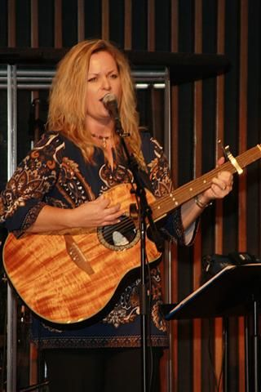

Addresses to contact the Ministry Volunteers

Keep Believing Ministries
P.O. Box 257
Elmhurst, IL 60126

Calvary Chapel Prison Ministry
Attn: Carmine Aleprete
P.O. Box 1965
Big Bear Lake, CA 92315

Otto & Jennie Ball
c/o Crossroads Ministry
P.O. Box 363
Hyde, PA 16843

LaVoz de La Esperanza
101 W. Cochran St.
Simi Valley, CA 93065

Set Free Prison Ministries
Bible Correspondence Course
P.O. Box 5540
Riverside, CA. 92517-9986

Jesus People Info. Center
4338 Third Avenue
Sacramento, CA 95817

Crossroad Bible Institute
P.O. Box 900
Grand Rapids, MI 49509-0900

Ministero de Prison
P.O. Box 543
Live Oak, FL 32064

Prison Pen Pal
P.O. Box 235
East Berlin, PA 17316

Little Lambs, Inc
John & Eileen Sala
P.O. Box 32
Sebring, FL 33871-0032

3 G Company
Correspondence
P.O. Box 1022
Canfield, OH 44406

Iglesia Puerta de Salvacion
202 Lafayette Ave.
Lindsay, CA 93247

World Challenge
P.O. Box 260
Lindale, TX 75771-0260

A Cup of Water Ministries
Pen Pals
P.O. Box 161759
Ft. Worth, TX 71611

International Prison Ministry
Bible, Dictionary, Concordance
P.O. Box 2868
Costa Mesa, CA 92628-2868

El Concilio Del Condado
301 So. C St.
Oxnard, CA 93030

Missing M.O.M. ?
We must constantly remind individuals that we need to be notified of changes of address or facilities. If we get returned mail (about 20 each month), we remove that individual from the files. If you have, or you are going to be moved, please drop us a note to keep your file active. We get mail returned for bad ID #’s, no cell #, and no bed #.
*********************************
Letters that Express it All
We like to post real life situations, because God works in real lives and He is the one that gives “Eternal Life.”
*********************************
Sharing Your Testimony

*********************************
There are 4 parts to an individual’s testimony;
- What my life was like before I met Jesus.
- How I realized I needed Jesus.
- How I committed my life to Jesus.
- The difference Jesus has made in my life.
The importance is not what you have done, but what God is doing.
- Your testimony Your life lessons
- Your godly passions
- The Good News

For those of you that communicate with individuals that have computer access, we have added quite a bit to our web site. The “Resource List” (48 pages), the “Pen Pal Friends” (discontinued), ALL past newsletters (“Letter From M.O.M.”), inmate lookup links, and artwork are available to be viewed or you may download.
www.MovingOnMinistry.com

Readily Available Printouts
Please help with postage
I would like to add that we have shared many wonderful testimonies. Many individuals are afraid to share their testimony because they are not sure what to write or feel inadequate in their writing ability. God’s Word says in Jeremiah 17:9 that “the heart is deceitful above all things, and
desperately wicked: who can know it?”

*********************************
PLEASE Pray that the churches, friends and relatives of inmates would become supporters of this Jail/Prison ministry.

We have downsized the mailing list according to those responding with profile sheet updates (previous list was 750+). Previous mailings were approx. $570.

This newsletter got mailed to about 231 individuals ($.47 stamp X 231 = $108.57), plus 231 envelopes (approx $6) and paper to print approx. 250 copies (1000 sheets = $8.00) plus toner and printer wear ($20). Approx. $143 We have also been getting 120 to 160 letters/requests per month. Let those on the outside know of how much good M.O.M. does.

MOVING ON MINISTRY
June 23, 2007
La mentiras del diablo

Cuando de primero que empeze a leer La Biblia “Cambia Mi Corazon” era una de mis favoritas canciones. Lo mas que cantaba, lo mas que sentia que si era verdad que Dios me amaba y que nomas tenia que estar lista y obediente a “EL”. Dios me perdono mis pecados y me rescato del infierno que me esperaba si seguia en el mismo paso donde andaba. Me perdono completamente y si lo se que cuando cayo una gota de sangre de Cristo Jesus que lo hizo por mi y por ti. Algo costo, verdad?
Dios nos ama con fervor, somos hijos de El Rey de los reyes y no hay mejor Maestro para nosotros. “No Lo Hay” come dice la cancion, “Hay poder, poder, sin igual poder en Jesus quien murio…..”
Cuando EL estaba en la cruz el penso de ti y de mi. Paso mucho y tan doloroso lo que le hizieron pero siempre dijo “Perdonalos porque ellos no saben lo que hacen”. Eso es un amor incondicional algo que nos hace falta a nosotros que somos pobre excusa de humanos que queremos seguir mal pasos. Somos como titeres, que nos hace bailar el diablo.
NO MAS!!!
Somos Cristianos, Somos Soldados De Dios. Peliamos una guerra que nomas nosotros que leemos La Verdad De La Palabra De Dios podemos ver. Porque yo creo que si en realidad podemos mirar alrededor de nosotros lo que hay en este mundo espiritual a la major nos vamos a morir de susto. Efesios 6:1-14
Tenemos que estar listos para seguir en el camino que Dios tiene preparado para cada persona. Cada dia es como una gema, brillante y maravillosa y ahora este dia tenemos que pidirle al Senor que nos guia cada paso.
Siempre hay mucho, mucho mas para servir a Dios. Hay una escritura en Job 38 que hizo abrir los ojos de esta mujer con el Corazon quebrado. You pensaba que sabia todo. Por anos y anos yo tenia tanto coraje en mi Corazon, y la furia me estaba matando cada dia. Mi mente nomas par pensar de la venganza de la violacion cuando estaba joven y ademas era una persona que le tenia confianza. El odio me controlaba. El diablo y sus diablillos nunca duermen. Nomas andan en todo lugar esperando cuando una persona caye en una simple trampa. Ni sabemos que estamos en un trampa, porque puede ser que tenemos dinero, y que no los hace falta de “cosas”, tenemos buen trabajo, casa, y con eso no pensamos en Dios. Pensamos que ya tenemos todo y no necesitamos nada. Pobre gente, verdad? Bien facile creemos las mentiras del diablo, nos caimos en un hoyo oscuro, hondo y despues andamos llorando “Dios, ayudame!”
Dios nos hoye, nos ayuda, y ya nos olvidamos de EL!
Es por so que ahora reclamo la Victoria en Cristo Jesus porque en El tenemos esperanza, gozo y salvacion eterna.
Juan 3:16
Porque tanto amo Dios al mundo, que mando a su Hijo * unigenito, para que todo el que cree en el no se pierda, sino que tenga vida eternal….
Tambien lee Salmos 18 y Salmos 118
Que Dios lo bendiga en su camino diario.

En Cristo Jesus
Linda



Preguntas? Yo no soy escolar pero si trato de obtener repuestas con el mapa que tenemos: LA BIBLIA……. :>) Dios te ama 100%

***********************************************************

MOVING ON MINISTRY
June 23, 2007
The Lies of the devil

When I first started to read the Bible one of my favorite songs was “Change My Heart”. The more I sang, the more I knew that it was true that God loved me and all I had to do was to be ready and obedient to “Him”. God forgave me and rescued me from the fiery hell that was waiting for me if I kept on the destructive path I was on. He forgave me completely and I know that when the drop of blood fell from Jesus Christ that He did it for me and for you.
It cost something, right?
God loves us with a passion. We are sons and daughters of the King of kings and we have no better Master for us.
“There Is Power” like the song goes “wonder working power in the blood of the Lamb. There is power, power wonder working power in the precious blood of the Lamb….”.
When He was on that cross He thought of you and me. He endured so much pain and torture yet He said, “Forgive them for they know not what they do”. That is unconditional love. Something that we lack so much of being a poor excuse of a human that we still want to keep going back on the wrong road. We are like puppets and the devil makes us dance.
NO MORE!!!
We are Christians, we are soldiers of God. We fight a battle that only those who read the Word can identify where the enemy is attacking, who the enemy is and how he uses any means possible to destroy us. I believe that if we could see the spiritual darkness that surrounds us daily we would probably die of fright. Ephesians 6:1-14
We have to be ready to walk the path that God has prepared for each one of us. Everyday is like a gem/diamond shining in magnificence of His Light and today is the day that we need to ask Him to guide our every step.
There is much to do to serve our Lord. There is a scripture in Job 38 that opened the eyes and heart of this broken woman. Here all along I knew what to do. Yeah right! Read it and see for yourself. For years and years I held on to a growing anger in my heart and the fury was killing me daily, slowly but surely. My mind was controlled by the thought of a plan of vengeance due to a rape at a young age and by someone whom I trusted because it was a relative. The hate controlled my being. The devil and his little demons never sleep. They go back and forth throughout the earth looking for weak people who fall in their simple traps. Why we don’t even know that we are even trapped because we might have fancy cars, houses, no need of “stuff” so we don’t think about God. We believe we have everything we need. Poor people, huh? We believe the lies of satan and we fall in a dark and very deep hole and then when we finally realize it we cry out “Help me God!”
God hears us, He helps us then we forget about Him again.
That is the reason why I proclaim the Victory in Jesus Christ because in Him we have hope, joy and eternal salvation.
John 3:16

“For God so loved the world that He gave His only begotten son, that whosoever believeth in Him shall not perish but have everlasting life…”

Read Psalms 18 and Psalms 118

May God Bless you in your walk with Him daily.
In Christ Jesus
Linda
( Volume 91 has my testimony if you have not read it yet. You may request it, This way you will understand more of where I am coming from. Bob’s testimony is Volume 91 also)
(also if you have extra copies or are finished with your reading, please share with others and you will see the blessings of His unconditional Love, 100%.) Read your map of Life….The Bible

Letters from the Bars
************************************************************************

To Bob & Linda and everybody there at Moving On Ministry.
First I would very much like to say Thank you very much for the Resource Book” and also your newsletter. It very much left me with a smile on my face. I don’t get mail very often, so it was really nice. I guess now that I am 59 years old, it is the little things, like getting letters, that means a lot to this old man. Before I got wrongfully locked up, I lived a very normal life. I went to the “Senior Center” every day and played games and talked to people my own age!! Now I just sit in my cell and hope to get some mail from someone. I am going to write some of those people on your resource book and hopefully I’ll hear from someone soon. I really think its great that all of you at Moving On Ministry try your best to help people. You are all a true God-Blessing and I’ll keep you in my daily prayers. Scotty Matthews
************************************************************************
I received your newsletter and the first writing I read was “What is Your Motive?” as I’m reading, realizing this writing is prophetically speaking to me. Everything hit right on the nose. I felt the witness of the Lord in my spirit. So, therefore, I thank you for listening to the Holy Spirit on leading you, and your obedience. It blessed me beyond, those precious words, to continue my journey on which God had assigned me to. I take these words from the Lord Jesus in stride, now having filled up with fuel, like a car having gas, the ability to perform the assignment, able to light up with the Holy Spirit fire and press forward to my high calling of God in Jesus Christ Esteban Argomaniz
************************************************************************

New Wine Church came in and shared an encouraging message. Plus, there was singing, raps, poems and plays (drama). Different ways of worshiping. Praise God!! We even had burritos – LOL. Best thing was that everyone except 1 person came to the altar call to accept (or confirm) Jesus as Savior. I got all teary eyed! WOW God is good. As for me, well, I’m still building a relationship with our Lord. . . . . It has been through , hard and dark times that I’ve experienced our Lord’s love closely. He’s been there through it all, and He’s also shown me that He’s faithful. Well Chaplain Bob, thank you for being a spiritual guide for me. I sure do miss the times you would visit me at Bob Wiley’s Detention Center in unit 31. Ruben Juarez
************************************************************************

I was so very happy when I received your letter. I really wish there is something I could do to help you in some kind of way. It saddens my heart that I didn’t hear about Moving On Ministry when I was living in Lancaster, California. But now that I have your mailing address, when I do get out of prison in a few years, I can then do something to help you. Scotty Matthews
************************************************************************

Update on Chaplain Bob
The Parkinson’s Disease continues to show its presence. Bob notices more shaking in his right hand (only area affected currently). Most of the time the shaking can be stopped by reaching for something or putting his hand in his pocket. His neurologist is increasing the dose of medication to better treat the effects and slow the process. The plan is to get every drop of energy in this body to be consumed in the sharing of God’s Word.
************************************************************************
ROAD TO VICTORY: BY DEE 11/19/16
My name is Dee, a volunteer of M.O.M. as a member of the Body of Christ. A bit about me from the past; I was raised in a single mom home with one older brother. My biological father abandoned my mom before my birth (to date I have never met the person). I began drinking at the age of 12 and experiencing drugs at 15. I struggled with these issues off and on throughout all of my entire adult life. I found myself in abusive relationships and moved in with a boy at the age of eighteen. I had two children early on and a mostly unhealthy marriage. After 12 years of a terrible marriage I divorced and the drug abuse completely ruled my life. Running around with more abusive men and committing crimes of which still to this day I am so ashamed of. I was eventually arrested and charged with identity theft in California. While out on bail I went with my (then) boyfriend and cousin in a car cross country delivering pounds of meth to Iowa. It was there that God finally said, “STOP ! ”. We were arrested and charged federally for the amount and crossing state lines with narcotics.
I did nearly 4 years in Iowa away from my children and family. While incarcerated my brother was killed ☹ ☹ and my mother had already passed away from breast cancer. ☹ ☹
I was literally an “orphan” at 31 yrs. old. It’s only by the Grace of God that I did not ‘self-medicate” with the overly prescribed drugs in prison. It was difficult, but….what I learned is feelings though sometimes are sad or angry are a gift. They also do change but… genuine “Joy” remains always! ☺ ☺ ☺ ☺
I came to know M.O.M. several years ago when I was incarcerated. Well, let me back up just a bit. I actually knew Linda long before my downward spiral that landed me a federal charge in the State of Iowa when my life was actually in California in 1998. I used to attend church with Linda. As the years past I separated myself from the Lord and eventually ended up doing nearly 4 years in Federal Corrections. One day out of the blue I received this heaven sent letter from Linda @ M.O.M. I can’t express how my spirit was lifted. This letter was affirmation that God was with me & that I had “sister & brothers” in Christ praying for me before I even realized it.
While I was serving time federally, I also had charges pending in my own hometown in the State of California. I can honestly say that I know who I am in the Lord and I know who I never want to be without; HIM! AMEN! That is my prayer for every individual who sleeps on metal bunks and has to drink out of a faucet connected to their toilet. : ) LOL!
NOTE: Dee is the Board of Directors Secretary for M.O.M.
I was eventually extradited to Tulare County. I was waiting several weeks for my court date. We had several volunteers sharing the love of Christ and giving hope. One day as the volunteers were passing by from cell to cell……..I looked out my little window to the face of an angel. It was Linda !! I remember that day so vividly we didn’t even speak just faced each other and cried. Even as I write this my eyes are filled with tears of joy! That was 9 years ago. It was that day that I knew I had to give the same hope to women (and men) just like me who felt lost, alone, hopeless, and lost everything. M.O.M. continued to send words of encouragement along with the Chaplains from the institutions I past through. I kept digging into the Bible and eventually the words became more clearly and the Holy Spirit literally lit inside me. I was released from prison in 2009. Though my walk with Christ is stronger than ever it still presents it’s challenges and here I am today. ☺
I have remarried since coming home and both my children came to live with my husband and I. My relationship with them is more than I could ever hope or pray for. They are young adults now and I’m so blessed by all that God has restored. (Joel 2:25) “ I will restore to you the years that the locust have eaten! ”
I soon was in contact with Linda again and my husband and I began volunteering. We are now actively being obedient to the Lord and sharing the love of God. It is my honor and privilege to spread the gospel with you now. I could be here till eternity sharing all that He has done and my testimony goes beyond these few paragraphs. The one thing I wish to impart with all is this: “There is nothing that you have done or will do that could ever keep you from the love of God. His mercy, grace, and compassionate love is greater than our sin! He will meet you right where you are & take you far beyond what you could imagine. “1 Corinthians 2:9”
( p.s. I also cried typing this up…..Linda ) Praise God!
Post Office 101

This article is reprinted by request and is not about the popular game of “Post-office” we may have played as a child. The group playing was divided into two groups – typically a girl group and a boy group. One group goes into another room, such as a bedroom, which is called "the post office". To play, each person from the other group individually visits "the post office". Once there, they get a kiss from everyone in the room. They then return to the original room.
Once everyone in the first group has taken a turn, the other group begins sending members to the first room.
Many play the mailing of letters with the same element of chance and mystery. We want to explain the “rules” of post office (USPS) as it relates to mailing letters.



Rules to begin with:

- Postcard mail is $ .34
- Oversize postcard is $ .47
- Mail up to one oz. for $ .47
- Each additional oz. is $ .21
- Max. letter weight is 3.5 oz.
- #10 Envelope & 5 sheets is 1 oz.
- Oversize are $ .21 additional
- up to 1-oz. letter is $ .47
- up to 2-oz. letter is $ .68
- up to 3-oz. letter is $ .89
- over 3-oz. letter is $ 1.10
- over 3.5 oz. is $1.31 or up

Count your pages. You can mail up to five full size 8 ½” X 11” sheets of paper for $ .47. If you use this fact for mailing, you can have what we call “piggy-back” mail. Five individuals can write a 2 page letter and put the 5 sheets into the same envelope and mail it for a total price of $ .47. Tearing the pages in half, would allow 10 people to mail a full page (front and back) letter for just $.47 total. Doubling these numbers would result in only costing $ .68 for mailing. Imagine 20 individuals able to write M.O.M. a full page letter for only $ .68 postage.
M.O.M. also likes to have update letters periodically to let us know that you are still receiving the newsletters. Notifications of location changes keeps individuals on the mailing list instead of being dropped because of a returned letter.
Cost of mailing a newsletter is $.47 to $.68 in ½ page size format. Full size page format costs $.68 to $1.31. Resources list (48 pages / 12 sheets) is $.89 for postage. Combining the Resource list and the Newsletter results in 16 sheets and can be mailed for $1.10 in postage. If the envelope is over ¼” thick, the mailing charge goes up to $1.31

************************************************************************
Kingman Arizona Trip
Towards the end of October, Bob and Linda took a trip to Kingman Arizona for about 4 days in October. The main purpose (or so we told ourselves) was to visit one of Bob’s ex-bosses, Joe, who had worked for Tulare County and had retired a year after Bob and moved from California to Arizona. On the trip, Bob and Linda had many opportunities to share the Lord and pass out newsletters.

************************************************************************

Linda shot this picture from the car showing the rain about to begin in “Sunny” Arizona
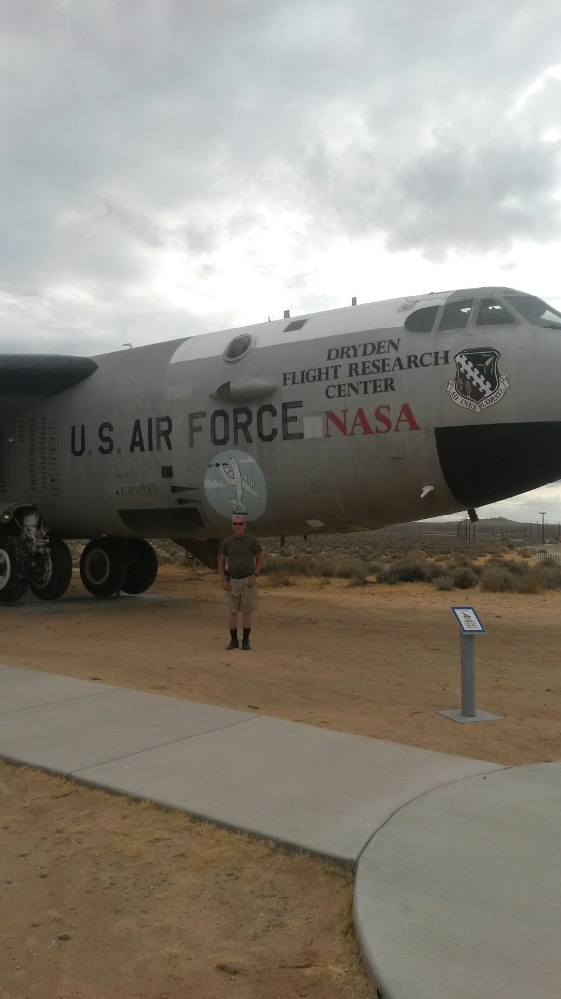
We stopped at Edwards Air Force Base so Bob could pose by this B-52 aircraft. It was aircraft such as these that Bob received his aircraft electrician training. He then put in 21 years in the Air National Guard, as well as 2 years in the Army National Guard corp. of Engineers.


The Majesty and beauty of God’s Creation with attention to EVERY detail.



Does not even nature proclaim His handy work?
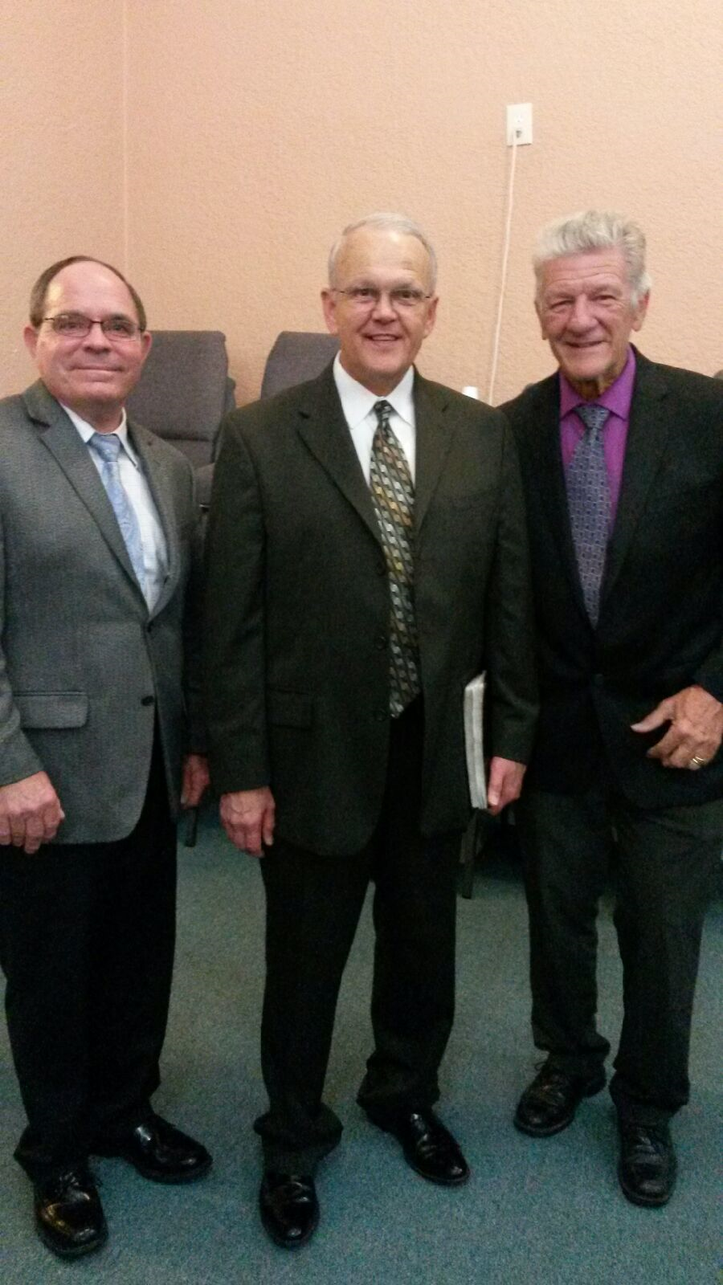
Pastor Tracy Ross Dr. Ray Young Chaplain Bob

Just had a 3 day encounter on Revival given by Dr. Ray Young. The following article is on ideas of “Revival.”
************************************************************************
“Revive – To bring something back to life or consciousness; to bring back into use; to quicken.” Revive when talking in the spiritual sense is to quicken (make alive) the spirit. The tendency is for the spiritual nature to become less active and the relationship with Christ to become more of a casual friendship instead of the intimate relationship as it was when first being saved.
************************************************************************
Note from Bob:
We are seeing a lot of ministries and churches fold up. Some of the churches have lost their “boldness” and thus have the members with non-committal attitudes. These individuals just think of the church as a place for social gatherings. Many of the churches and ministries are closing doors because of the increasing cost of operation and lack of income/donations to support them. A quick look at the Resources available shows the trend of closure (60 pages down to 48 pages) for these much needed outreach. Pray for dedicated individuals that truly have a calling for the ministry. Too many individuals are in positions of “employment” for their “calling” and if money stops, so do they. M.O.M. as made itself available for nearly 16 years (April 2001 – April 2017) and God has seen fit for our volunteer (though we donate money for expenses) services to continue. ************************************************************************
Regarding response on letter from Jan from # 94 Newsletter.
(I had to ask if this could be printed) 11/07/2016
Dear Chaplain Bob and Linda
……Well, I would be more than glad to share with you. My mom had six children altogether, but, three are from a prior relationship, which was my real father. He used to see us every weekend….. well…for almost two and a half years he was raping us in the most craziest ways. We told our mom and stepdad who contacted police & they said there was no proof and refused to do any paperwork and we still had to see him every weekend. This continued until I tried to end my life at the age of 7 and that’s when the police got on the ball and arrested him for it. Mom and Step-dad (Rick) filed papers with the courts for our real father to give up all rights and on August 5, 1992 Rick adopted us and gave us his last name and that was the best thing ever!
Us kids don’t call him Rick of course, we call him Dad, because he’s more of a father to us than the other one was ever. On April 6, 2007 we were told that our real father had passed away from a massive heart attack and I have to say God got even! HE sure doesn’t like ugly. With all the stuff he put our family through, I was happy to hear that he had passed away. Does it sound mean? NO, because he not only did that to us kids, but he beat up my mother on a daily basis that due to all the beatings my mother is now blind and it’s because of him. To see my mom come here every two weeks and having to lead her around…well it’s just hard to swallow. Let me just give you one example of what he did. He drank a lot. She forgot to bring home a bottle of beer so he beat her with a hammer! ☹  How can any human be so cold? I’m in tears. I hope this opens eyes to all who read. God bless to all.
James / PA-SCI.CampHill

Thank you James for sharing…I know this was hard to as to memories while writing this. May the Lord bless you and your family. AMEN
************************************************************************
M.O.M. Ministry “Do’s and Don’ts”

What we don’t do:

Send money to you or family
Trade personal information
Contact people for you
Look up information on people
Spend time doing research for you
Set you up with individuals for romance
M.O.M. is NOT a dating service
We Do NOT do legal work
Will not give our phone numbers
Will not accept collect phone calls
Might not send pictures
Pen-pal list / service discontinued

************************************************************************
What we will do:

Chapel service at prison facilities
Ministry program for churches
Transitional Planning class
Send newsletters with S.A.S.E. ($.47)

Send 56 page resource list with S.A.S.E

Contact Heather Layne about concert
Take it to the Yard event
Platform speakers
Motorcycles
Concerts
Magicians

Print testimonies & artwork.

************************************************************************

For those wishing to get a mailed copy of current newsletters, please send donation (if able), stamps or S.A.S.E. and request the current newsletter. The newsletters (all 95 volumes) are available on the web site;

www.MovingOnMinistry.com

as well as the 48 page “Resources From M.O.M.” list. You can have a loved one or someone with internet access print the newsletters or Resources and mail them to you, or send a 6” X 9” S.A.S.E. with $ .89 postage and any donation for printing of Resources.

************************************************************************

Suggested donations for printouts.

Newsletters $1.00

Resources List $3.00 (or 6 stamps)

Please distribute this information to your visitors and inmate loved ones.

********************************************************************************************PLEASE also send us the names of your Chaplain and Inmate Services Program Directors. We need these to confirm and schedule events.
********************************************************************************************

