Letter From M.O.M.”

“9th Year Anniversary
The Bi-Monthly newsletter of Moving On Ministry

WWW.MovingOnMinistry.com
www.PrisonMinistry.net/movingon
Volume 74 – Sept/Oct. 2012 (Published since Oct. 2003)

“I Can Only Imagine”

As you receive this volume of Letter From M.O.M., we are continuing with more of the testimonies of “How God Changes Lives” as well as some more of our own written articles. We can truly say that the “high” that many of our inmates have been trying to get through the wrong methods, is being surpassed by those putting God in control of their lives.

Watch our website www.MovingOnMinistry.com

We have also become affiliated with International Prison Fellowship
www.PrisonMinistry.net/movingon

Fellowship
We have now communicated with about 80% of the prisons in California, as well as writing to Africa, Egypt, India, Nepal, Ireland,Tennessee, Minnesota, Idaho, Texas, Arizona, Washington, S. Carolina, Florida, New York, and Michigan. We have also had communication thru email as a result of our web sites. We would like to know of the impact we are having and also cherish letters from inmates or relatives to the churches to let us know how we are doing
Intentions & Wishes
The intentions of this newsletter are to allow an understanding of jail & prison ministries. It is our intentions to get input from those incarcerated as well as those “free” to visit. Life experiences of the faith and fellowship from those locked up in the facilities are always desired to let others know of the value of “visitation”. I am certain that each of us have many stories of the miracles God has done in our lives.
Our wishes are that we would have a list of supportive churches that individuals might look forward to attending, once released.
A list of services, such as housing, employment, and counseling services, as well as some individuals available for friendly fellowship are also much needed items.
God’s Word says if a man stumbles, how can he continue lest there be another to help him up. Ecc. 4:10 “For if they fall, the one will lift up his fellow: but woe to him [that is] alone when he falleth; for [he hath] not another to help him up.” Proverbs 24:17 “Rejoice not when thy enemy falleth, and let not thy heart be glad when he stumbleth:” John 11:10 “But if a man walketh in the night, he stumbleth, because there is no light in him.”
Addresses to contact our Ministry Volunteers
Moving On Ministry
Chaplain Bob & Linda
P.O. Box 6667

Visalia, CA. 93290

Moving On Ministry
Spanish Ministry
P.O. Box 6667

Visalia, CA. 93290

Awaken Church
c/o M.O.M.
P.O. Box 6667

Visalia, CA. 93290

Andrea Shannon
8405 Jalimo Ave.
Norfolk, VA 23518

Credit Where Credit is Due
We would like to mention that many of the photos used in past newsletters were taken by Bob’s daughter, Vanessa. Also noted were some of the pictures shot on trips by Linda. We note this because Bob’s photo ability is about as good as his singing ability.
Due to receiving complaints from inmates that some of the addresses do not write back and others are “Return to Sender” because of going out of business, as well as the cost of stamps to inmates, we have discontinued mailing the 12 page Pen Pal List and the 32 page Resource List.
Special requests will be filled with the note of understanding that there are no guarantees. SASE or postage is appreciated for faster service.
The Coffee Creek article is a partial reprint from Willamette Week

Letters that Express it All

We like to post real life situations, because God works in real lives and He is the one that gives “Eternal Life.”
Enjoy the letters, articles and testimonies from those that now know th joy of having God in ownership of their lives

***********************************************************
Missing M.O.M. ?

We must constantly remind individuals that we need to be notified of changes of address or facilities. If we get returned mail (about 20 each month), we remove that individual from the files. If you have, or you are going to be moved, please drop us a note to keep your file active.
***********************************************************
Attitude
We get a lot of letters, and requests from inmates. A lot write to request pen-pals (usually of the opposite gender). We are not a pen-pal service (and definitely not a dating service) but have provided Resource List and Pen-Pal List. Some write to request Study Bibles and Bible study courses. We do get some responses of ‘Thanks’ if/when we send the Resource List or current newsletter. Look how many ministries are no more because of lack of thanks or support.

***********************************************************
Recommended Reading

For the new Christian, or the individual desiring to know God, we would like to recommend the following reading:

The Gospel of John – This is a great introduction of Christ’s walk on Earth.

The Book of Romans – This gives an introduction of many of the Bible stories shared and helps build familiarity of Christ’s plan for our lives.

The Purpose Driven Life by Rick Warren – 40 chapters will change your life in 40 days

Book of Proverbs – Read one chapter a day with the chapter read being the day of the month. This will allow the book to be read almost 12 times thru the year.

Ephesians 4 – 6 – This gives the pattern for life that we should live. All 7 S’s are displayed in these 3 chapters. We are given the purpose of the gifts, changing our character, husband/wife/family relationships, and the type of life we are to live and display.

Men’s Relational Toolbox – Another fine work by Gary Smalley with both of his sons adding to this book. This book avoids “male bashing” but rather teaches men to use and modify the inner tools they have to improve their relationships.

Prayer of Jabez – A truly fine first book from Bruce Wilkerson. This short book will change your mind about being disobedient to God by not taking care of people in need
Sharing Your Testimony
There are 4 parts to an individual’s testimony;
- What my life was like before I met Jesus
- How I realized I needed Jesus
- How I committed my life to Jesus
- The difference Jesus has made in my life.
But in reality, those who believe in Jesus have the testimony of God in them; each of us needs to periodically share our testimony with others. The importance is not what you have done, but what God is doing.
- Your testimony;
- Your life lessons
- Your godly passions
- The Good News

I would like to add that we have shared many wonderful testimonies. Many individuals are afraid to share their testimony because they are not sure what to write or feel inadequate in their writing ability. I think all will agree, that the testimonies that move people are not the ones written from great minds, but are actually the ones written from a great heart.
God’s Word says in Jeremiah 17:9 that “the heart is deceitful above all things, and desperately wicked: who can know it?” When the heart is changed by Christ (salvation – separation – sanctification), it becomes the center of where God works from in our life. The testimony written from the heart is truly God inspired, as compared to the one that is a work of the mind. These are the ones that change others lives also, when shared.

Testimony of Bruce Davis

The trial dragged on for months, and the jury was out for weeks. My hopes rose during the several days they were hung, only to fall when the last holdout voted to convict. Finally, scenes of my life, especially of my crimes, reeled through my mind when the judge pronounced the sentence: "LIFE IN PRISON."

A Way Which Seems Right

By age nineteen I had little reason to believe things at home would change. My father's drunken outbursts were always verbally degrading and sometimes physically violent, and my mother's attempts to protect my sister and me were largely ineffective. I retreated from them both, feeling rejected, worthless and angry. Behind a smiling facade, I pacified myself with overeating and sexual fantasy. I decided to put distance between myself and those I considered the cause of my troubles. From Tennessee I headed west.
In Southern California, the welding and metalworking my father had taught me led to good jobs, nice things and bad habits. I believed possessions would satisfy me. However, the more things I acquired, the emptier and more frustrated I felt, then I began attempting to satisfy myself with drugs.
"For what will a man be profited, if he gains the whole world, and forfeits his soul? Or what will a man give in exchange for his soul?" - Matt 16:26
During my first L.S.D. experience, I encountered a compelling spiritual presence, who camouflaged my fears with counterfeit euphoria. Allured by feelings of self-exaltation, enchanted by prospects of personal power, I was finally seduced by an "angel of light." "...for even Satan disguises himself as an angel of light." - 2 Cor. 11:14.
As Ecstasy dulled my despair, I accepted psychedelic drugs as the key to happiness. But continued psychedelic experiences began to whet my appetite for the bizarre, and subtly sowed seeds of destruction, which lay dormant for years.
Those seeds were germinated in a crowded Los Angeles jail cell. A false charge against me seemed reason enough to commit myself to rebellion. This decision was exploited by a spirit-being, like that of my first L.S.D. experience, who encouraged me to reject the system which had falsely accused and abused me.
Soon after my release, I met Charles Manson and The Family. His engaging style, plus the offer of sex and drugs, made his invitation to join the Family easy to accept. The Family gave me a sense of belonging, which I substituted for the love and respect I craved. "There is a way which seems right to a man, but its end is the way of death." - Prov. 16:25. At the end of Spring in 1968, the Family moved to an old movie ranch and I returned to Tennessee.
My father, I later learned, had become a Christian, which explained his efforts to befriend me. But, before I could understand the change, he died from a stroke. Still resentful, I refused to attend his funeral. I did, however, attend the settling of his estate, took my share and again ran from the reminders of my past.
I turned twenty-six that fall aboard a Portuguese freighter. Hashish, Hess's Siddartha and Joplin's Ball and Chain did a lot to fill the time until the Acores anchored off the Biscay Bay in the Spanish Basque port of Bilbao.
Spain and then Portugal led me to North Africa. But even Tangiers' abundant drugs were unable to satisfy me. I drifted to Gibraltar and then to England.
In London an invitation to a lecture introduced me to the Scientologists. I was attracted by their hospitality and began to study their New Age philosophy. These ideas eventually lost their charm and soon afterwards I was back in California. Manson and one of the girls met me at Los Angeles International.
"Get out -- This is trouble!" My gut warned me when I first saw them. I ignored the warning and returned to the old movie ranch, the point of my previous departure. "Suddenly, he follows her, as an ox goes to the slaughter ...he does not know it will cost him his life." - Prov. 7:22-23
During my absence, Manson's mantra of "free love and drugs" had turned to one of racism and violence.
A few weeks later, I drove three others to the home of Gary Hinman. He was a former Family acquaintance they intended to rob. They would not believe Gay's plea that he had no money and the robbery turned into a murder. When I heard of Gary's death, my gut warned, "Get Out!" Again, I ignored it. I was not present at the time of the murder; however, having driven the car and later being in the house, I was implicated. Later, I was present at the murder of Donald Shea. This time, to ensure my involvement, Manson insisted I make a cut on Donald's dead body. I was afraid to refuse and made a shallow three inch cut on his shoulder. Soon after, I was indicted for conspiracy to commit murder and became a fugitive.
Being a fugitive from man was easier than being a fugitive from God. Because of my relatives' prayers, I saw the hopelessness of my situation and after months on the run, I accepted prison as inevitable and surrendered to the authorities on a rainy day in December 1970. "Man's steps are ordained by the Lord, How then can a man understand his way?" - Prov. 20:24

The Truth
Fall of 1974, my second year in Folsom Prison, God began to deal with me. One afternoon, while awaiting a drug delivery, a thought invaded my mind, "You will never get high again." I was first amused and then stunned with unbelief when the drugs arrived and I actually refused my share. I felt powerful when I realized my bondage to drugs had been broken.
Later, at a water fountain, God spoke into my mind, "Look at the yard, what do you see?" I saw everyone as if they were cloaked with death and said, "I don't like this." Then He explained, "This is the result of your choices." I suddenly understood that the death I was seeing on the others was really my own. "I need help," I admitted. That simple statement brought a marked sense of peace.
Some days later, I picked up The Late Great Planet Earth, thinking it was a science fiction. Realizing it was not science fiction, I was about to discard it when the Voice said, "You said you needed help." "So what," I scoffed. He replied, "This claims to be help; read it and if it does not help, then throw it away." Doubtfully, I continued. I wanted to deny the obvious truth of the fulfilled Bible prophecies the writer presented and God's requirement that surrender to the Lord Jesus was the only way to salvation. "...there is salvation in no one else; for there is no other name under heaven that has been given among men, by which we must be saved." - Acts 4:12
Finally, I agreed God's way must be better than my own; mine had definitely wrecked my life. Later, lying in bed, I muttered, "This God stuff is crazy. I'm probably just talking to the walls." He reminded me, "You've done far worse than talk to the walls." I knew then that resistance was futile. Even so, in a last ditch effort to justify myself, I tried to make God respond angrily to me like my father had, so my "surrender" was surly and disrespectful. "Okay God," I said, as if giving Him His big break, "You say you love me; I don't love you. You say you want to help me; I don't believe you. But, if you are willing and able, then do anything you can." Surprisingly, I awoke the next morning having had the best night of sleep that I could remember. When you lie down, you will not be afraid; "When you lie down, your sleep will be sweet." - Prov 3:24
Over the next few days I was amazed by His love as my entire outlook began to change. I had been born again just like Jesus said, "Truly, truly, I say to you, unless one is born again he cannot see the kingdom of God." - John 3:3
God accepted me like I was, but He loved me too much to leave me that way. Big changes were coming. "...if any man be in Christ, he is a new creation, the old things passed away; behold new things have come." - 2 Cor. 5:27
His Life
Years on the psychedelic roller coaster had destroyed my peace of mind. God began His restoration by giving me an attitude adjustment, a spiritual heart transplant. "Moreover, I will give you a new heart and put a new spirit within you; and I will remove the heart of stone from your flesh and give you a heart of flesh." - Ezk. 36:26
Then He began to focus on particular parts of my life. My faith and respect toward God increased when He instantly delivered me from tobacco. His gracious act let me see the difference between His strength and my weakness, between His righteousness and my crookedness. Right then I admitted to deserving death for my sin; He let me see that only Christ's sacrifice had satisfied His judgment against me. I said, "Lord, if you will have me, then I am yours." God continued to change me.
Next came the racist attitude I'd adopted. I saw a black man named "Bad News" just after he had been stabbed to death. I felt concern and sadness for him and his family, but kept trying to deny my feelings and stop my tears. His body and the pool of blood reminded me of the enormity of my own crimes. This was the first time I felt the sorrow and pain of those I'd hurt. I also felt remorse and shame for my crimes and regretted ever going along with Manson's lies and manipulation. "I have heard of You by the hearing of the ear; but now my eye sees you; therefore I react, and I repent in dust and ashes." - Job 42:5
My former loyalty turned to disgust. I was glad Manson was in prison, and agreed that I deserved to be there too.
The Lord directed me to study His Word, and I began to consume the Bible and anything related to it. Attending church came next, and soon I was the Chaplain's clerk, and started teaching the Bible and assisting in worship services.
The calling to music was confirmed to me when the Lord impressed a prayer group to give me a Martin guitar. The D-35 was dedicated and inscribed, "To the Gospel of Jesus the Messiah, March 1, 1977."
God used those six years in Folsom to anchor me in His foundation and to teach me that His love is greater than all my sin, fear and doubt.
In 1980, I was transferred to the California Men's Colony at San Luis Obispo, where I became involved in the chapel program and have continued to serve the Lord. Four years later, He sent me the woman who would become my wife. The following year we were married. She is a wonderful, Spirit-filled woman, the crown of my life, and the most loving and honest person I have ever known.
Our marriage carried a high personal price for her. Though supported by a brother and sister, the rest of her family rejected me and our marriage. But, when she had a serious bout with melanoma, her mother came to investigate our situation. During that visit she began to appreciate what my wife valued in me. Our shared love for her daughter became the basis for a growing relationship, which really blossomed when she surrendered to Christ on the occasion of my daughter's dedication.
Yes, a daughter! My wife and I participated in a program which provided two-day private visits for inmates and their families. We wanted to delay having children while I was in prison, but the Lord instructed us to let nature take its course. Our daughter arrived healthy and beautiful. What a blessing she is to us! Now, unlike the families in which we were raised, our's is centered in God's love which enables us to be the parents our daughter's needs. Meanwhile, by loving a child of my own, I am learning that God loves me simply because I am His own.
Over the years, God has used my wife and daughter to help me mature spiritually and emotionally and reinstate my social graces. Now, by His love and grace, my life is greatly restored; and I am a part of a family in which He is Lord.
At first, I tried to solve my problems with self-indulgence and blaming others. It felt right but brought frustration and destruction. Then Christ gave me His simple truth: Living on His terms assures eternal life on earth and in heaven. He gives me hope and help in every situation. His solutions are worthy of my trust, although not necessarily according to my directions or wishes. He remains faithful; I remain His. Bruce Davis

************************************************************************

Mark and Gloria Chapman have started a new ministry.

COPE
Attn: AAJM/HAPP (Hungry African Prisoners Program)
1001 W. Euless Blvd. Suite 212
Euless TX 76040

Chaplain Bob’s Life
Many of those receiving this newsletter have asked for another printout of the testimony of Bob from past life to volunteer chaplain with jail and prison ministry and evangelism for church commitment.
----------------------------------------------
I would like to share a story of the seeds planted in my life and the insight as I look back.
The greatest influence in my life I would have to say was my earthly father. This man would do what ever he could to provide for his family. The greatest reference of his nature was my mothers dearly love always for him.
When I was probably 8 to 12 years old, I had a Sunday school teacher named Malcolm that worked on planting Godly seed in my life. As I look back, I am sure there was the appearance of the seed going dormant, or even dying. As I entered middle school years, I bounced through a variety of churches because of going with friends and relatives. Still, any seed that may have been planted was basically “dead.”
As I was finishing my high school years, I started a job in a restaurant where I met a black man, Otis, that was the dishwasher. He let me know that he was an ordained pastor. I thought I want nothing to do with this man. Otis would take the garbage out to the room to empty and would stay a little longer as he pulled his New Testament out of his pocket and read for his break. Then (the nerve of him) he would come back in and share with me about God’s love for me and God’s purpose for my life. I would tell Otis that I did not want to hear about it. I explained that my relatives would use the Bible and religion to tear apart and slay one another. I further explained that my feelings were that he read the Bible in the garbage room and that was where it belonged. God should have taken my life for a statement like that. I now am thankful that God did not remove my life on earth, because I would not have been going to be in His Heavenly presence. But God had another plan and had not given up on me. I was accepted to California State University Humboldt and moved to Eureka, CA. I have to admit that this was really God’s country, but I still did not have a personal relationship with Him. As I looked for work, I found an opening in the service department of Sears. I was hired to do television and stereo repairs. The manager of the shop came to me and let me know that he was a pastor of a local church. Again I thought “I’ll stay away from him” but that was not God’s plan. I began to think “either this man has something real or he is totally nuts.” I decided that I would ask some questions, and so we would spend lunch together in his Volkswagen and discuss Bible reality.
In January 1971, at the age of 23, I finally told Him, God I accept you as Lord and Savior and want you in control of my life but (1) do not expect me to go to some God forsaken country like Africa as a missionary, (2) don’t expect me to work with youth, and (3) never expect me to be involved with inmates, jail or prison ministry.
As I went on in life, thinking I had cut the best deal I could with God, he started to reveal to me that he wanted me to release some of those things “I” was holding on to and fully submit my life to Him. This happened over an extended period of time and it seems God knew just the right timing and speed for me to grow (you might realize because He is the creator/builder). As I released those fears I had and let God have control of those objects, there continually were burdens being lifted. I now tell people that while people were getting high on weed in Humboldt County, I was getting high on the Spirit.
I became involved in teaching youth and running a youth group. While dealing with the youth, I noticed one principle that can be applied with our relationship with God. I took a group of youth out gold panning. All day long I watched the young men panning the gold. At the end of the day, I noticed the young ladies had the bottles of gold going home with them. When I asked how that happens, the ladies said that the men did it because of love and labored for the ladies. We actually get to take home the “Gold” at the end of “our day” while God was the one laboring for us all those days.
I had a friend that invited me to do jail ministry with him. I told him that I had told God “no” and he said that was probably a good reason to do it. I have been involved in jail/prison ministry for about 3 ½ years now and can truly say it is my greatest blessing that was almost missed because of “trying” to say NO to God. Later in life, God revealed His progression pattern for me to follow;
- Sin
- Salvation
- Separation
- Sanctification
- Soul Winning
- Stewardship
- Service
Many people try to separate from the temptations of the world before receiving salvation. Others try to receive all God’s blessings (sanctification) before they have separated from the sin of the world.
Read Ephesians 4 thru 6 and see if you can see this pattern revealed. Notice that 1 John displays the same progression, as does Colossians.
Now to get back to the “but” three exceptions I had to turning my life over to God. “But #3” was not doing Jail/prison ministry. Well, I have been blessed with 3 1/2 years of involvement as a volunteer with what God has called me to do. “But #2” was to not be involved with youth ministry. I have volunteered as Sunday School teacher, Youth director, AWANA Club boys director at 2 different churches, and organizer for youth outings. The final one, “But #1” was to not go to some God forsaken country like Africa as a missionary. I had made this known to those around me and one Wednesday afternoon, I had a pastor tell me that he thought I would have my passport by then. I said “Oh, you read my testimony in the newsletter.” That evening at our church we had a guest speaker from Cameroon Africa. He then told of being involved with jail ministry too. As I went to talk with him after the service, he said he did not know why, but God told him to give me something – a snakeskin checkbook cover. Those that know me, know my snakeskin boots are a trademark. Four incidents in one day? “OK, God, I will go.” I said.
We then met Bruce Wilkinson in Tulare, CA, who had quit his ministry of Walk Thru the Bible and moved to Africa to start a ministry called Dream For Africa. We decided it was time to sign up
We were truly blessed by the experience. Ask for the Swaziland Special Edition newsletter.

Linda’s Life

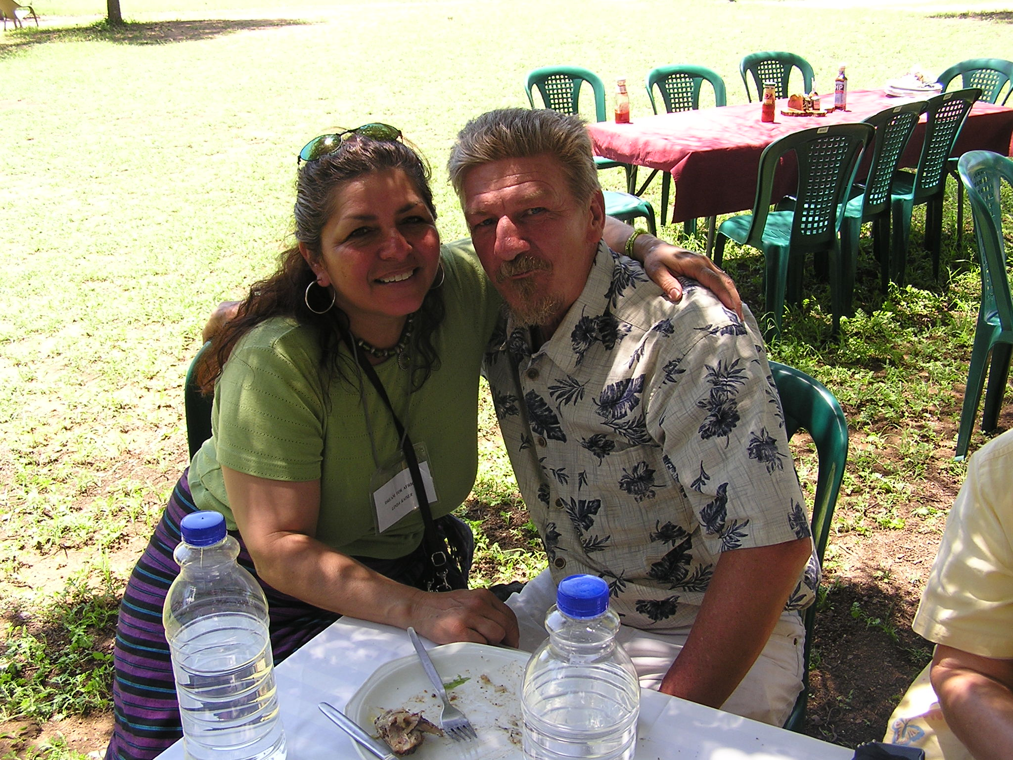
What a great God we serve!!

When my husband asked me to share my testimony I had a picture of my mother and father and the small towns of Fowler and Selma California in my mind. We lived in a three room house with only a light bulb hanging from the middle of the ceiling. There was no plumbing, no bathroom but we did have a woodstove. The outhouse was a distance from the house. We drew water from a well until we graduated to a pump. Years later my “daddy” and “mama” added pipes for a sink and we thought we were rich. We grew all of our own vegetables, had to go out to the henhouse to collect the eggs daily and took care of the Coolidge Ranch consisting of irrigating, pruning, picking grapes, driving tractor etc…. It was the neatest experience. It was survival.
We did not get into town very often so when we did it was a treat. We would visit my dad’s family in Tulare and my mom’s in Visalia California. If we went to church it was for a wedding, funeral, Easter or Christmas that I could remember.
The earliest experience of any prayer that I could remember was an elderly lady by the name of Nellie Metzler and her husband Henry. When the Wizard of Oz would come out on TV every year they would pick up all of us kids and take us to their house. Nellie would pray for our delicious chocolate cake and glass of milk while we sat to watch the movie on this big blanket that was laid out for us in front of the “color” tv. Color TV! Wow! To see color for the first time and listen to Judy Garland sing “Somewhere Over the Rainbow.” There is just something about that song that stayed with me. I could picture myself singing, seeking for answers that would lead to a beautiful new world where there was no tears and everyone was filled with a joy and love for each other.
I did not realize that “Nellie” was put in my path to pray for me until 1992. Thank God that she was a prayer warrior. She was also the person that gave me this book called “All About Trees” and told me to read and I could travel all over the world anytime. Yes, I do love to read and write and encourage others to do so.
My father was a very hardworking man. He was also an alcoholic which led to the abuse of my beautiful mother. In my teens, during their divorce I started hanging around with people who were eight to ten years older than me. WRONG!!
Selma When I was 12 or 13 years old I was brutally and violently raped by a relative whom I trusted. Being dragged down a dirt field by the hair is like those cartoons shown of cavemen dragging the female. With a can opener to my throat and after fighting for my life I finally stopped when I felt this calm over me as if I was not to move anymore. (I am still alive. Thank you Lord!)
My heart was shattered, my mind was confused and the silent rage filled my being. Every person was a target of my fury. The twig of anger turned into a bush of bitterness. Finding myself “alone” in all of this ugliness I chose to “survive”. I vowed that on one was ever going to hurt me again. I delved in new age not knowing that it was leading to a nightmare of hell. I did not know any other way until the day I accepted Jesus Christ into my life in 1992. Praise the Lord!!
I did not care about anyone but myself. I wanted to belong somewhere so like a magnet all my friends were about in the same boat. I was living a wild and very dangerous and promiscuous lifestyle. Misery loves company. That is so sad that some people live life through a tunnel vision. They cannot see the whole picture.
I had my first child at 16, married at 18, had my second child, divorced by 22 and lived (not married) with my third child’s father for another 7 years. During my first marriage I usually ended up by myself with my children. My husband at that time was a heroin addict of which I would go visit him in prisons all over dragging my children along with me.
I was at death’s door at least 6 times either by being almost strangled, beatings, knifed, or shot, well, you name it, from various relationships. We lived in a little cabin in back of my in-laws. Actually it was my then husband’s grandparents who raised him. Whenever Grandma would hear any screams he would try to cover my mouth so he did not have to confront any of them and yell back to her….”Nothing is going on. We are okay.” [Liar, Liar pants on fire :>)]. I would get slapped across my face, onto the bed, his knees would be on my shoulders and I would get called every name in the book as he slapped me back and forth until I would get away which would land me next to the little frig, get slapped toward the stove then slapped to the floor. It was a never ending story. Usually happening on Friday or Saturday nights after he would come home and I would find matchbooks with from the Rainbow Ballroom or he would smell of perfume. It was always something. (That is if anyone remembers those “OLDIES DANCES”.) There were always other women in his life. I was not naive in what was going on all around me. One day I had just about enough and in self defense I grabbed the scissors where I had them up to neck and until I heard “Grandma’s” voice then I pulled back and I was safe…..for one day.
Being in and out of prison is no life for children and thinking there was no way out I felt lost and hopeless. I did not go to church besides visit and never got connected. I finally chose to get divorced leading to dead end relationships that were like a revolving door, over and over again.
The relationship I had for seven years was a roller coaster of emotions. I carried all the excess baggage with me everywhere. This relationship was full of arguments, no trust and insecurity. I had one child from that relationship. My son was loved by everyone and was tragically killed with his best friends in a fiery auto accident. He was a marine and home for several weeks when this happened. It involved alcohol. The enemy never sleeps.
Kings James 1 Peter 5:8,
NIV version 1 Peter 5:8
If I had not known the Lord then, even the little that I knew at that time during my life, I shudder to think where I would have been now. I had two more children without their fathers in their lives.
During 1990 I moved to Visalia. The doors were opening in all areas of my life. I started working with the developmentally challenged, office, auto dismantlers and as a merchandiser working all over the valley. God sent several people in my path to encourage me. I was married in 1994, very involved in my church so when I was served with divorce papers it was as if I was going through the grieving stages of another death. I was devastated. In James 1:2-8 the scriptures speak of “when you face trials” not “if”, for they will surely come. The only thing you have to rely on is to have faith and trust in God. Like Jeremiah 29:11 and also Colossians 4:17 where Paul writes; Tell Archippus: “See to it that you complete the work you have received in the Lord.”
Well we have been given gifts, yes…You! You and I and we have to use them. It is like a nugget of gold. You use it to share the gospel and it increases in value everyday as you go out in obedience for His glory. It could be singing, using an instrument, reading to others, writing, sewing, painting, art, math, woodworking, ironwork, gardening…etc, etc, etc. Those skills are perfected and the giver of gifts will be well pleased…”he that is faithful in little will be faithful in much” What I am getting at is for you to look back at your childhood. What are your skills and gifts and how have you used them? What did you want to be when you grew up? Did you lose your dream? It has been said that the richest place in the world is the graveyard where people’s hopes and dreams are buried along with them. The time is now! Do not wait a second longer. Pray for guidance in whatever you do. Maybe you will end up in Africa as my husband and I did. You do not know but I suggest you start getting prepared for this great adventure. If that train pulls up at your station I suggest you get on. Don’t let that enemy put doubts in your head or allow him to set these words in your mind and heart like “I’ll wait for the right time”, “Maybe later”, “I don’t believe I am ready yet”, or the classic:
“Look at you! Who is going to believe you, after what you have done!?” That dirty devil is the author of lies, deceit, confusion and the lord of the flies.
I am here today to write this because I know that we serve a great God and God loves me. As a young child I was robbed of my youth, joy and hope. When I realized that Jesus took it all for me I asked Him into my heart. He had to be the Lord of my life for the rest of my life. I asked for forgiveness and gave up trying to carry that heavy load of guilt, anger, sadness and the pity parties that I was the host of and was the guest of honor. Like I said misery loves company. If you want to be a winner you have to hang around with winners. Think back at your life and ask God to guide you from this day forward. Allow your life to be filled with a joy that is so overwhelming that you cannot contain it and share it with everyone. You can have it now. Just ask Jesus in complete submission. (search your heart)
Lord, I am here today because I am a sinner. I repent of my sins and ask for forgiveness of _____ (tell Him now) I accept Jesus Christ as my savior and into my heart. I trust in you from this moment on. Give me a hunger for your word. Guide me in the gifts that you have given me so I may serve and share of You daily and whatever I do and say will be glorifying to You. Less of me, and more of You. I am a new creature in God’s kingdom. I am royalty and will act upon it accordingly. May the words of my mouth encourage others, give me the wisdom to turn away from wrong and the strength to run the race and follow you all the days of my life.
AMEN. (There, was that so hard?)

December 15, 1992 Woodland Drive Baptist Church Office
Pastor Ernie and Margie Martinez

When I accepted Jesus Christ in my heart was the day that I said, “Lord, please take away this ugliness in my heart. I want to have joy and peace in my heart. I am sick and tired of being sick and tired. Then all of a sudden I said; (I was truly tired and desperate so I wanted to God to know that I meant business) “ Lord if I ever see the person who hurt me I will tell him I forgive him and tell him of Your love.” Then I said and if I ever see Nicky Cruz I will thank him thanks for his book “Devil on the Run”. Margie gave that to me. The Bible is the living Word. It made this hard headed woman see the light. I got to see Nicky in Fresno and he prayed for me.
Years went by as I noticed so many changes in my life and saw how I viewed “things”. My pastor Isidro and Cleo Carrasco said to get rid of things in my house that were not godly and if in doubt get rid of it. I did as instructed. My eyes were open to all of the stuff that I was allowing into my children’s lives. I had to ask for forgiveness from my children. I then got rid of all kinds of items and broke them up ( gods, idols) thousands of dollars of books and tore them up so no one would pick them up. If we give them to others or set them where another would pick them up and use then or read them, it is opening up the window to the darkness for them and we will be accountable.
Well, one day it happened. I was singing at a funeral and low and behold there he was right across from me. There was the man that had shredded my life into pieces. The first thought that came to me was “Okay Linda, finish singing and get out of here.” I did get to see tears stream down his face under his sunglasses as I sang “Go Rest High Upon That Mountain” I started to leave when I heard a very clear voice tell me “What happened? I thought you were going to tell him about my love?
???? Wow! I immediately asked for forgiveness and followed this person home and went up to him in front of all of his friends to ask him if I could speak to him
When he saw me it was as if he seen a giant with a facial expression that I will never forget. He walked around away from everyone and kept saying “please, don’t look at me. I’m not worth the ground you spit on.” I told him that I thought about many ways to get revenge but that on December 15, 1992 when I asked Jesus into my life there was a heart change. I told him that I was there to tell him that I forgave him and wanted to be sure that I did not go to my grave or he did not go to his grave before I told him that I had repented of all anger and bitterness against him and wanted to be sure he knew Jesus too. He cried and said please don’t tell me that. It burns like hot coals. He was like a crumpled, broken doll on his knees. I gently helped him up, hugged him and told him “I love you and now the ball is on your court. I serve an amazing God and I want you to know Him and let him be the Lord of your life too. Proverbs 25:22, Romans 12:20, NIV.
Romans 12:9-21
Asking for forgiveness does wonders and heals our heart wounds. It had to be real. It was life changing and the newness and the joy I knew at that moment I could not even describe.
Psalm 18, Ephesians 6:10,
1 Thessalonians 5:16-19
My present husband, Bob and I are growing closer…..The truth is ….At first it was a bit of a struggle for me. I would think “forget this” at times. When you are a Christian it doesn’t mean that everything is “live happily ever after”. It just means that we rely on God to guide us in our decisions especially when we “humans” get to a low point. When the storms come we are not alone, especially in blended families. There is so much more. I could go on and on about God’s miracles in my life and the lives of others that I would love to share. You may write me. God Bless you all.

God is good all the time....All the time God is good.
In Christ Jesus, Linda.

Aleisha’s Testimony

The enemy had it out for me from the very start. I was born into a life of violence. My dad & mom were fighting all the time. My dad drunk and running out one minute and the next minute he would be back to beat on mom and take the welfare check.
That wasn’t good enough for the enemy, so it then went to being molested at a very young age. That went on for several years, which lead to the start of my drug problem.
My drug problem was a problem that I had for 33 years. During that time it lead to me becoming a person I didn’t like at all. I was a cheat, a liar, a thief, an unfit mother, bad wife, bad sister, bad daughter and bad friend. You name it and that was me. I was te worst of the worst.
During those 41 years of my life I had cried out to God many times. I thought I was so bad that he couldn’t even love me. I thought He was not even hearing a word I was saying. Boy was I ever wrong!
God answered my prayers on May 2010. the cops showed up at my front door and I went to jail. I had to go into a single cell (high custody) and be PC up because I was married to a Sergeant of Sherriff’s department. He had no clue of who I was or what I was. It was at this point that I started seeing just how much God does love me. He loved me so much that He did not want to share me with anybody for a while. It was just me and God in my cell. God delivered me at that very moment from my addiction. I didn’t have to withdrawal. At one point I felt death. I thought maybe something bad was fixing to happen to one of my children or husband. It was all I could do to pray and cry out to God. God showed me later on that there was a death. It was my own. It was the old me dying. It was very painful and scary. I knew nothing else but my old ways.
Then the new birth began. It was my birth, god began to restore my life. All of the screaming in my head had become silent. For the first time I was able to heart a bird sing. I was able to cry tears of joy. I was able to hear God. For the first time in my life I was finally free. Yes, behind prison walls I was a free woman. God has taken my mess and turned it into my message. God has filled my heart with so much love, I can’t help but toi want to go out and share it with others. Some of the best times of my life is when I get to go out and spend time with the homeless people, the drug addicts, the alcoholics, the prostitutes and even the pimps. Not to judge them, but just show them God’s love.
So never think that God is not hearing your prayer. Just sit long enough to hear Him and trust Him and He will in His time Respond. Aleisha (Alice) Campos

***************************************************************************
Mark David Chapman sent a great suggestion of having a column of “Quotes from Cons” and we would like to add these to the newsletter. Please send yours to us

(1) I’m a Realist (and believe me, Jesus is Real)
(2) Join AARP (American Association of Redeemed Prisoners)
(3) When you are down to nothing; God is up to something.
(4) Worry looks around, Faith looks forward
(5) Free on the inside, showing on the outside
(6) The 1st Amendment does not replace the 1st commandment
Carol’s Testimony

When Chaplain Bob asked me about sharing my testimony in written form, I took some time to really think about it. I did not want to write a typical testimony because over time I’ve learned that much of my early story is very similar to so many other people. The first 22 years of my life are very typical for many who have suffered a childhood of sexual abuse, secrets in the home, having no one to protect you, not only not protect you, but contribute to the abuse. The result of that for the growing up years is not uncommon. A person grows up with feeling guilty, shamed, low self-worth and that manifest itself into having problems attaching to people, developing healthy relationship and very early on in life, taking on various substances that numb the pain, such as drugs, men, stealing and other self-destructive ways. I had an abortion in my late teens which also is not uncommon. I did not tell anyone or try and seek help because there was no one in my home who seemed to care what I did. I had been molested and emotionally raped over and over and over during my childhood, so when I was raped twice at 18 and again at 22, it just layered on top of a lifetime of neglect, pain and abuse. I had no concept of what love was, who I was and I had zero ability to sort out all the mess. I simply grew up with the need to survive.
One twist I took that not everyone takes is I jumped from one form of addiction into an extreme opposite addiction. I had been raped in my early 20’s and was really emotionally struggling. I was drinking heavily and met someone and got married within a month. The marriage was not a safe one as he was an alcoholic and a mean drunk. He was scaring my extended family so after a month of marriage, I asked him to go. He did. I found out shortly after he had left that I was pregnant with my first child. She was like my “saving grace” as no way was I going to raise her with the pain of substances & that life, so I let the old bar and street crowd go and did a complete flip into religious addiction. Where I attended, God’s judgment was taught, not grace. I went to church 3 times a week, hearing about condemnation. They taught about the rules and a person could lose your spot in heaven with just one slip. I stayed there for a long time and although I was no closer to God, I was much safer physically and for that I am thankful. During this time, I did meet some truly kind people and I did see some examples of genuine love. God did use this period of time in my life. Seeds were being planted.
In 1982, I jumped into a new marriage with a man who was in so much of his own personal pain, a man heavily into substance abuse and other addictions and we attached to one another quickly. Even before we married, I knew something was wrong. Something in my gut did not want to get married to him, but we’d already had sex so I thought I HAD to marry him or I’d burn in hell for sure. So I accepted my fate and we married just two months later. I had two more lovely daughters and I stayed in a role of caretaking the family, the home and my husband for the next 20 years. From all appearance on the outside I was doing quite well, but inside I was literally dying. The same pretending I had to do as a child went right on into this long marriage. He was a man who could get angry and explode about anything. We never knew what mood he’d be in. I lived those years trying to keep peace in the home. I lived as a buffer between the children and him. I tried to do anything to divert him from yelling at the girls. It was a “walking on eggshells” existence for all of us. I did my best to protect the children from the rage but I did a very poor job of it and I have had to ask each of my girls for forgiveness in not being able to address the dysfunction in their home. I’ve learned through my own recovery he is what is called a “dry drunk.” He was a person who was extremely wounded, was not in recovery either and so his own pain interfered with his being able to join into a relationship with his family. My youngest asked me during her teens why I allowed him to talk to me the way he did. My answer to her was, “it could be worse.” I gave my girls the role model of “passively enduring abuse.” I was trying to stay in the marriage and not go to hell, but my girls and I we were already living a type of hell here on earth. I remember feeling during this time that I’d try to give my girls all the love I could give in hopes to counteract the emotional pain they were suffering. It did not work. We were all suffering. Now I know, this part of my story is also very common. Many people live lives just like I described for a long, long time.
What I believe is unique about my story is what happened at 46 years old and how God brought my own personal need for recovery into my life and opened me up to facing the truth. I was working in Human Services and one day I saw a job opening at the Substance Abuse Treatment Program in the new Corcoran Prison. I just HAD to apply for it. I had no idea what I was doing but I simply had to work there. I truly did not have the skills I needed for this job. I was supposed to lead groups and talk in front of people, but honestly, I could not even talk to more than one person at a time without crying. I could not talk in front of a group at all. My immediate supervisor must have been able to sense I was not able to do what the job I was hired for because he took me under his wing and had me do the intake paperwork for the inmates coming into the prison. I was so scared of people, but I could interview and talk one to one, just not in front of a group. It did not take long at all and the experience was starting to touch my heart. I found myself listening to people, taking in their stories, their history and their feelings about the events in their lives. The truth flowed out of some of these men, the truth of what they’d lived through and some of what they’d done. Some of them told me the abuse they’d suffered and I was the first person they’d ever told. The TRUTH is what was touching my life. These men were telling pieces of their truth.
One day I found myself with a new thought, “I wanted to live.” I’d spent my whole life wanting to die, but suddenly realized I wanted to live. It was hard to understand where that thought was even coming from. I called a girlfriend and told her I did not know what was going on inside of me but I did not want to go home from the prison. I told her I wanted to live at the prison. She was a little scared for me and did not understand. As the men and I would talk and share their lives, I’d started to share pieces of my life. It was a mutual sharing of truth. I can see now this was my first taste of unconditional love and acceptance. Those are two things I’d never experienced before. I’d grown up being criticized, love never shown, never felt accepted and I’d had absolutely no concept of what unconditional love felt like. The only people I’d ever had in my life that I had any attachment to were those 3 beautiful daughters that God had given me to love. But people knowing and loving me unconditionally, I’d never come in contact with that in my life. My soul was being touched and I’ll never forget what that felt like. It was like I’d been under water and had never breathed and suddenly I exploded out of the water, arms raised high for my first breath of life. It was exhilarating. I was alive and I was happy to be alive for the first time ever.
I started to explode with my emotions, feeling things I’d never felt before. I felt for the first time as though I had a family who cared about me, people who genuinely accepted me just as I was. I did not have to follow any rules, I did not have to act a certain way, do anything for them and they just loved me. They treated me with respect and they never hurt me. They were kind to me and never were critical. They honestly asked questions and showed concern. I did not even understand half of what was going on, but now I use the word “kindred spirits” to describe how I felt. One day one of the men and I were talking and he asked me what I needed and I just like short circuited. I remember saying, “What are you talking about, I don’t have any needs!” I sputtered around for a week, working with that question, trying to figure out what in the world he was talking about. When I spoke to him again about a week later, I told him I had no idea I had any needs. No one had ever asked me that question or ever shown any genuine interest in that part of me. He assured me that I did have needs. But I had to tell him, I did not know what I needed. Me………….I had no concept of me. I had no idea who I was or what I was doing or what I needed.
As the few months went on while I was working at the prison, I spiraled emotionally out of control and ended up having to stop working. I was taken off from work by my doctor and put on disability and went away for a month to stay with a friend in a different state. My girls were almost all grown, my last a senior in high school and so I went. During the month away, all the emotions of the last 20 years of marriage were pouring out of me and I honestly could not even stand the man I was married to. I was sick of living a lie and I went back home, I told him the truth. I had to stop pretending. I proceeded to go through a divorce and immediately both he and I went back into our previous ways of coping. He had his old sexual addiction and substance abuse relapse and I relapsed and I got quickly involved with a man I’d gotten close to at the prison. What I have learned is people can live these lives of pretense for so long, because people can and do literally freeze emotionally when trauma occurs. I had been frozen for the first 46 years of my life.
My journey did take me into recovery. I sought counseling and help. I left the religious addiction and started on a journey of genuine relationship with God. For the next few years, my “guy friend” would get out of prison and he’d relapse, I’d relapse too. I never stopped worshipping during this time. I went to worship and didn’t worry if I cried the whole hour or two. I needed to be at worship. I told the pastor and his wife all about me and that I needed help. They loved me through it all. Through them, God continued to teach me about unconditional love and acceptance. We need to allow others into our lives to help me. I was allowing this couple to re-parent me and nurture me. As time went on I was able to take in more of what God’s love truly is about. I was taking my mask down slowly and allowing people to see me. It was an essential part of God healing me. The pastor was a truth teller. He did not try to sugar coat life. He was gut level honest about how much we need God’s grace and love because human beings struggle. I slowly was able to connect the same kind of love I’d come into contact with through my time with the men at the prison to people in the church. I could see the inconsistency of how I was living. One day during worship, a few years after the start of my recovery I just crumbled at the altar. My guy had relapsed and was using again and I had relapsed again. The pain was so intense and I fell onto the floor and wept like a baby, just confessing I was an absolute mess and I needed help. I surrendered my life to God. He and I started the journey of “We.”
I wanted to clean my life up. My guy friend and I were not married, so we married over the telephone while he was in L.A. county jail. Our next years were him in and out and in and out. I tried to get the parole department to allow my husband to come to live with me in my county. I was having problems achieving that goal and someone gave me the name of a man to help me. After meeting this man, he told me he’d help me, but as a part of the deal, I HAD to get into a class. He said I needed recovery too. I had no idea why I needed a class. I thought everything was great and I had the love of my life tied to me, I’d started my walk with Jesus and I did not really understand why but I kept my part of the deal because I wanted my husband home. I just knew we’d live “happily ever after.” I sat and listened to the ladies, each telling a version of MY story. I was starting to see maybe there was something going on with me and maybe I did need some recovery too. I’d never heard about co-dependency. Over the next couple of years I took classes to understand more about my addictions, classes to learn about my sexual abuse, a class to understand what real love is, several on emotional healing and self-esteem, having healthy relationships and a class on having healthy boundaries. I have ended up with years of individual counseling to open up pieces of me that God desired to heal.
But, back to the story: about 3 years after we had married, I finally got my husband home and within 4 months, I found out through the phone log and a little investigation on my part, he was having an affair. I lost it, screamed, yelled and cried my eyes out. I did not understand how anyone could do that to me. After all, I’d worked so, so hard to get him home, how could he? My magical thinking that I was all he needed got “blown out of the water.” I tried to work with the affair for about 10 months, but I was not OK. He was not in recovery. I had our marriage annulled and even after I had the marriage annulled, we tried to make it work several times, me insisting that he go into treatment. We can never insist on anyone else go into recovery. That is a roller coaster ride that I choose not to take any longer. During that time, I went into a downward spiral and I crashed. I was taken off from work again. I was confused, scared, in so much pain and had no idea what God wanted me to do in my life or with my life.
I decided to go see my family. I packed up and left the state. I rented a house close enough to my parents that I could go and see them, but far enough away that I was by myself. This is the period of my life when God really got my attention. I was in deep pain. I was angry. Nothing I’d ever done had worked and I did not know where God was in all of this. I’d tried and tried and all I felt was pain and failure. I had to confess I was a control freak and I needed to go into a deeper surrender to God’s truth. So I fell flat on my face and God and I went deeper. Some days I’d write all day. Some days I’d listen to worship music all day. Some days I’d just cry all day. I never stopped worshipping and I stayed in union with my Father. It became a very beautiful and expressive period in my life. I was writing quite a bit and sometimes genuine joy would erupt. More clarity came. A deeper healing took place. It took time, but God became my Daddy, the parents I never had, the husband I never had, my everything and more, my everlasting peace. God and I developed a bond that was super glue tight. God had never, ever let me go and now I know He never will. I would not change anything in my life. God has used it all.
My experiences in life have taught me that it takes time, lots of time to work on the process of healing and recovery. The healing comes in pieces. The damage of abuse sort of shatters a person and it is a process for God to mend people back together. I know for a fact that I’ll continue to have growth and healing in my life as long as I have breath on this earth. I am His work in progress. I confess I still don’t know what I am doing at times. Sometimes I do get it and sometimes I still fall. When I fall, I wonder how God even continues to love me, but he DOES. The love He has for me is solid. I believe one of the most important things for me to share is the HOPE that never has left me, the FAITH that God is real and even when I could not see it my Father had me so, so tight in His arms of LOVE. Life in Christ means God is our refuge and He will never leave us. We need to run to Him all the time, anytime, anywhere and under any circumstances, confess our sins, be honest, genuine and real. What I’ve learned is God can’t work with us when we hide from Him or try and hold back part of the control and keep it. We have to drop our mask and give Him 100%. When we do that and surrender it all, His healing power is complete.
During that time when I was away on my retreat, I went so deep with God and I am now able trust Him more. I’ve learned to love me more. No more keeping pieces of me away from Him. What was I thinking? He already knew anyway, but I had to learn the lesson for me. I attached to God and clung to Him. He LOVES us! He is FOR us! Now I understand I am still His mess, but I am MORE than a mess. You are MORE. When we surrender our lives to Christ and allow the blood of Jesus Christ to cover us, we are forgiven. We are new creatures in Christ Jesus. It takes time for Him to heal and pull our lives together. God’s arms are open for us exactly as we are, no matter what we’ve done. As His children, we then have the gift of the Holy Spirit to live in us and guide us into all truth. He is our Daddy and even if it feels at times, like everyone has abandoned us, our Father never will. Psalm 27

***************************************************************************
Ten Qualities of a Luke Warm Christian

- They crave acceptance from people more than acceptance from God

- They rarely share their faith in Christ.

- They do whatever it takes to alleviate their guilt.

- They think more about life on Earth than eternity in Heaven.

- They gauge their morality by comparing to others.

- They want to be saved from the penalty of sin without changing their lives.

- They only turn to God when they’re in a bind.

- They give whenever it doesn’t hinder their standard of living.

- They are not much different from the rest of the world.

- They want the benefits of what Christ did without conforming to who He is.
“Gang Members Will Not Go to Heaven . . . “
By Isaac Meraz

I know that there are many that are involved in jail house political movements, that believe in God, read their Bible and pray regularly. And I know that in the majority of all these circles, that turning your back on the cause to serve God is looked upon as an act of cowardice and weakness. But I warn you brothers that our God says the exact opposite. He says, that “The traditions of men make void the Word of God.” He says, “Love not the world, neither the things that are in the world. If any man loves the world, the love of the Father is not in him.” For everything in the world – the cravings of sinful man, the lust of the eyes and the pride and boasting of what he has and does – comes not from the Father, but from the world. The world and its desires pass away, but the man who does the will of God lives forever . . . “ (1 John 2:15-17). “Whosoever transgresseth and abideth not the doctrine of Christ, hath not God, he that abideth in the doctrine of Christ, he hath both the Father and the Son” (2 John verse 9).
In other words, God says that the real coward is the person who doesn’t want to take a stand for Him. And what is the destiny of a coward who strives for the approval of his peers rather than the approval of his maker? Revelation 21:8 says; “But the cowardly, the unbelieving, the vile, murderers, the sexually immoral, those who practice magic arts, idolaters and all liars – their place will be in the fiery lake of burning sulfur. This is the second death . . . “
I love the way the Message translation captures this line of reasoning in Jesus’ words, “Stand up for Me against world opinion and I’ll stand up for you before my Father in Heaven. If you turn tail and run, do you think I’ll cover for you?” If you don’t go all the way with me, through thick and thin, you don’t deserve me. If your first concern is to look after yourself, you’ll never find yourself. But if you loose your life and forget about yourself for my sake, you’ll find both yourself and me.” (Both from Matt. Chapter 10)
And its trouble ahead if you think life’s all fun and games. There’s suffering to be met and you’re going to meet it. There’s trouble ahead when you live only for the approval of others, saying what flatters them, doing what indulges them. Popularity contests are not truth contests – look how many scoundrel preachers were approved by your ancestors! You task is to be true, not popular. (Chapter 6 of Luke excerpt)
What makes Heaven, Heaven, is going to be that the people there chose to obey God. The people there appreciate what Jesus did on the cross for them and they weren’t afraid to tell others how much they appreciate Him and explain how they also could be saved in this life.
My brothers, there is another life and there is a judgment day when all of mankind will stand before the judgment seat of Christ. Jesus came as a lamb the first time and He will come as a lion the next time. Life is a test. Don’t believe the deceivers that say that dropping out to serve Christ is a cowardly act. I used to be a super vicious and outrageously violent gang member. I was rewarded for that by my peers and given leadership status and bestowed with the title of Norteno Soldado. I caught many D.A. referrals and cases for that cause and am now doing life without possibility of parole for murder for my old gang. I chose to ‘drop out’ for many righteous reasons, the chief one being God’s calling on my life. I’m not a coward, and trust me, if God wanted me to go to war against unbelievers, I would, and I would not hesitate. But no one is forced to believe in Jesus. We face the totality of information regarding Him and God’s purpose for this world and mankind, and we make a choice. Some honor God, but the majority want to impress people and maintain a reputation and go on living in fear of having their “good name” reduced to a cuss word. Which are you?
Brothers, read Proverbs chapter 1 verses 10-18. Look at the perfect description of a gang and look at the advice God’s word gives: “My son, do not walk in the way of them; restrain your foot from their path; for their feet run to evil and they make haste to shed blood (verse 15).
And I don’t care what gang you’re from, brothers, look around you; you’re taught how to think within the circle, whatever circle the influence in your hood pushed you in. You’re brain washed in there and are taught that anything that you’re taught otherwise is poison. Is God’s word poison, or is it the words of a bunch of homeboys who are locked up?
Consider your ways, or rather the ways you were brain washed into adopting. Behind the walls you’re taught that being ‘disciplined’ is necessary; that the use of hard drugs is unbecoming; stealing, disrespecting or taking advantage of others is wrong; and that in order to live in a place where people could live peaceably and co-exist in harmony, that a security force must be established. Homeboys create laws to govern their people’s conduct and maintain this desired state, and they function as police, detectives, judges and every homeboy is expected to cooperate with these authorities. Everything is exactly like the real world! There is so much wisdom, but yet so foolish in failing to see the hypocrisy and evil usurping of power. The K-9 is the #1 enemy and cooperating with the police is snitching. But it’s okay for homeboys to recreate the same systems of government? Why is that so? Government is not wrong but we have to respect the true one. Failing to recognize you are a U.S. citizen and having a dream that your circles leaders will rule California from Pelican Bay is stupid, they’re just making you think that you’re something, to profit from you, however they can. If you remain loyal to them long enough, you’ll pay the price because the true government rules the land and plucks those off the street who break their law. Let’s get it right brothers. Everyone is entitled to security. Everyone’s person and property should be respected at all times. Drug use is always a bad habit. This isn’t something that is meant only for society behind the walls, it’s meant for everyone. You can’t have order without law and as we understand that behind the walls, recognize that it is much more deserving to be understood in the free world where population is much more greater and where our mothers and children live and play.
The Bible speaks on this subject too and I will provide a few verses to prove that, but I encourage you to open your Bible and read on. (Romans 13:1-2) “Everyone must submit himself to the governing authorities for there is no authority except that which God has established. The authorities that exist have been established by God. Consequently, he who rebels against the authority is rebelling against what God has instituted and those who do so will bring judgment on themselves.”
Brothers, here are some more verses to read (Proverbs chapter 6 verses 12-19) Open your Bible and check those verses out, but allow me to write a few right now so I could make a point.
(Proverbs 6:12-19) “These six things the Lord hates, indeed seven are an abomination to him; A proud look [the spirit that makes one overestimate himself and underestimate others], a lying tongue, and hands that shed innocent blood, a heart that manufactures wicked thoughts and plans out lies [even under oath], and he who sows discord among his brethren.”
Consider that against the conduct of those you call your brothers or friends. Homeboys do all those things and especially the last one. In my world, if you’re from the wrong hood, homeboys might try to kill you, and God hates that. He wants you to see that He made every hood, town and city on earth and all of mankind are his children. He wants us to look at each other as family. This is why He says that we should love our enemies, because many are still blind, aimless and mislead. He said us all. But ‘loving’ doesn’t mean uniting ourselves with evil. Love means the opposite; it means helping and leading them towards safety (i.e. the Savior Jesus Christ).
My brothers, read chapters 37-39, in the book of Ezekiel. These are the last prophecies that detail the wrapping up of this part of the world history as we know it. It was written thousands of years ago and paints the world exactly as it is today. It’s a world where the Jews have returned to their homeland after being scattered throughout the world. It names the surrounding nations that would hate it and speaks of a great war that will end with the return of Christ and today the countries named by Ezekiel are all Islamic and they plan to acquire nuclear weapons to destroy the Jews and eventually conquer the world. The reports regarding their plans are constantly broadcast. So invest some time and research my claim if you don’t already know that the world is already at war against the forces of Islam. And my point is to hurry up and repent. Be baptized and learn what it means to give your life to Jesus. This world ends with this last battle and then Christ returns. The end is near, be saved while you still can. Be strong, be true and be bold.

Serving God from Being “The Called;” Isaac Meraz

************************************************************************************************

California Families Incarcerated

Prisoners currently serving life sentences for non-serious, non-violent crimes that would not result in a life sentence under the new law can apply for a sentence reduction. A judge must reduce the prisoner’s life sentence to a term of years no less than double an ordinary sentence unless the sentence reduction would cause "an unreasonable risk to public safety." The burden is on the prosecution to prove by a preponderance of evidence that the prisoner is an unreasonable risk to public safety. The prisoner must be re-sentenced to the shorter sentence if the prosecution cannot meet this burden. A prisoner will have a right to a court-appointed attorney at any re-sentencing hearing. All relevant evidence can be considered at the sentencing hearing, including but not limited to: prison disciplinary records (both positive and negative reports), health records, family support, sobriety, and employment prospects. An estimated 3,000 inmates will be eligible for a new sentence under this initiative.

Our trip to Mount Hood and Coffee Creek Women’s Prison

This is Timberline Lodge at Mt. Hood, Oregon


Mount Hood, Oregon – where you can ski ALL YEAR – This was June 2012

Jail Birds - The fastest-growing group of inmates in Oregon: Women.

A look inside Coffee Creek Correctional Facility.



IMAGE: leahnash.com

The archetypal prisoner of the last century wore stripes and carried a ball and chain. In the early part of the 21st century, he wore an orange jumpsuit.

The typical 2012 inmate may instead look like Dawn Pearson. Pearson is a 42-year-old mother of four who is serving more than two years at Coffee Creek Correctional Facility for spending $342 with a stolen credit card at Walmart, Shell, Tobaccoville USA, Ross Dress for Less, Fred Meyer, Dollar Tree and Dairy Queen.

This inmate’s most distinguishing characteristic? Pearson is a woman. Instead of orange, she wears blue. Instead of tattoos, she wears heavy black eyeliner, and her bangs look like they miss the ’80s.
Pearson’s daughter was initially blamed for the stolen credit card because it was lifted from her middle-school principal.

REPEAT OFFENDER: Dawn Pearson, 42, is in Coffee Creek prison for the second time on identity-theft charges. IMAGE: leahnash.com

“She was so humiliated,” Pearson says, crying. “My children have probably paid the biggest price for my coming to prison.”
Taxpayers are paying a high price as well. Pearson is part of a largely unnoticed but expensive trend in Oregon—the increase in the incarceration of nonviolent criminals. And this development has sent women to prison much faster than men.
In the past 10 years, the number of men in Oregon’s prison system increased by 28 percent.
During that same period, the number of female inmates grew by 86 percent.
Last year, Gov. John Kitzhaber formed the Oregon Commission on Public Safety to study how to rein in corrections costs. The commission found the prison population had increased much faster than Oregon’s population during the past 30 years.
What the Commission has yet to confront is how females are the fastest-growing segment of the prison population, and that imprisoning women, when you consider all the costs, is more expensive than imprisoning men.
Females require more staff, medicine, programs and time—with counselors, visitors and caseworkers—than men.
In addition, more than 75 percent of Oregon’s female prisoners are mothers, which often means the state has to take care of their kids. Sometimes, it means the state pays to deliver their babies.
Starting last January, this trend will only accelerate. Measure 57, which went into effect Jan. 1, lengthens sentences for repeat property and drug offenders. The more likely transgressors: women.
Craig Prins, who heads the Oregon Criminal Justice Commission and serves on Kitzhaber’s committee, says no one realized it was happening until after the fact.
“It really makes us think about, ‘What are we sending people to prison for?’” Prins says. “If we’re not thinking about these issues, we’re dealing with a stereotype in our minds, and the stereotype is not always what’s going on. If you say ‘ex-con’ or ‘criminal’ to someone, their mental image isn’t a woman. But that’s changing.”

In Oregon, if you are a woman and sent to state prison, you go to Coffee Creek Correctional Facility, which fully opened in 2002 and sits on 108 wooded acres outside of Wilsonville. Between 1,100 and 1,200 inmates are housed in the two units there, including one who waits on death row in a modified confinement cell. In 2004, the population at Coffee Creek was smaller by 350.
From the outside, Coffee Creek looks like a bland office park, except for the coils of barbed wire along the tops of the chain-link fences. Several low-slung buildings make up the campus, and in between it’s all parking lots, beige paint, big doors, sidewalks and manicured shrubs.
It looks like a place where people might be doing your taxes. (In fact, about a dozen women are answering your DMV questions.)
Inside, it feels more like a community college. Colorful posters hang on the walls. A yellow one offers ideas about parenting. A purple one lists ways to eat healthier. In a cubicle in the fingerprinting room, a photo of Justin Bieber looks down.
Classes include quilting, small-business ownership, barista training, cosmetology, parenting, GED classes, yoga and nutrition.
An organic garden takes up most of the courtyard in the minimum-security complex. Soft, green shoots poke out of the tilled soil.
The high ceilings create odd acoustics. Doors slide and slam so loud they disrupt regular conversation. A woman walks by with a brown paper sack; its crinkling sound carries for yards.
Even smells are stronger. The odor of lemon-scented cleaner is overpowering. Rover and Omaha, two of the puppies in the service-dog training program who go everywhere with their inmate trainers, can be detected before they come around a corner.
In the cafeteria, inmates eat on trays like the ones in elementary school, divided into sections for different foods. They can have only a plastic spork utensil. Normal cutlery is banned.
Interestingly, although they can’t have forks, they can have razors for shaving.
Some female inmates sport heavy eyeliner and glossy lipstick, while others opt for no makeup at all. Every woman wears jeans, blue or red shorts and athletic sneakers. They wear dark blue T-shirts; some wear sweatshirts or jean jackets. If they’ve misbehaved and lost privileges, they wear neon green shirts.
Inmates at Coffee Creek can’t touch each other. There are three exceptions to this rule: when grieving (with permission), for congratulations (with permission) and when they braid each other’s hair at the beauty bar.
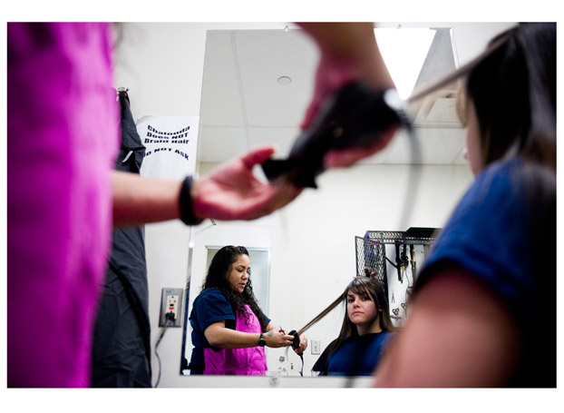
PLAYING DRESS-UP: Chalonda Ford straightens Natalie Donohoe’s hair. This is one of the few times when inmates are allowed to touch each other. - IMAGE: leahnash.com
Heidi Steward, one of three assistant superintendents at the facility, says a women’s prison presents different challenges than a men’s prison.
Steward is tall, lanky and energetic, and wears a small nose stud. Along with Coffee Creek’s superintendent, Nancy Howton, she is among several women who run the prison, although a few men can be found in the administration.
Steward, 37, has spent most of her career with the Department of Corrections. She’s prepared with pie charts and statistics, but she talks about Coffee Creek’s inmates with compassion. She knows as much about their before-prison lives as she does about their crimes.
“A lot of the pathways that lead to prison are connected,” she says. “More women than men are victimized, and you just see them in a vicious cycle.”
“If you’re on the edge, this may push you over,” Jana Russell, the state administrator for behavioral health services, says. “Where they were masking symptoms with drugs or alcohol, we begin to actually see the symptoms.”
Last year, 52 inmates at Coffee Creek tried to kill themselves. One succeeded.
Among the entire population at Oregon’s 12 male prisons—which comprises about 13,000 inmates—72 tried to kill themselves in 2011. That’s about 5.5 attempts per 1,000 inmates—one-tenth as many as the women.
Running a female prison has costs that male prisons don’t have. Coffee Creek has to pay for more mental health medication, according to Russell. Inmates also need counseling for those problems.
Steward says women require more time with caseworkers and counselors. Coffee Creek has one counselor per 150 inmates. Two Rivers Correctional Institution, a similar men’s prison in Umatilla, has one for every 300 inmates.
“Males function in a hierarchical structure, but women are communicative,” Russell says. “We want to talk and we need to talk. Women share every aspect of their lives. Men keep secrets.”
“If there’s a conflict in a male facility, we can separate them by sending one of them somewhere else,” Steward says. “But with Coffee Creek, there’s no way to move them elsewhere.”

Females are still a small minority in Oregon’s prison population—8 percent. But it’s the fastest-growing group in the penal system. Why? It’s not, despite what many believe, because of Measure 11, the 1994 citizens’ initiative that voters passed to establish mandatory minimum sentences for violent crimes.
Instead, it’s because the Oregon Legislature passed a number of laws over the past 15 years focusing on nonviolent crimes.
In 1996, the Legislature passed a bill that sent repeat property offenders to prison. Prior to 1996, repeat property offenders were typically given probation.
In 1999, the Legislature passed a bill that included “identity theft” as a property crime. Identity theft was only becoming an issue at the time, but within a few years, thanks to the growth of the Internet and availability of credit cards, it became a frequent crime.
In 2001, the Legislature created a broader definition of “repeat offenders” for property crimes, resulting in more people being sent to prison rather than placed on probation.
Because women commit property crimes at very high rates compared to other crimes, those changes created a spike in the number of women going to prison.
According to Department of Corrections data, roughly the same number of women commit felony property crimes every year, but during the past decade, more have gone to prison for them.
Only 6.5 percent of women convicted of felony property crimes in 2000 went to prison. But in 2011, 18.6 percent of them did. (That’s slightly lower than the peak of 21.7 percent in 2010.)
Eric Mellgren, a retired Medford police chief and Southern Oregon University criminology professor, says ID theft goes hand-in-hand with meth addiction, and it’s popular with women because it’s a relatively safe crime.
“There is very little physical risk,” he says. “You’re not going to get attacked by a large dog or get shot by a homeowner. Women might tend to do [ID theft] rather than commit a violent crime.”
It’s also lucrative. “One good ID thief can steal as much online as all the burglars and robbers in Medford in a year,” Mellgren says.
Oregon isn’t alone in this trend. Susan Phillips, a research analyst with the Sentencing Project—a national research and advocacy group—says putting more women in prison for property crimes is a national trend.
According to the Sentencing Project, the number of women in prisons nationwide has increased 400 percent since 1985, double the growth rate for men.
“You’re not leading the country in this by any means,” Phillips says. “[Oregon] isn’t the craziest state in these things by far.”
But the feminization of this country’s prison system is unique. The United States imprisons more women per capita and more women as a proportion of all inmates than any other major developed country in the world, according to data collected by the international Organization for Economic Cooperation and Development.

Kevin Mannix is a former state representative and ex-chair of Oregon’s Republican Party. He has run unsuccessfully for governor, attorney general and Congress, but he is best known as the father of Measure 11, the aforementioned initiative that put more violent criminals behind bars. He is also the reason why, in 2012, the number of women entering prison is expected to grow, creating concerns at Coffee Creek, which has room for about only 100 more inmates.

Four years ago, Mannix gathered enough signatures to put Measure 61 on the ballot, which sought to create mandatory minimum sentences not for violent offenders, but for repeat property and drug offenders.
The Oregon Legislature was so concerned about the consequences of Mannix’s measure—namely, building more prisons—that it referred to voters a competing measure that also established minimum sentences for nonviolent crimes but wasn’t so tough as Mannix’s measure.
Measure 57, the alternative to Mannix’s 61, passed in November 2008 but only went into effect January.2012
Until the start of 2012, an ID-theft conviction would earn someone at least 13 months in prison. Now, ID theft carries a minimum sentence of 18 months.
Mannix says he never considered how his ideas would impact women. “It did not come up,” he concedes.
BARE HALLS: The hallways at Coffee Creek stay empty and spotlessly clean.
IMAGE: leahnash.com

Mannix says he never considered how his ideas would impact women. “It did not come up,” he concedes.
But he says prison could be good for some women: “There could be a chance to change someone’s life by pulling them out of the corrosive environment they were part of.”
Sen. Floyd Prozanski (D-Eugene), one of two Democrats who sponsored House Bill 3057 in 1999—making identity theft a property crime that could carry a prison sentence—says no one thought about gender at the time.
“I don’t remember us having any data in front of us as to the impact on either gender,” he says. “I think anyone who has been a victim of identity theft wants anyone who is committing those offenses to be held accountable, whether they’re men or women.”
For all the issues that accompany female inmates—mental illness, razors, relationship needs, sanitary pads—the most profound is motherhood. More than 75 percent of the inmates at Coffee Creek have children, and some are pregnant when they enter the prison. Inmates had 16 babies last year, down from 21 in 2010.
This creates indirect costs for the state: foster care. Most children live with their mothers, so they must go somewhere when their moms go to prison.
Gene Evans, spokesman for the Oregon Department of Human Services, says it costs the state about $2,000 per month to have a child in foster care. The average stay is about 15 months, which means each stay costs taxpayers about $30,000—the same as one year in prison.

STUDY TIME: Inmates take a range of classes at Coffee Creek. Parenting, a 12-week class for incarcerated parents, is popular. IMAGE: leahnash.com

Among Dawn Pearson’s four children, one of them lives in a foster home. Frankie, 16, looks like a smaller version of her mother, with tomato-red fingernails and a big gray sweatshirt whose cuffs she pulls over her hands.
Frankie is an expensive teenager. She has drug and anger problems and requires a drug support group, lawyer, regular urinalysis tests, special classes at school and a caseworker—all paid for by taxpayers.
If this is an argument for keeping women out of prison, Multnomah County Circuit Court Judge Michael McShane doesn’t buy it, particularly for longtime meth addicts.
He says sometimes motherhood can keep a woman out of prison. DHS pays for mothers to go through drug treatment, so judges sometimes allow women who are unlikely to reoffend to stay on probation and go to rehab. Often, however, meth trumps motherhood.
McShane says he has seen women addicted to meth starve and neglect their children, but then insist they stole credit cards to feed them. “No,” he says. “You were buying meth.”
In Dawn Pearson’s case, she stole the credit card of her daughter’s principal only 18 months after ending her first, five-year stay at Coffee Creek for identity theft and meth offenses. After she got out, she began using drugs again.
That’s the reality of Coffee Creek. Women are likely to reoffend because their crimes are so connected to their addictions, and for many of them, probation doesn’t work.
“Usually if we’re looking at sending women to prison, they’ve burned through the programs here,” McShane says.
He opposes mandatory minimum sentences and would like to preserve more judicial discretion. But he says many of these women need to go to prison.
“Sometimes we’re worried that a person’s going to kill themselves if we don’t send them to prison,” he says.
McShane says prison is often the only way to get addicts into drug treatment, which is the only way to make them stop offending. He says that’s largely because local drug treatment programs have been cut and also because addicts are required to get treatment in prison. He says they need to spend at least two years in prison to make real progress.
Though it’s controversial to say, McShane maintains that a woman who simply will not stop breaking the law, to whom drugs have become more important than her children, the choice is clear—Coffee Creek.
“If they’re there,” he says, “it’s because no one trusts they can be let out in the community.”

************************************************************************
NOTE FROM CHAPLAIN BOB: Linda and Bob personally met Dawn Pearson at the chapel service we preached at Coffee Creek C.F.. She presented herself as a God fearing woman that is totally in love with her Savior. She was a good display of what Christ can do in your life and we were watching regeneration in her life. If God can mend a heart of stone, how much more can he do with this woman’s passionate love for Christ. Please keep all these women in prayer.

Guess what is being sold in the Dollar Tree Store in Oregon ?


The test kit box is being sold for $1 in the Dollar Tree store we visited in Oregon. The box has the following writing on it;

Marijuana Home Drug Test; - 1 Drug Test
97% Accuracy - Results in 5 Minutes – Easy to Use

We now wonder if the kit is for parents to check their children out, employers to do a quick pre-employment test, or for those needing to “study” and take a “pre-test” or “practice test” before the “final.”
AFFECTION

When I first thought about writing on the topic of “affection” it seemed to me that some people may think this is an easy subject talk about. For me, the topic is really so complex. My becoming aware of real affection is has come to me in layers. God teaches in his Word what real affection and love is, but I’ve had to process it in layers as it has been presented to me by life experiences. All of us have life experiences that have taught us what affection is, but unfortunately often what we think about affection and what it really is, that’s two different things. Some people have grown up with a distorted view of affection because of the abuse in their lives. I believed from my childhood that affection & love equaled sex. Others may not feel they have ever been abused, but maybe they had a lack of proper affection, the lack of safe, no healthy touch and so there is a missing ability to show healthy affection. I’ve often found as I’ve talked to people, it’s not only hard to give healthy affection, but it’s just as hard to accept healthy affection. And not only did we have home environments that caused the wrong idea of affection, but our very society has misguided much of our thinking in many areas. Music had taught us, television has taught us, people have taught us, but much of what we were taught was not the truth of what God teacher affection really is.
In sharing the lives of other people, I know others struggle in this area too. I personally have gone through a time of self-evaluation and recently was just thinking about what I’d share with others about affection. I started asking what about me? What do I think about affection and how does that match up to what God says about affection and genuine love? What does affection mean to me? Why did I grow up feeling as I did about affection? Where did I get my misunderstandings and how has my life been affected? I had to come to a place where I had to stop living in denial and ignoring this issue and I had to turn towards this subject, allow God into this area of my heart and mind and pray for His help, His wisdom has allowed His healing to begin. I had to ask my heavenly Father to help me learn what should have taken place in my life when I was first learning these basic concepts, but I had not. I needed help.
Like so many, I didn’t have very many positive and loving touches. For me, I experienced the wrong kind of touch. Many of you, that same misunderstanding took place. When this subject came up with my counselor during a session, we were talking about what human beings need. From early formation, ideally in order to experience a healthy mindset about affection, we would have received positive, safe touch. Humans need it. We needed it. Humans desire it. We desired it then and many of us still seek it. The reason why I kept seeking the answer in all the wrong places is connected to the misunderstandings I’ve had from when I was very young. So the questions continue. What am I truly seeking? How has my distorted thinking about what affection and love is, affected my relationships, my ability to enjoy life and my peace? Where am I off track in how I view myself, my body and my needs? What do I need?
God made us to experience healthy love and affection. Ok and so if I did not (we did not) experience healthy human love, touching and affection, where do we move forward from here to relearn a more healthy awareness of what real affection is and how do we get it? Why was I filled with conflict and pain in my relationships? Why did I continue to choose people who were just as messed up as I was about what human love and affection was and how in the world was I ever going to change this pattern? Why were my views so different from what God teaches in the scriptures? What was myth inside of me and what was the truth? How is my mind going to heal in this area?
What God has taught me is that genuine affection is safe. It’s an experience that is soft and welcome. Affection affirms me and helps me to feel alright in this world. Relationships in which the affection is healthy, makes my life more peaceful, not chaotic. Now I see that I receive affection from more places other than people. Now I can see affection can be felt from soft things like a kitten or playing with my daughter’s dog. I have felt affection from a simply grasp of someone’s hand or a simple hug. The sun or a warm breeze can show affection. I’ve learned that not everyone in this world can give affection and many can’t take in affection. Many can take in the act of sex, but the simplicity of pure affection……….that is a much harder concept to understand. To misunderstand affection steals so much of the joy that God has in mind for us, I decided it’s a good topic to talk about. God desires our lives to be peaceful and abundant.
Over the years, I personally experienced fall after fall in this area. Our being able to form healthy affection, love and touch is started at such an early time in our lives. We are supposed to be shown healthy affection as young children, so we can pass it on and participate in giving and receiving the healthy kind. If all we’ve ever known is affection equals sex or we had zero affection in our lives, the healing won’t come overnight. For me, the concept of healthy affection was hard for my mind to take in. It might be that way for you too. God’s Words helps us to learn what healthy affection is and so the process of rebuilding our wounded thinking can take place. When we fall, we are supposed to learn from it. If we allow God into that place of our mind that caused us to fall, we can learn from it and do things differently next time and get back up. Each time we fall, God can pick us up. We pray, the Lord forgives and helps us to try again. With me, He was revealing truths to me each time, not only about affection, but many other wrong beliefs in my life.
The understanding of God’s truth started to come into my life in one piece at a time. I could see what healthy affection was supposed to be. I could see where I still was messed up and I had to allow God into that place and let Him fill in the pieces. I had to surrender all areas of myself to Him and that is hard, but we have to let him in. It does not matter area I was holding back on, God is and continues to be the place of true and genuine healing. In this area of affection, it’s taken me so long to truly see just how mixed I was. I was truly placing myself at real risk. For me it played out as an addiction to relationships and men. I was attracting to others who were equally wounded and in these types of relationships, I have this natural yearning for affection and love, but going to the same unhealthy pattern over and over again. The Holy Spirit was at working helping me to feel and see something was wrong. My life was in conflict. I really was at risk of all kinds of abuses and living in chaos. That is not at all what the Lord has in mind for his children.
Looking at the scriptures, it helped teach me what genuine and real affection and love looks like. As I started to build my own life in Christ, God was pointing out areas that I needed to be enlightened. I could see my actions were not the same as what the scriptures were teaching me. Several times I’d rationalize what I was doing and compromise in areas that truly was just me living in pride and stubbornness I had not fully surrendered this area of my life. I was living from emotion and doing what I wanted to do, not what God had in mind for my life. So many can see the obvious addictions, such as drugs or alcohol, but what about the things not so easily seen? What I was experiencing was just as dangerous not only to my body, but to my heart and my soul. Any area of our life where we compromise or have to rationalize, the result will be chaos and the end result will be pain and confusion. I wondered why things never worked out. Why was peace absent from my life? Why were relationships and old wounds not fully healing? After all, I’d prayed and prayed for God to heal me, but why was that not happening?
What I learned was I first had to clear up this misconception of what genuine affection and love is and I had to learn how to apply all I was learning to me. One of the greatest pieces I had to learn first is to truly love and have affection towards myself. I could not give or receive healthy love and affection to anyone else until I started to become aware of how to give that to me. As life and my own recovery went on, I was able to turn affection and love towards me. I needed this awareness so I could stop putting myself at risk for a life of pain and confusion. God has to be enough for me. He is the source of full love and affection. He is the only source of the perfect love and affection that we need. As human being we won’t be perfect, but until we understand and accept His view on what healthy love affection truly is, we will continue to fall down and seek the wrong things. I had to learn to be still in the Father’s love, rest in the affection I have from Him and allow myself to grow in build in my affection and care for myself first. Once He and I developed a healthy, stronger relationship, the yearning turned from trying to find it in the world, to understanding our only true source of affection to use as our model for life, begins in our heavenly Father. The more we draw closer to Him, the more we can put into place what healthy love and affection is.
I want to share some of my favorite examples of affection from His Word as I wrap up this topic. I find that the scriptures show us examples of many types of affection. From Colossian 3, I love these scriptures on how we show our affection in life by how we live.
So, chosen by God for this new life of love, dress in the wardrobe God picked out for you: compassion, kindness, humility, quiet strength, discipline, be even-tempered, content with second place, quick to forgive an offense. Forgive as quickly and completed as the Master forgave you. And regardless of what else you put on, wear love. It’s your basic, all-purpose garment. Never be without it.
God helped me to see that He gave His affection towards us in Psalm 139 when He speaks these words:
Oh, yes, you shaped me first inside, them out, you formed me in my mother’s womb. I thank you, High God-you’re breathtaking. Body and soul, I am marvelously made. I worship in adoration, what a creation. You know me inside and out, you know every bone in my body. You know exactly how I was made, bit by bit, how I was sculpted from nothing into something. Like an open book, you watched me grow from conception to birth; all the stages of my life were spread out before you. The days of my life all prepared before I’d even lived one day.
In Luke 7:36, we have an example of physical affection: One of the Pharisees asked him over for a meal. He went to the Pharisees house and sat down at the dinner table. Just then a woman of the village, the town harlot, having learned that Jesus was a guest in the home of the Pharisee, came with a bottle of very expensive perfume and stood at his feet, weeping, raining tears on his feet. Letting down her hair, she dried his feet, kissed them, and anointed them with the perfume.
In the book of Galatians, it has several pieces of that book that help to understand how just the act of having sex to try and find affection is not the way God desires I was to live:
It is obvious what kind of life develops out of trying to get your own way all the time: repetitive, loveless, cheap sex; a stinky accumulation of mental and emotional garbage; frenzied and joyless grabs for happiness; trinket gods, magic-show religion; paranoid loneliness; cutthroat competition; all-consuming-yet never satisfied wants; a brutal temper; an impotence to love or to be loved…………….
In Ephesians 4:29, we have an example of giving affection to someone by using our words: Watch the way you talk. Let nothing foul or dirty come out of your mouth. Say only what helps, each word a gift.
We also show affection by giving and serving and in Acts 4:32-35, we have a great example:
The whole congregation of believers was united as one—one heart, one mind! They did not even claim ownership of their own possessions. No one said, “That’s mine; you can’t have it.” They shared everything. The apostles gave powerful witness to the resurrection of the Master Jesus, and grace was on all of them.
I would go on and on with scriptures that teach us about the affection and love shown to us by Jesus example. Luke 9 talks about Jesus showing care, affection and love by feeding the 5,000 people. In Mark 10: 13-16, Jesus talks to the children and holds them and loves on them and Matthew 18 and the parable of the lost sheep. I could go on and on and on with examples of God’s affection for us. God has given us the story of the woman at the well and how Jesus loved and accepted her. We have the greatest example of love and true affection in the sacrifice that Jesus made on our behalf that He died for our sins.
True and genuine affection is not what we often have experienced in the world, but it truly is beyond this world. True and genuine affection for others and ourselves is grounded in the teachings of God. True and genuine affection is found in allowing our lives, our character and out actions to be more and more like Jesus. True and genuine affection will come into our lives as we continue to surrender our lives daily to becoming more and more like Him. For me understanding what healthy and genuine affection is has enriched my life. For all of us, in all areas of our lives, that truly is what our Father desires for us. God loves us so, so much and He has only the best in mind for all of us. Jeremiah 29: 11 tell us that God’s plans for us are to prosper us, to teach us truly what the abundant life is all about.

God Bless all of us as we continue on this journey,
Sister Carol Ann

Monthly “Feed the Hungry” Event

Two of the five rappers from West Coast Believers “Souljahs for Christ”

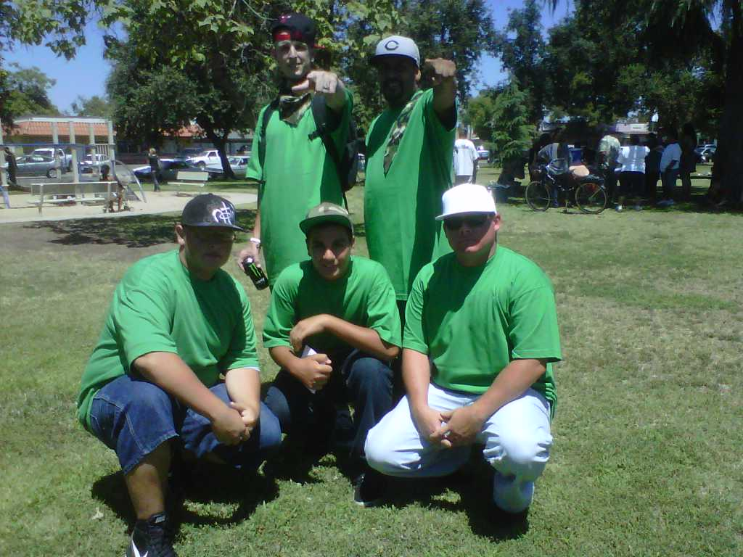
Souljahs for Christ
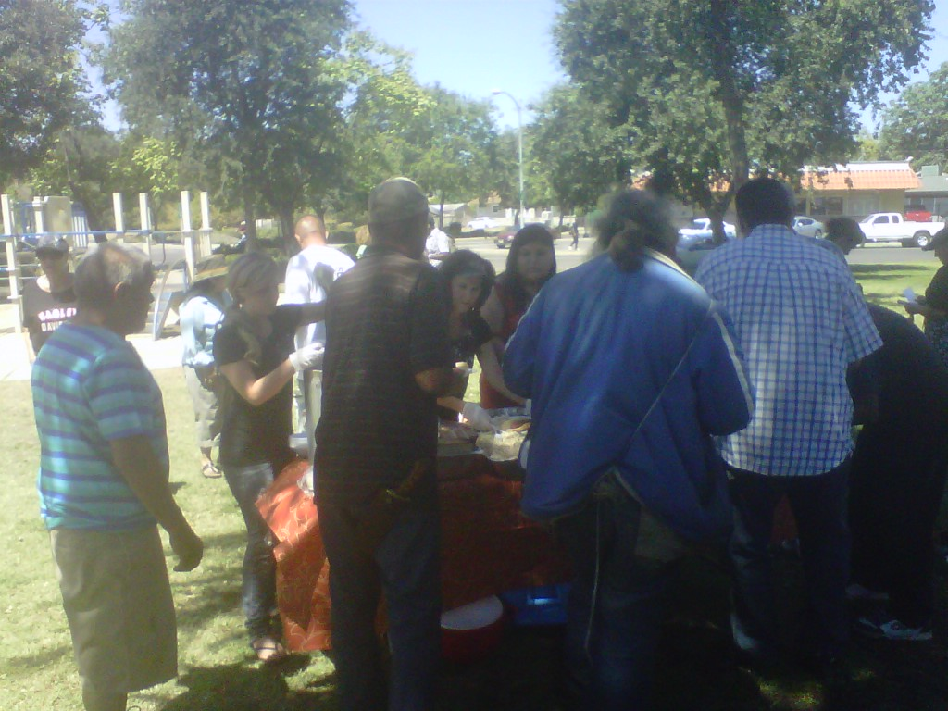
Homeless, hungry and needy being fed

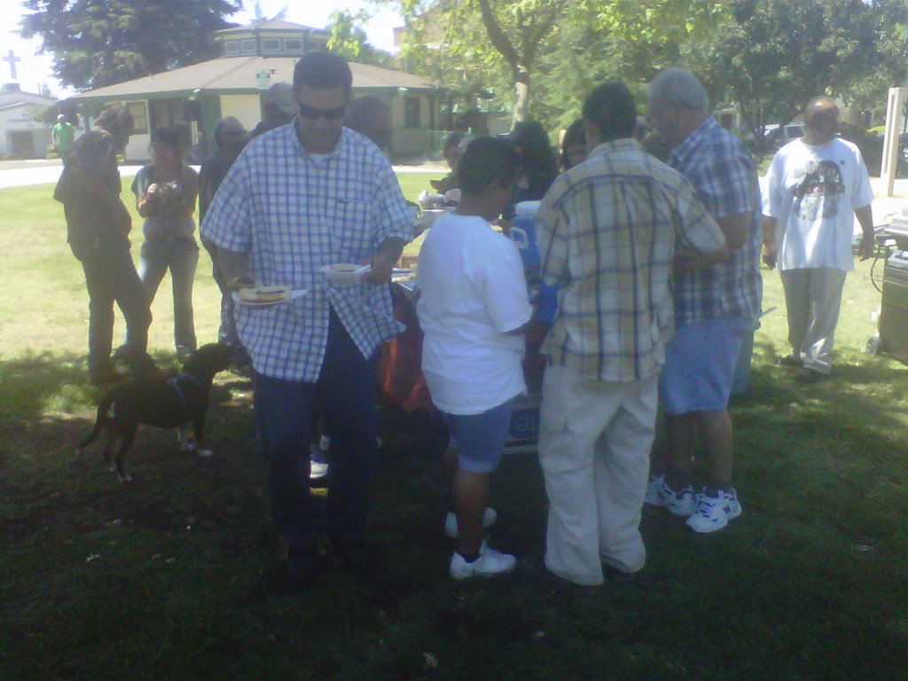
M.O.M. and Awaken provided for approximately 80 people in May & 50 people in June.

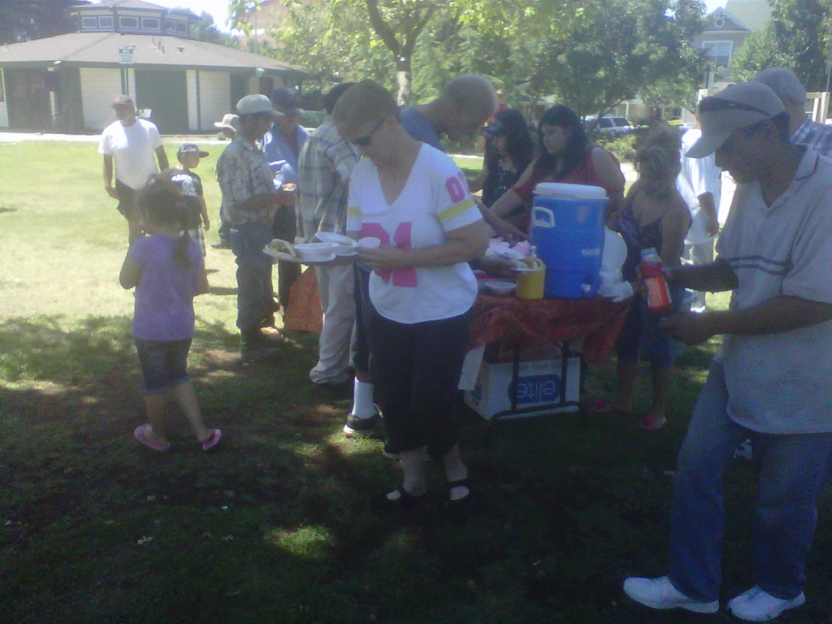
Bar-B-Q’d Hot dogs, beans, macaroni salad, cupcakes and punch

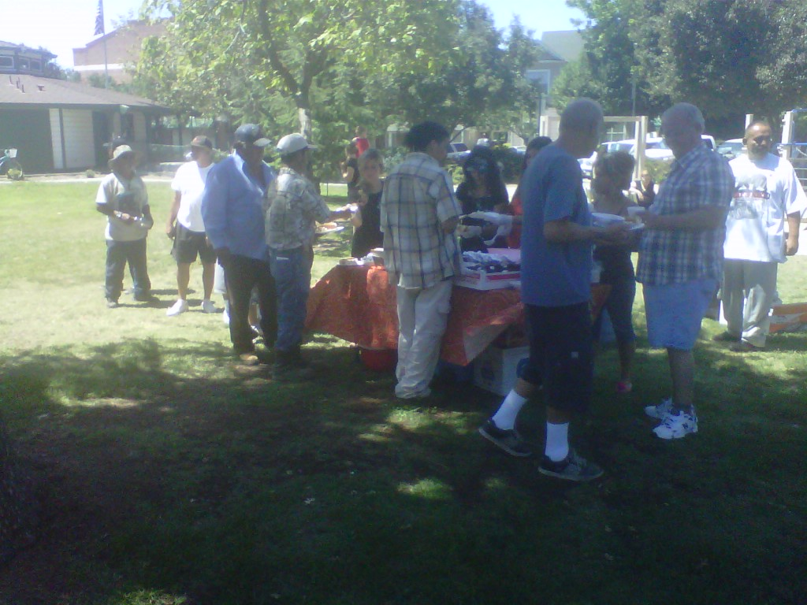
There is always enough to feed everyone – much as Christ did with the 5 loaves and 2 little fishes.
A Portrait of Wisdom and Foolishness
By Isaac Meraz

Everywhere we go in the world, we are forced to find out that there are rules we must obey to ensure our safety and guarantee our happiness. Those of us in jail and prison have had a problem with accepting this or we’re so selfish that even attempting this as an established fact, we’ve still chosen to disregard this. Others are so full of themselves and prideful that they have decided to rebel against every authority and teacher, and have become so blinded that they have even abandoned common sense, treated their own parents as enemy, and are intent on having their own desires and wisdom as the only rule that matters and the only code they will live by. In their mind you can’t tell em nothing, cuz they already know and they don’t care. As the Bible says, “A fool has no delight in understanding, but in expressing his own heart.” Prov. 18:28
I used to be that kind of fool. I remember my buy, Cisco, who is on death row in San Quentin, once told me that I was the only gang banger on the streets and I took pride in hearing such things about my protective stance against my imagined enemies day in and day out. But I was a fool and God’s word says: “A man of great wrath will suffer punishment; for if you rescue him, you will have to do it again.” Prov. 19:19 and I suffered and was punished over and over as a young man because of my wrath and rebellious nature. From juvenile hall to group homes, to boot camp, to the California Youth Authority, until I got sentenced to Life in Prison without the possibility of parole for killing a rival gang member, one made in the image of God, a precious human being.
Scripture says “a person who remains hard headed after being corrected many times, will suddenly be destroyed without remedy” (Prov. 29:1). I saw this come to pass. Drunk drivers die everyday, burglars encounter homeowners with guns, and criminals die in fiery car crashes running from the police. Everyone knows someone who’s been a victim of gang violence, or reckless driving, or can say they’ve come close to death. I hope to remind you of these consequences, not only to achieve something better in this life, but also in the life to come. Tomorrow is not promised to us.
“Wisdom calls aloud in the street, she raises her voice in the public squares; at the head of the noisy streets she cries out, in the gateways of the city she makes her speech: ‘How long’ will you stupid ones love your stupid ways? How long will mockers, delight in mockery and fools hate knowledge? (Prov. 1:20-22)
As I just pointed out, consequences warn us and teach us valuable lessons to avoid a similar fate, but I’d like to take it to a step further and say that everything, everywhere teaches us about the need to respect rules, and the reality that you can’t do whatever you want without suffering consequences that are detrimental to peace and happiness. In our immaturity we might think that rules keep us from having fun, but the truth is that they protect you and are enforced to serve this purpose.
The Bible tells us that all the evil in the world is caused by bad influence and breaking Go’s commandments. I can say with authority that this is true and you can prove it to your own self. Anyone who takes an inventory of all the mistakes they have done and the pain they have suffered at the hands of another or their own actions, can imagine the night and day effect that would result if in every disappointing circumstance, decisions were made that honored God. God hates divorce and I saw my mom struggle with depression all her life because of a broken heart. It would have been nice to have had a dad and a pleasure to see my mom happy. I grew up in a very tough Goshen neighborhood and I remember when my homeboys and I would be running a muck late into the night. Our friends with dads would always have to be in the house by ten P.M. there were one or two exceptions, but that was because their dads were criminals too. A lot of crime would have been prevented if we all had dads that we feared and respected, like the other boys. I look back on all the things I missed out on because I didn’t honor my mom’s counsel, or listen to my teachers; all the memories I don’t have. I never went to a high school dance or felt the admiration of my peers, because of my ability to excel in sports. I never had a high school sweetheart. I’ve never given my mother the pride she deserves to have in me, and I’ve never read my daughter a bedtime story. I’m never going to experience what it feels like to wake up to a wife’s kiss, or live with the knowledge that I’ve been a good dad. Mark Twain got it right, “Twenty years from now you will be more disappointed by the things that you didn’t do, than by the things you did.”
And yes, I know, it sounds like a “Oh, poor me” pity party, but the point I’m trying to make is: Poor you if you are as stupid as me and continue down a path that only leads to failure, death or prison. The point I set out to make is that if I would have honored God’s law all of my life, all of my bad memories would have been good ones.
Rules are not meant to be broken as some would lead you to believe. Even a dog if it starts destroying your property needs to be put on a leash until you could teach him how to behave. And this ability applies to all, whether man or beast. Whoever or what ever poses a danger to the safety and security of society must be and will be addressed and corrected. We’re taught this from a young age and all order demands it. Failure to learn this or refusal to accept this, means that you will be corrected, disciplined, isolated and punished until you reform your behavior and conform to the standard of civilized society. Kids get grounded when they don’t obey their parents. They get detention or suspension when they don’t obey their teachers. And then if they don’t obey the law of society, they might get incarcerated. You disobey your boss and you might get fired. If you cross the road without looking both ways, you might get hit with a car. If you don’t study for an exam, you might fail your class. If you fail to work hard, you might end up homeless and hungry. There are rules and all would be wise to follow them by their own freedom of choice, because whether you like it or not, you’re going to mind someone. Don’t wait till you are thrown into prison to realize this, because in prison, what you didn’t want to learn by gentle persuasion and a friendly hand, you will be forced to respect by aggressive demand and an iron fist, political group segments and correctional officers ensure this.
The Bible says that God has placed a moral compass within us all. He says that He’s literally written His ten commandments in the fabric of our DNA that converses on our hearts and minds. He calls it our “school teacher.” As God’s children, as well as our parents, we know that we should obey them just as we would naturally desire our own offspring to obey us. We know we shouldn’t kill because we wouldn’t want someone to kill anyone we love. We know we shouldn’t steal because we wouldn’t want anyone to steal from us. We know it’s wrong to commit adultery because no one wants to be cheated on. And now that I have a daughter, I understand why it’s important to save ones self for marriage. Like I’ve said, “Rules are for our safety and that rule protects her; it prevents her from catching a harmful disease, and it lessens the chance of her marrying a dishonorable man. It magnifies her chances of having a happy life. It brings her honor and the approval of her parents.
As the Word says, “Whoever loves wisdom makes their father proud” (Prov. 29:3). “Happy is the person who finds wisdom and the man who gains understanding” (Prov. 3:13). “Wisdom is the principle thing; therefore get wisdom, and in all your getting, get understanding. Exalt her and she will promote you, she will bring you honor when you embrace her” (Prov. 4:7-8). “For wisdom is better than rules and all the things one may desire, cannot be compared to her” (Prov. 8:11).
I know that most of my reading audience is incarcerated and thus can see the truth shine forth through everything they’ve read and can easily relate, but some will disgard sound advice simply because its origin is rooted in the Bible. “A wise person fears and departs from evil, but a fool rages and is self confident” (Prov. 14:16).
We’ve been these fools and have called these type of fools our friends for a long time. But the wise hope these friends will eventually change and decide not to be a fool. It’s more likely that a bad friend will bring you down before you raise him up, if he’s not ready to change because peer pressure is real and bad company corrupts good habits. So put some distance between yourself and your friends who mock God. Recognize that they are incapable of being a friend that holds your best interest at heart because their selfish desires are their god and they seek only their own glory and satisfaction. These poor fools would quicker believe a ghost story told by a drunk, thieving bum, before they accept wisdom that is confirmed thru its billions of adherents and the historical fact that Jesus Christ walked the earth surely as Christopher Columbus, George Washington and Abraham Lincoln did, and had His supernatural majesty witnessed by thousands. So get on with your destiny. This type of mockery only holds weight in a circle of blind people too dimwitted to understand that our lives are a badge proving that they are disqualified to dispense knowledge.
And I’m not trying to be mean to drunk bums that steal. I have compassion for their struggle and desire for all to change, do their part and make the world a better place and achieve the peace that is ordained by obeying the gospel. I just wanted to clearly display the contemptible position of those who would believe in the source and reason that this nation, the greatest in the history of the world, was established. I hope you will be wise.
I close with a very wise quote and a final plea to accept salvation, If anything matters, then everything matters, because we are important everything we do is important. Every time we forgive, the universe changes; every time we reach out and touch the heart or life, the world changes; with every kindness and service seen or unseen, God’s purposes are accomplished and nothing will ever be the same again.
Jesus said “If you’re not willing to confess me before men I will not confess you before my father in heaven.” If you want to be saved, you’re going to have to take a stand before all. Stop looking for the approval of your peers and your own selfish desires. You know this has brought you nothing but problems. God will soon judge the world. The only reason evil exists is because we are evil and God in His mercy has given us time to learn and be forgiven if we’re willing to change. So be humble, bow in prayer and ask Christ to come into your heart and give you the courage and strength to blaze a new trail by a new living way as we’re taught in the Holy Scriptures. Find a Bible and study it. Find Christians as if your life depended on it – it does.
Awaken Church Ordaining Bob

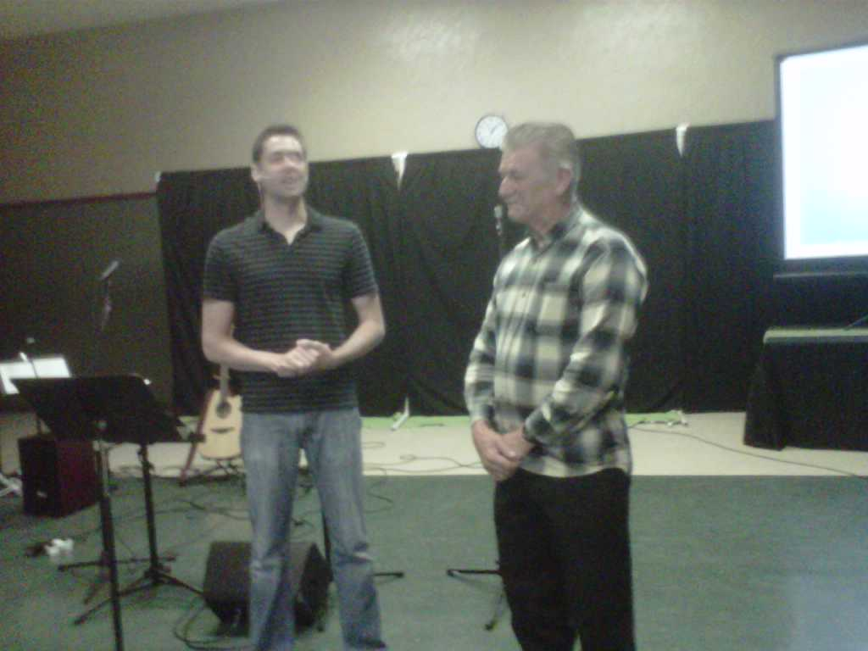
Pastor Jarrod MacClintick introducing Bob

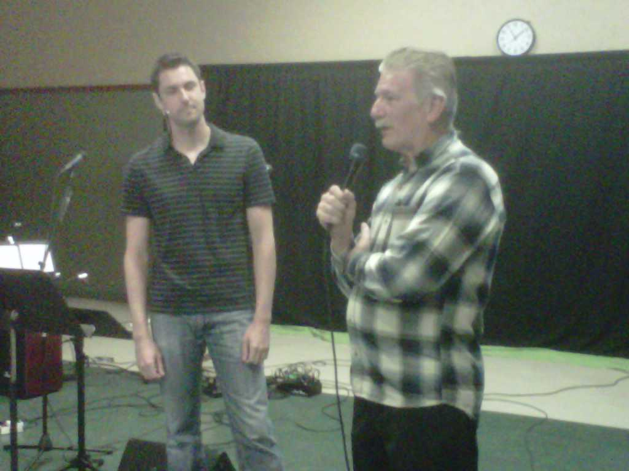
Bob telling of the outreach that M.O.M. does
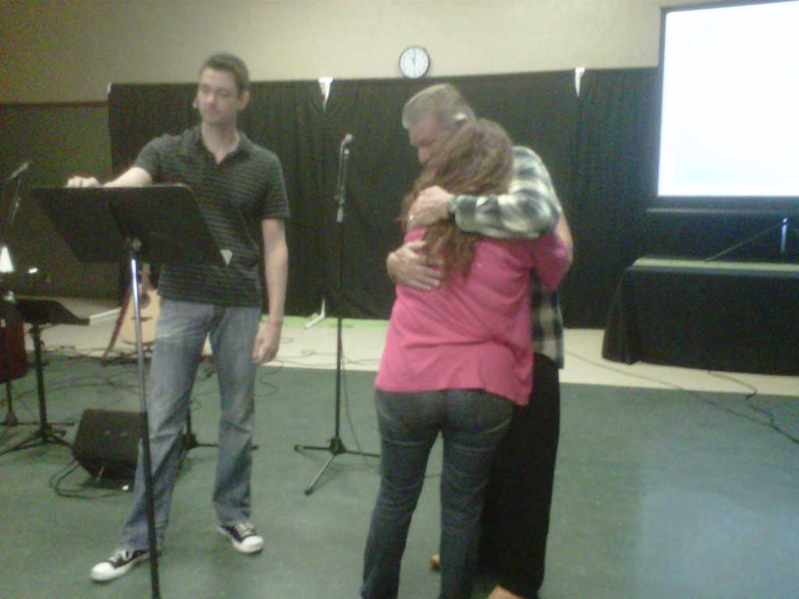
Aleisha (prior inmate) coming up and joining Bob all emotional

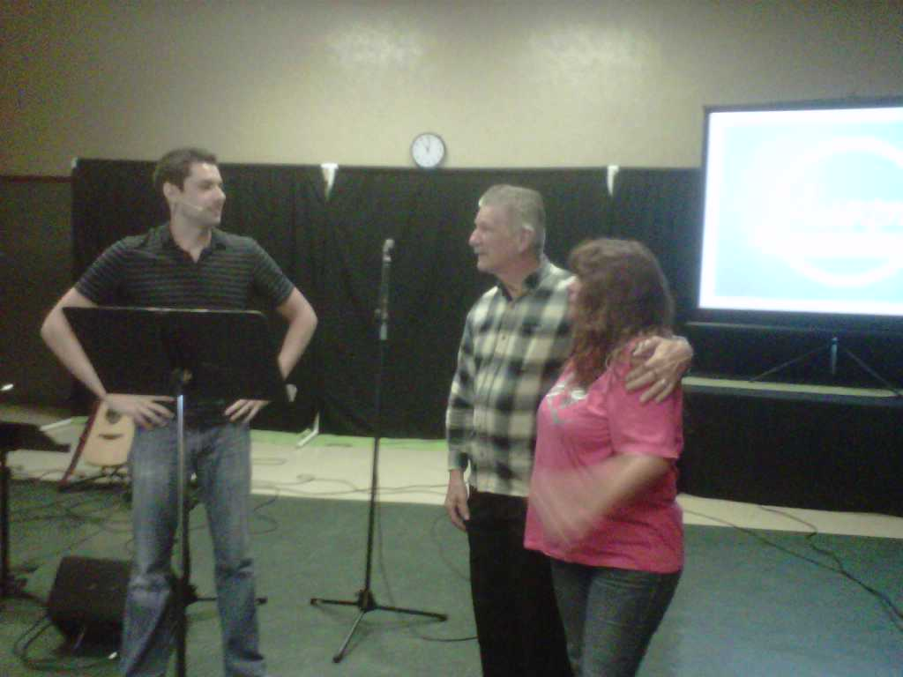
Aleisha sharing what M.O.M has done for her.
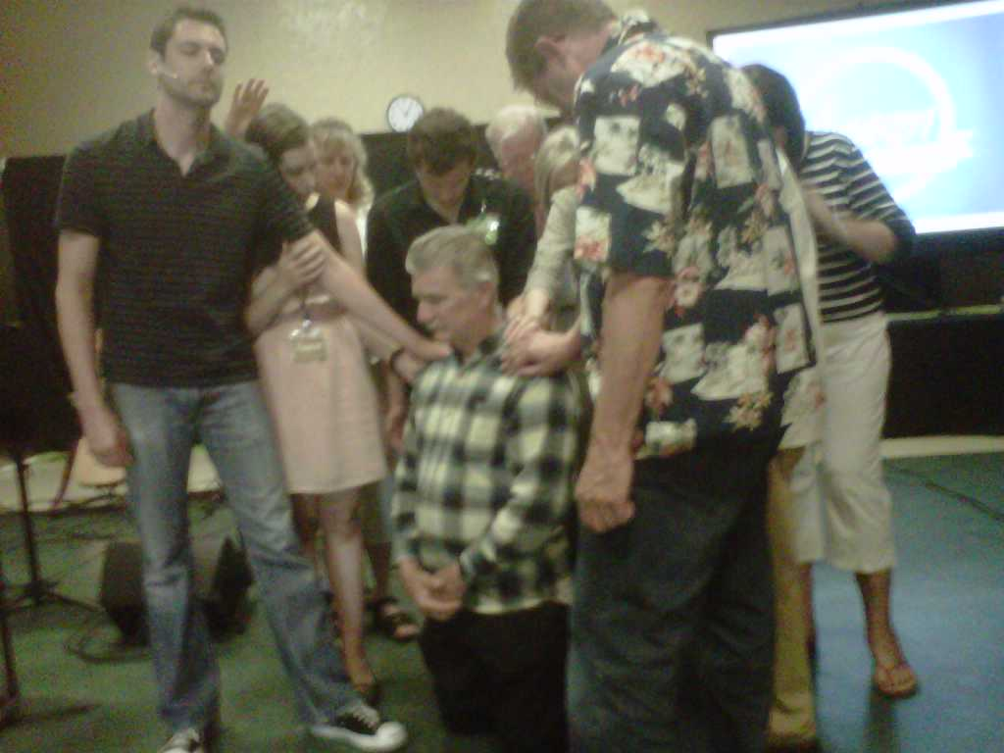
Prayer of Ordination

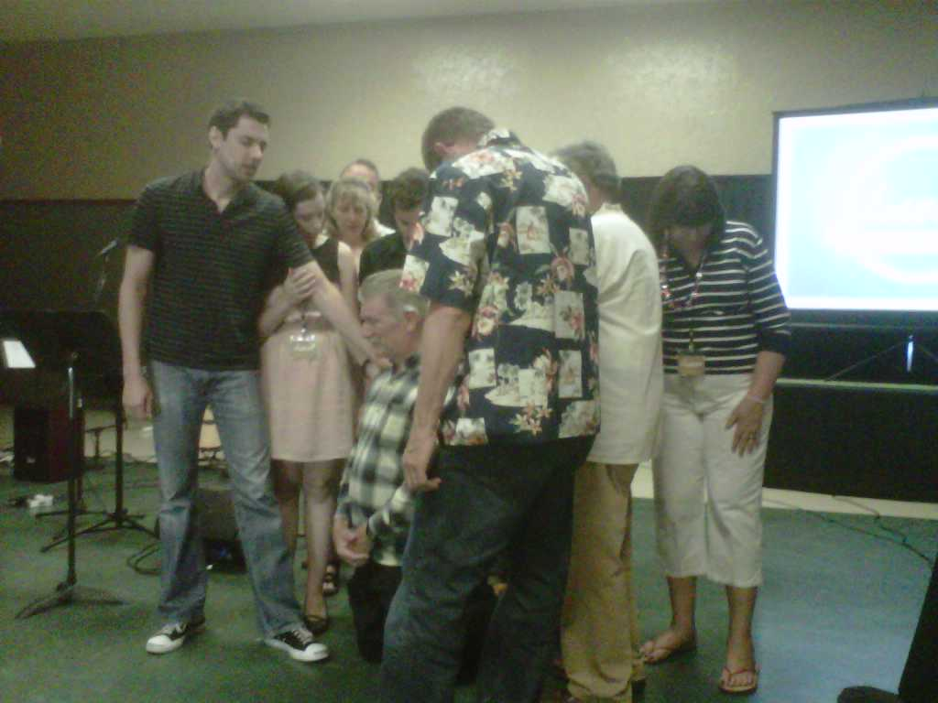
Laying of Hands on Bob by Ambassadors of Awaken Church
Trying to provide the Hope and Blessed Assurance for Inmates

As most of you that follow our ministry know, we try to provide the little things that are missing when an individual is incarcerated. Things such as a bi-monthly newsletter, personal correspondence (to replace the family members that do not write), and even birthday cards (hand done by volunteer Carol Ann). We got the following birthday card returned and noted as shown in the following picture;

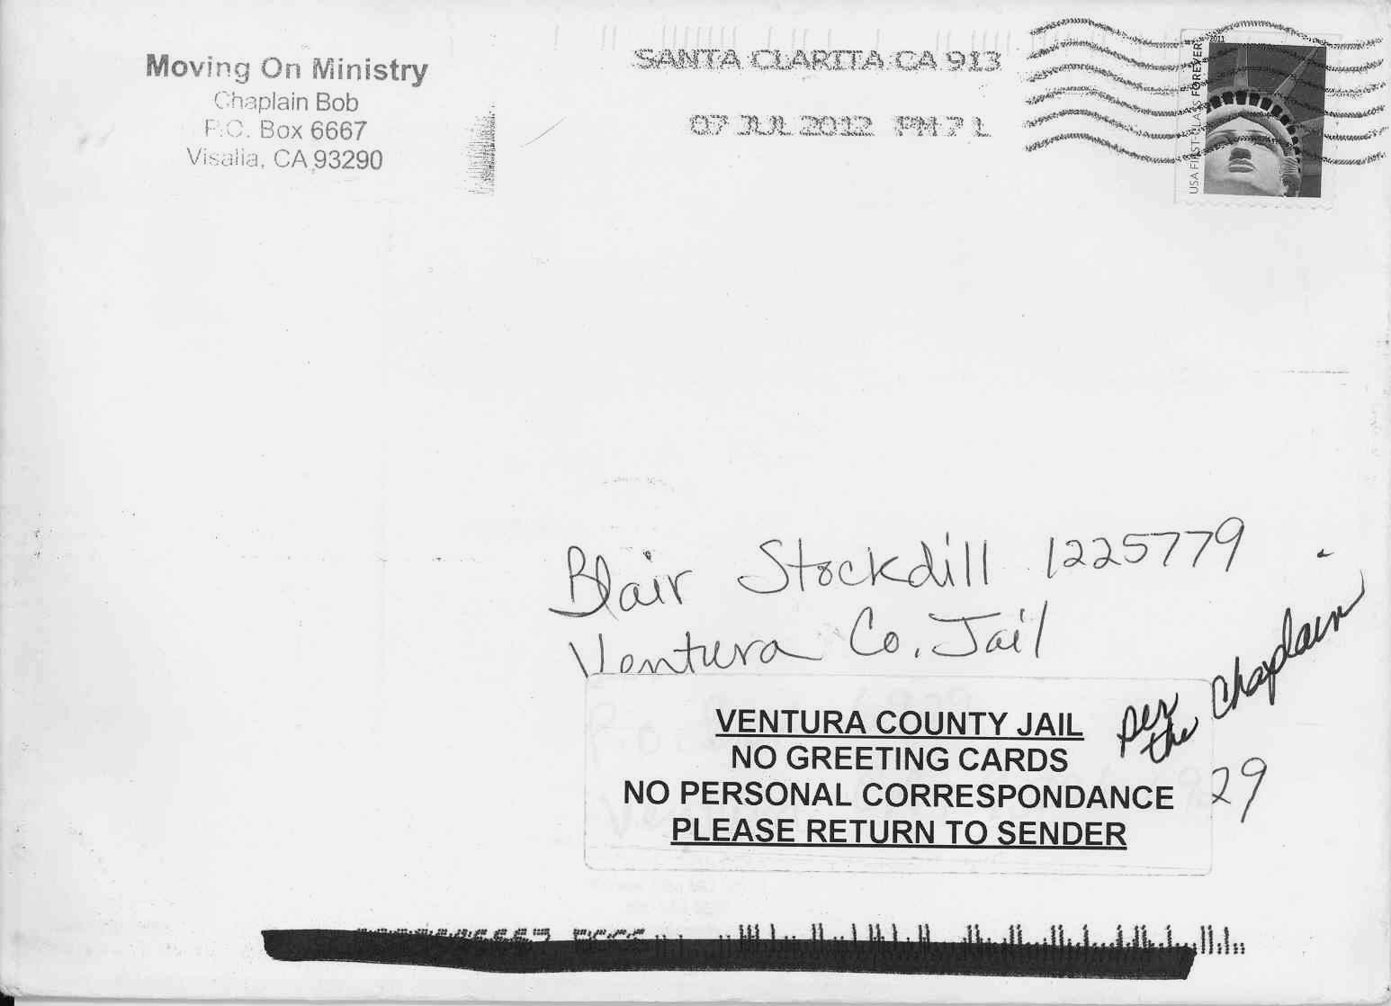

Not allowing birthday cards is something new for us. The rejection was “per the Chaplain.” M.O.M. has been sending about 40 cards a month for the last 4 to 5 years. This was a first.

As many of you know there are requirements for us at M.O.M. to visit facilities. These include annual training at each facility, clearance forms, background checks and often a medical physical. Many times Bob, Linda and the other volunteers get scheduled, only to find that after taking time off from their work, the training or chapel sessions are cancelled. One of our newer addition prison facilities has cancelled training on us twice and had a conflict of date while we were in Oregon preaching in June. It has now been three months and not able to get training or do ministry in facility.

In another attempt to mail the individual, the letter was returned because the ministry logo or letterhead was not used. Without acceptable logos or stationary, even though M.O.M. is a 501(C)(3) non-profit corporation, the staff and chaplain do not allow ministry mail.
Drawing by
Art Bastardo

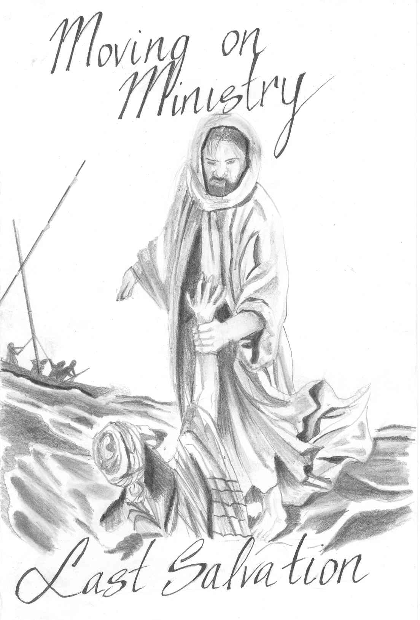
Drawing by
“Unknown”



