“Letter From M.O.M.”
The Monthly newsletter of Moving On Ministry

WWW.MovingOnMinistry.com
www.PrisonMinistry.net/movingon
Volume 57 – May 2010 (Published since Oct. 2003)

“I Can Only Imagine”

As you receive this volume of Letter From M.O.M., we have many new writers of articles, we are putting some more of the testimonies of “How God Changes Lives” as well as some of our own written articles. We can truly say that the “high” that many of our inmates have been trying to get through the wrong methods, is being surpassed by those putting God in control of their lives.
Watch our website www.MovingOnMinistry.com

We are affiliated with International Prison Fellowship
http.//PrisonMinistry.net/movingon

and Good News Jail & Prison Ministry Volunteer
www.GoodNewsJail.com

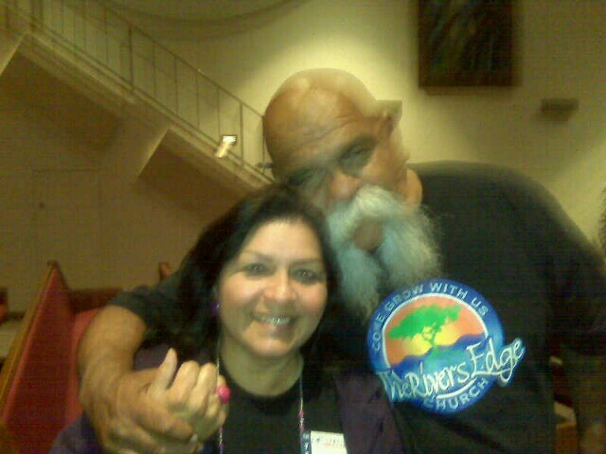
Sister Linda and ‘Big Al’, Past co-founder of Mongol Nation.
Intentions & Wishes

The intentions of this newsletter are to allow an understanding of jail & prison ministries. It is our intentions to get input from those incarcerated as well as those “free” to visit. Life experiences of the faith and fellowship from those locked up in the facilities are always desired to let others know of the value of “visitation”. I am certain that each of us have many stories of the miracles God has done in our lives.
Our wishes are that we would have a list of supportive churches that individuals might look forward to attending once released.
A list of services, such as housing, employment, and counseling services, as well as some individuals available for friendly fellowship are also much needed items.
God’s Word says if a man stumbles, how can he continue lest there be another to help him up. Ecc. 4:10 “For if they fall, the one will lift up his fellow: but woe to him [that is] alone when he falleth; for [he hath] not another to help him up.” Proverbs 24:17 “Rejoice not when thy enemy falleth, and let not thy heart be glad when he stumbleth:” John 11:10 “But if a man walketh in the night, he stumbleth, because there is no light in him.”
Please help us with input for this newsletter as we strive to serve God. We appreciate any articles or input.

Addresses to contact Ministry Volunteers

Moving On Ministry
Chaplain Bob
P.O. Box 6667

Visalia, CA. 93290

Moving On Ministry
Spanish Ministry
P.O. Box 6667

Visalia, CA. 93290

Jesus Prayer Ministry
Pas Denise
P.O. Box 7925
Chula Vista, CA 91912

Andrea Shannon
P.O. Box 553
Dover, NH 03821

Ask for a copy of our complete “Resource Supplemental Letter”

M.O.M. Needs
- Continued tractor repairs
- Pen-pals to write inmates
- Finances & stability
- Testimonies
- Poems to publish
- Possible sale of Squaw Valley Property (Camp Clarius)
- Development of Tollhouse property (Camp Cripple Creek)
- Development of Nevada property
- Development of Arizona property
- Volunteers for ministry
- Drawings to publish and share

*********************************
We are still looking at doing some services at C.M.C. San Luis Obispo, Avenal State Prison, Wasco, and SATF, Corcoran, CA. Schedule has been VERY busy lately.
April 29 thru May 1 was the Bill Glass Ministry. Bob went to Wasco & Avenal. Linda went to both Chowchilla Women’s Prisons.

Prayer Praise
We like to post real life situations, because God works in real lives and He is the one that gives “Eternal Life.” Every week we get many letters that state “I love hearing the testimonies.” There are so many, we cannot publish them all, and the sad part is – people not involved in jail / prison ministry do not get to read the many letters we receive daily (average 2 to 11 each day) and we try to keep up with and answer them.
“See Why We Do What We Do.”
*********************************
March 25, 2010 we had the passing from this earth to graduate to Heaven, Otis Parks. This was a man that was instrumental of Chaplain Bob giving his life to Christ.
Pastor Otis Parks was born on Feb. 4, 1928, in Pine Bluff, Arkansas, to Mr. Willie and Rosie Parks.
He was the youngest of four children. As a young man, he moved to Chicago, Illinois, where he met and fell in love with Pearl Roshell, who was the girl he waited for out of high school. They were married on Feb. 21, 1953.
To this union were born seven children. He and his family moved to Fresno, California, in 1963.
In 1963 his wife Pearl got saved and filled with the Holy Ghost. He followed in 1965. In 1968 he was ordained as a minister to preach the gospel to every creature by Pastor Elder A. L. Madden Sr.
In 1973, he opened his first church in Pinedale.
About 1982, he was asked by Pastor Willie Tate to pastor Mt. Zion Church of God In Christ for a short time and was there for 5 years.
In 1995 he pastored on Clinton Ave. and Fresno St.
In 1998, he bought “The New Church” on Olive St.
Pastor Otis Parks was husband, father, grandfather, great grandfather, brother uncle, cousin, brother-in-law, friend, pastor, minister, evangelist.
He was preceded in death by his wife, Sis. Pearl Parks, after 43 years of marriage, by twins Saundra and Aundra, his parents, brother Cledis and sister Willie Mae Newton.
As I was finishing my high school years in 1966, I started a job in a restaurant where I met Otis Parks, who was the dishwasher in the restaurant. He let me know that he was an ordained pastor. I thought “I want nothing to do with this man.” But Otis had one goal in mind, to lead as many souls to the Lord as God would allow. Otis would take the garbage out to the room to empty it and would stay a little longer, as he pulled his Gideon New Testament out of his pocket and read for his break. Then (the nerve of him) he would come back in and share with me about God’s love for me, and God’s purpose for my life. I would tell Otis that I did not want to hear about it. I explained that my relatives would use the Bible and religion to tear apart and slay one another. I further explained that my feelings were that he read the Bible in the garbage room and that was where it belonged. God should have taken my life for a statement like that. I now am thankful that God did not remove my life on earth, because I would not have been going to be in His Heavenly presence. But God had another plan for me and had not given up on me.
September 1970, Chaplain Bob moved to Humboldt County for college. In January 1971, at the age of 23, I finally told Him, God I accept you as Lord and Savior and want you in control of my life but (1) do not expect me to go to some God forsaken country like Africa as a missionary, (2) don’t expect me to work with youth, and (3) never expect me to be involved with inmates, jail or prison ministry.
After moving back to the Visalia area, I got involved in all areas with 8 years in youth ministry, a mission trip to Swaziland Africa, and prison ministry for the last 8 years. I knew I needed to find Otis and let him know that his prayers were answered and my life was seeking God’s purpose in my life. In 2003, I made contact with Otis over the phone and found he had a church he pastored. He said that when I identified myself to him, that I had made his day, week, month, in fact whole year. I explained that I got the better deal, because he had helped make my eternity. I did a surprise visit to the church. The surprise was that when I walked in, Otis said, “Bob, today you are giving the message.” Of course that was Otis’ forward way of us finding God’s will in life, perhaps we can call it the “Otis nudge.” I have to admit that God really smiled on me when he introduced me to Otis. The thing that was most important to Otis, has become the most important to Chaplain Bob, and that is “Reaching as many souls for the Lord as He will allow Bob.”
*********************************

The ‘Michigan Trip of Bob & Linda of M.O.M.

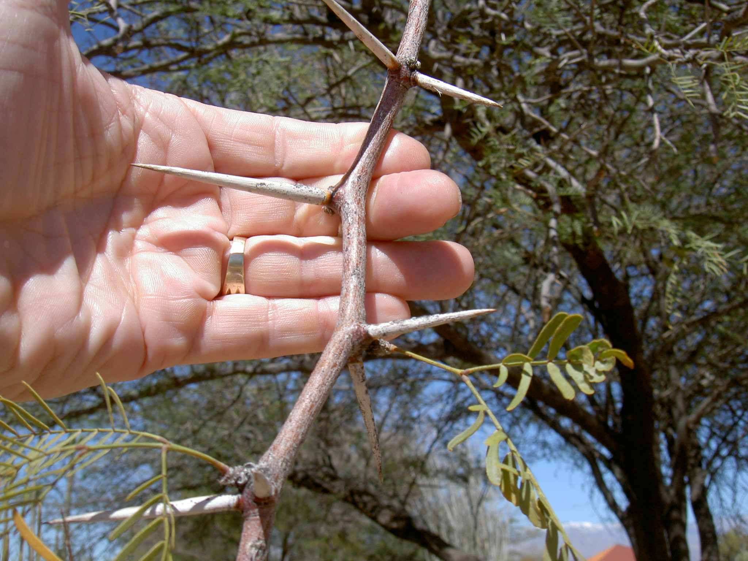
This tree from our Tucson, AZ. Trip, had thorns up to 3” long. I just loved the design of it and had to show it again. Reminded us of the Lord’s ‘crown’

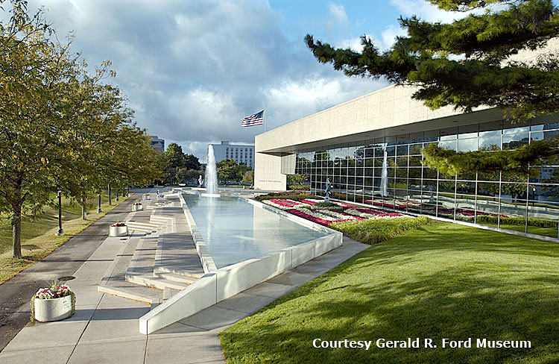
Gerald Ford Museum in Grand Rapids Michigan. The day we went was Betty Ford’s birthday and admission was free. Thank you Lord! Gerald Ford’s favorite Bible verse was “Trust in the Lord with all thy heart: and lean not on thy own understanding. In all thy ways acknowledge him and he shall direct thy paths. Proverbs 3:5,6.


Meyer Gardens had the dome filled with varieties of freshly hatched butterflies. There were 1000’s and they would fly around and land on you.



Most important is the fact that Grand Rapids, Michigan is the home to Cornerstone University, Calvin College, Kuyper College, Grace Bible College, Grand Rapids Baptist Seminary, and many others. Truly this area is the Bible belt of America.

“The Test Results Say Otherwise”

Often we are afraid to confront a situation or expose it. We try to remain neutral and non-participatory. We do not want to bring confrontation or offend an individual. We need to realize that either we offend the individual(s) or we offend God.
Jesus said “Take up your cross and follow me.” If you are not following, you are going the wrong way. “There is one name under Heaven, given among men . . . “
The M.O.M. ministry is based on the “7 S’s” and bases its statement of faith on Ephesians 4 thru 6. In the middle of these 3 chapters we find the following;

Ephesians 5:1 Be ye therefore followers of God, as dear children;
Ephesians 5:2 And walk in love, as Christ also hath loved us, and hath given himself for us an offering and a sacrifice to God for a sweetsmelling savour.
Ephesians 5:3 But fornication, and all uncleanness, or covetousness, let it not be once named among you, as becometh saints;
Ephesians 5:4 Neither filthiness, nor foolish talking, nor jesting, which are not convenient: but rather giving of thanks.
Ephesians 5:5 For this ye know, that no whoremonger, nor unclean person, nor covetous man, who is an idolater, hath any inheritance in the kingdom of Christ and of God.
Ephesians 5:6 Let no man deceive you with vain words: for because of these things cometh the wrath of God upon the children of disobedience.
Ephesians 5:7 Be not ye therefore partakers with them.
Ephesians 5:8 For ye were sometimes darkness, but now [are ye] light in the Lord: walk as children of light:
Ephesians 5:9 (For the fruit of the Spirit [is] in all goodness and righteousness and truth;)
Ephesians 5:10 Proving what is acceptable unto the Lord.
Ephesians 5:11 And have no fellowship with the unfruitful works of darkness, but rather reprove [them].
Ephesians 5:12 For it is a shame even to speak of those things which are done of them in secret.

For those of you that like to work thru the scripture with statistics, let’s look at some logic. I Cor. 6:9-10 states the following;

I Corinthians 6:9 Know ye not that the unrighteous shall not inherit the kingdom of God? Be not deceived: neither fornicators, nor idolaters, nor adulterers, nor effeminate, nor abusers of themselves with mankind,
I Corinthians 6:10 Nor thieves, nor covetous, nor drunkards, nor revilers, nor extortioners, shall inherit the kingdom of God.

Now, God has given us a partial list of the things that restrict us from entering the kingdom of God. Lets just start with the first item listed, “fornicators.” How often do we see the acceptance of sex out of marriage? How often do we hear the excuse of “they are in love?” We have heard of the movement of “Love Waits.” I Corinthians 6:9 clearly states that these individuals shall not inherit the kingdom of God. So the question is, can a Christian be denied access to Heaven? Do these individuals loose salvation? Or, are these individuals not really saved?
God has promised the following to his followers;

John 10:28 And I give unto them eternal life; and they shall never perish, neither shall any [man] pluck them out of my hand.
John 10:29 My Father, which gave [them] me, is greater than all; and no [man] is able to pluck [them] out of my Father's hand.

This shows that there is eternal security for those ‘really’ saved. Many that hear Chaplain Bob preach on salvation, hear his explanation of salvation. “Salvation is a point in life, followed by a process.” There is also the principle of “Once saved, always saved, IF really saved.” Every true Christian can think of a point in life that they came to a saving knowledge of God. At that point a (1) decision is made to give our life to Christ and for us to follow. Repentance is a requirement of salvation. Repentance is the “stop doing want you are doing, turn around, and follow Christ.” The thing we are doing is ‘sin.’ To stop doing requires turning around and turning away from the sin. When we turn around, we are now facing Christ (sin before because of having our back to Him). Now we must be out of neutral to follow Christ. (2) We commit ourselves to serving Christ. We cannot just stop doing the sin of before, but we must do as Christ would have us do (WWJD). (3) We must enter into a ‘covenant’ relationship with Christ. Yes, it is easy as 1. 2. 3 . . . decision, commit, covenant (the process).
Christ has made a promise to his followers of being with him in Heaven. This brings us back to the statement in I Corinthians 6:9 Know ye not that the unrighteous shall not inherit the kingdom of God? Since the situations listed restrict those individuals from heaven, who are these individuals referred to? These are the individuals that may have made the decision, but never entered the commitment or covenant. These are the individuals that thought they had a point, but never had the process. Hebrews 3:14 For we are made partakers of Christ, if we hold the beginning of our confidence stedfast unto the end. The process must continue. Truly, living in habitual sin is a sign of not fully understanding a covenant relationship with Christ.
Familiar with the court system? Accidental crime is forgivable. Even pre-meditated crime is forgivable. The unforgiveable comes when it is premeditated and habitual. Just as this applies to fornication, we could also include idolaters, adulterers, effeminate, self abusers, thieves, covetous, drunkards, revilers, and extortionists, when premeditated and habitual.

Contacts for your next Step Tulare County

Visalia Rescue Mission- They have place to stay and eat and also a recovery program for men and women. Call (559) 740-4178 or write to Carlos Baldovinos (program director) 322 N East 1st Ave, 93291

Homeland Mission Tulare- They have a recovery program for men call (559) 723-4823

Recovery Unlimited- call if you need a helping hand, not a hand out. "We invest in developing, training, and returning people to work". Call (559) 798-0841 or write to Recovery Unlimited INC. 15839 Av.320 Ivanhole, Ca 93935

Sisters of Grace- Trauma/Crisis Healing & Support for women. Call (559) 471-9171 or write to Ruthann Bailey Doyle (CEO Founder/Director) P.O. Box 1533, Visalia Ca. 93278

Partners in Freedom-Support group for men getting out of prison or jail. Call Chaplain John (559) 735-1770 for more information about when they meet.

Love In The Name of Christ (Love INC)-Love INC is a vehicle that helps churches, collectively and individually, reach out to the poor and needy. They will also show you, places to go for your next step. Call (559) 688-8870 or write to Love INC, P.O. Box 6074 Visalia 93290

CSET-Locating jobs for released inmates. Call 559 732-4194 or write
CSET
312 N.W. 3rd Ave.
Visalia, CA 93291

Visalia Employment Connection
4025 West noble Ave, #B
Visalia, CA 93277
(559) 713-5000

Tulare Employment Connection
115 East Tulare Avenue
Tulare, CA 93724
(559) 684-1987

Porterville Employment Connection
1063 West Henderson
Porterville, CA
(559) 788-1440
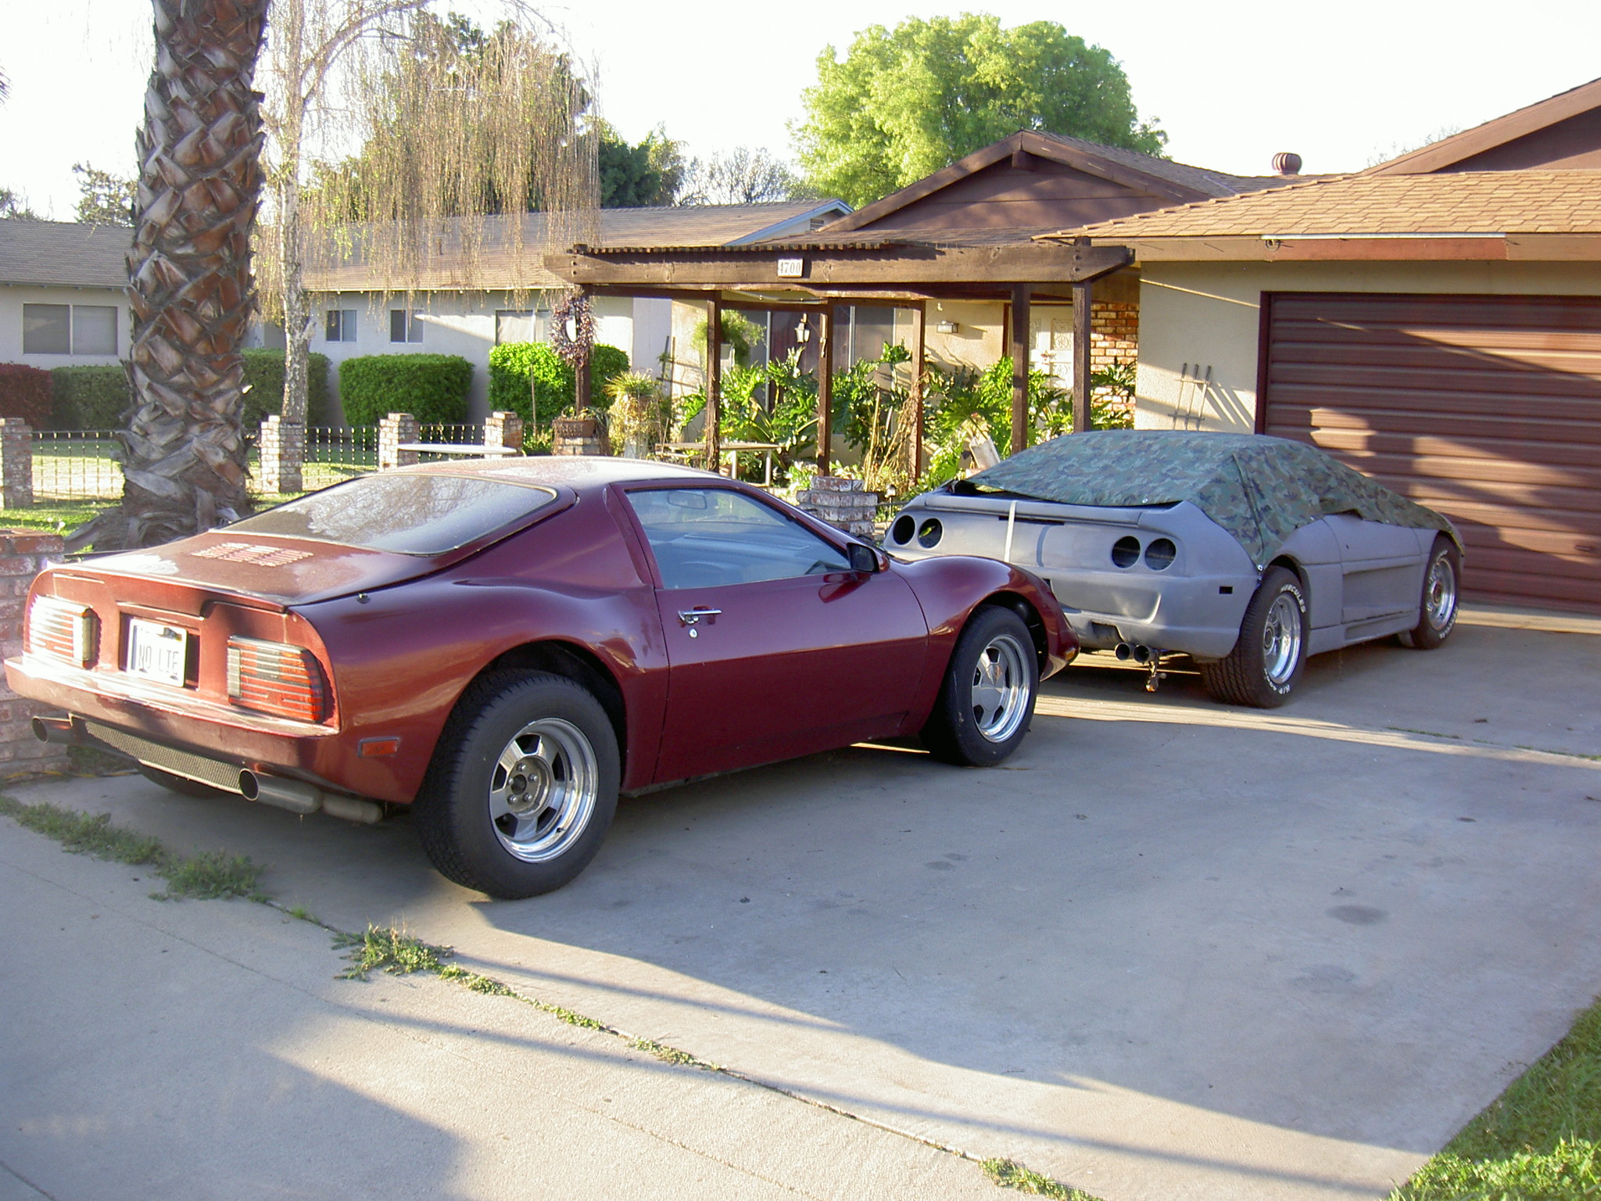
Chaplain Bob’s Fierro 600 & F-355 Replica
MAY 2010

 |  |  |  |  |  | 1
2 | 3 | 4 | 5 | 6 | 7 | 8
9 | 10 | 11 | 12 | 13 | 14 | 15
16 | 17 | 18 | 19 | 20 | 21 | 22
23 | 24 | 25 | 26 | 27 | 28 | 29
30 | 31

Chaplain Bob’s Lamborghini Kit
June 2010
 |  | 1 | 2 | 3 | 4 | 5
6 | 7 | 8 | 9 | 10 | 11 | 12
13 | 14 | 15 | 16 | 17 | 18 | 19
20 | 21 | 22 | 23 | 24 | 25 | 26
27 | 28 | 29 | 30

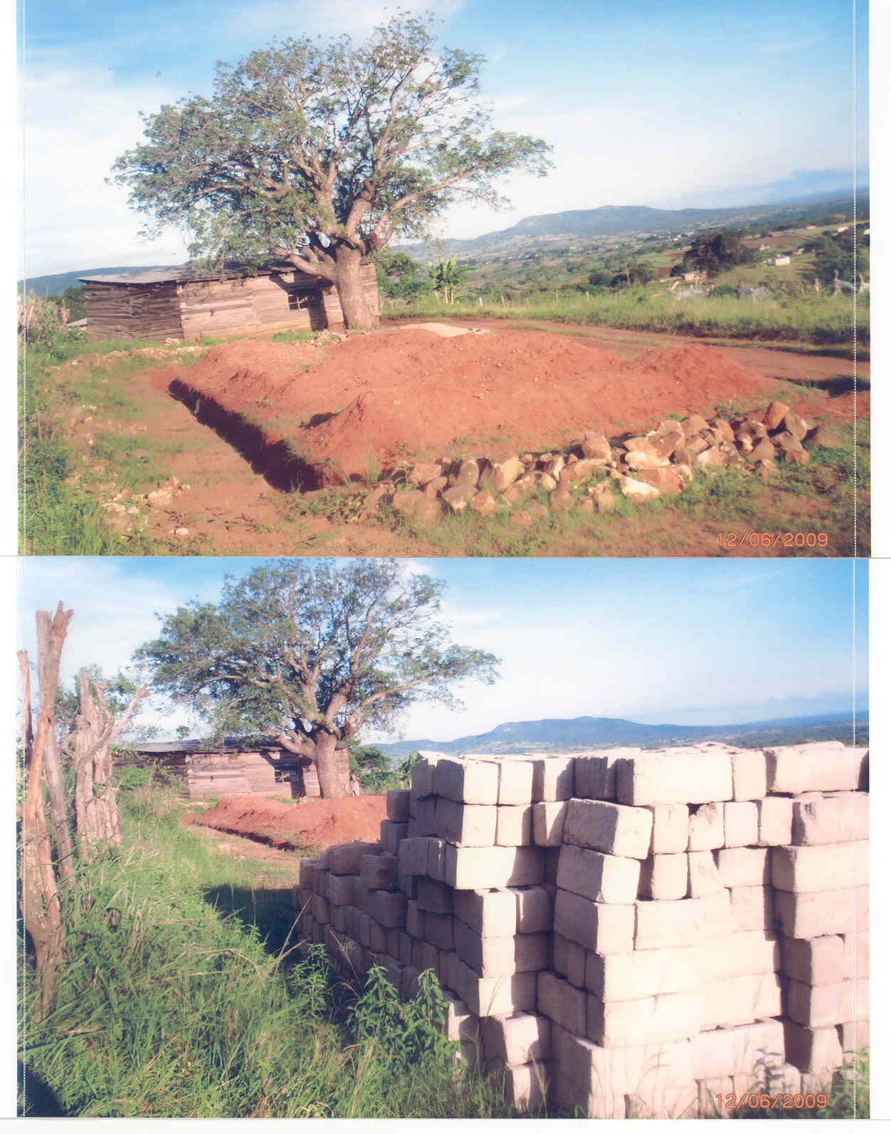
The mound where the new church was to be built and the 6” square bricks (rejected) for construction.
Chaplain Bob’s question to Pastor Jeffrey was “Has the new church opened yet?
Pastor Jeffrey’s letter response was; “Not yet. After hard labour as you may see in the enclosed pictures, the builder told us that the 6 inch blocks we made were not good enough for such a building which measures 15 meters long by 5 meters wide. And more over the church is to be at the top of that small hill which you might have noticed during your visit to Swaziland. He suggested that we make the 9 inch blocks because those may resist the strong winds we experience these days. That has made us to start making some 9 inch blocks, about 2000 blocks to complete the church. That means we have to buy 350 bags of cement of which a bag costs R80.95 each ($1 USD = R7.44500) or $10.87 USD. That means we have to collect about R28,332.50 ($3805.57 USD) before we start the building.

* * * Now for the Challenge: * * *
I know the economy has been tight on America, as well as other countries in the World. This Swaziland church is a project that needs to be finished for the Glory of the Lord. Please share these pictures and the story with others, that there might be a giving to this cause. If you know of churches that can help in even a small way, the address is;

The donations can be made direct to the church and Pastor Jeffrey;
Mawombe Holiness Union Church
Pastor Jeffrey Khumalo
P.O. Box 16
Msahweni, Swaziland

Donations to wire funds into account;
Mawombe Holiness Union Church
Account # 0121414986701
Standard Bank of Swaziland
Piggs Peak Branch #661164

As always, M.O.M. is not looking to have any control or management of this project. M.O.M. just wants the glory to go to God. If you could ever sit in one of these services, as Linda and Bob did, you would be searching the congregation to find where the singing voices of angels were coming from.
----------------------------------------------------
Letter from Pastor Jeffrey;
Brother I want to say thanks to your newsletter which is read by many people. I say this because a person by the name “Michael Elton,” New York State Department of Correctional Services Inmate Correspondence Program, read the M.O.M. Newsletter and sent us a cheque of $10.87 ($10.87 = R78.264) (this was the cost of 1 bag of cement). When we took it to the bank, the bank told us that we could not deposit the cheque because the bank charge was more than the amount of the cheque. The bank charge would be R85.00 ($11.80). We had no choice but to return the cheque. We were very hurt in our hearts as church members because the donation would help us a lot.
So we write you brother to kindly request you send him words of appreciation to him, because he had a desire to see the church started. We know he was hurt, but we pray that God helps him to understand that it was not us, but the bank charges.
----------------------------------------------------

Poetry Section

My Forever Dream
I dreamt one night in my cell
of a man dying on a cross.
Before He died he said “I’m doing this for you . . .
A convict that is lost.
He then said “I’ve always known
The sinner that you’d be . . .
And even after you failed over and over
I’ll still set you free.
When you were headed toward death
I was there and am forever by your side
See my outstretched arms on the cross?
That is your bridge and my spirit your guide
These nails in my hands and feet
They’ll keep me stuck in your heart
Just like I am to this cross
My forever love for you will never part
When your going through sickness
See these stripes on my back?
I was whipped for you, for your good health
And to put your life back on track.
See this crown of thorns on my head?
Its for your peace of mind
Through every torment lie and worry
of this world you’ll overcome and be fine
se as that soldier mocked, hit me
and then tore out my beard.
In Me as you walk in my spirit
This you will never fear
Did you see that soldier?
As he stuck a spear in my side
Its for your most inner secret and sin
From my spirit you’ll never hide
See as I walked up that hill
with the rugged cross on my back?
I cried and died for every sin of this world
So nothing you ever lack
He said all you have to do
Is my commandment
Be baptized in Jesus name
Then your sins will be forgiven
And your life will never be the same.
See I died for you and conquered death
The third day rose again and sit as your heavenly father.
I am here to be your savior and friend.
I woke from this “forever dream”
Still in my cell
Remembering the story of Jesus
By His blood, I never have to go to hell
As I sit here in my cell
Brothers and sisters this is no ordinary poem
But my only hope to make heaven my home.
Ramiro C.

************************************************************************

Jesus our Fortress
When life seems to skip a beat
And of pain you can’t see an end
Look to our Father in heaven
In Jesus Christ we have a friend
Open your heart to God’s endless love
Fill your soul with His eternal grace
The Holy Spirits presence and guidance
Will forever help you run the good race
Remember this world is not your home

We are here but for a short while
Amidst life’s rocky shores and storms
Soon to be given rest in God’s isle.
A rock that encompasses all eternity
A fortress built upon loves holy strength
Each brick saturated by Christ Jesus blood
Upholding all of existences, height, and length.
We have a mighty advocate, comforter
Who will intercede for our every need
An eternal sacrifice, He gave us his all
As from each piercing nail He did bleed
If we give our life to Lord Jesus
God will be more than fair
He will call us gladly safely home
Before God our name will proudly declare.
Jeffrey P.

************************************************************************

There is Still Hope
The sun shines
But my heart weeps
My heart weeps with Godly sorrow
For my soul is deeply distressed
The sins of my youth
Can no longer be suppressed
My head lifts upward
Drawn from the comfort of the sun
My eyes tear
My vision blurs
There is nothing I can see
But rainbows, through its golden rays
Whose warmth caresses me
Assuring me
Reminding me
There is still hope.
Tremayne

************************************************************************

Happy Belated Birthday Linda

Linda’s belated birthday gift from Bob.


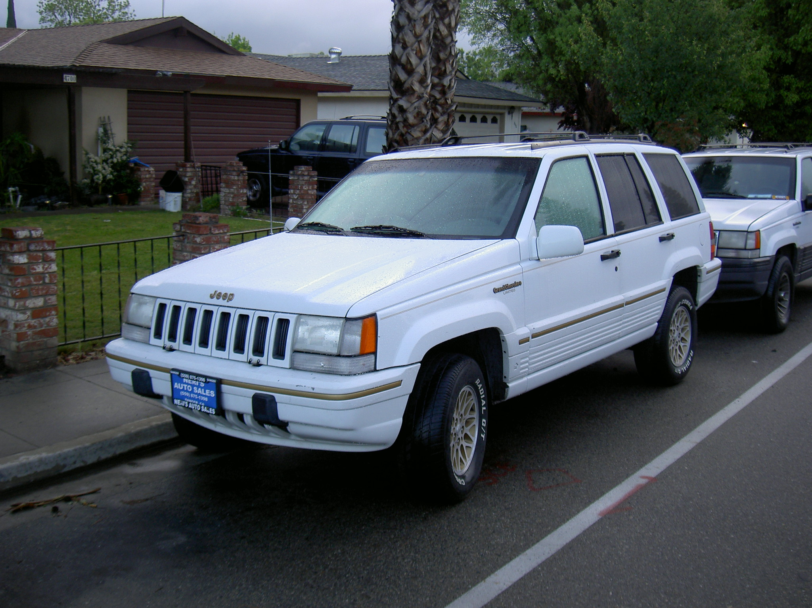

Printers to be added to M.O.M. List price of approx. $5000. M.O.M. purchase for $50 each. GOD IS GOOD, ALL THE TIME.


Inmate Art
by
“Richard Sanchez”

We received the following letter from Richard in response to the Swaziland Africa church request;

. . . But getting back to the church in need of 9” blocks, as I read it, I wished I could contribute some money but I have none, so I thought maybe someday I could. But God reminded me I could contribute something now, and that is my skill to draw. So I will send you five of my drawings for you to sell any way you wish as God lays on your heart. I am a prolific drawer, so its not even a stretch for me to do this. My hope is that you might get at least $10.00 a drawing for them. That will be $50 you could send them. If you got that much, I could send 5 more. Just let me know as I already have started to put this together. As soon as I hear from you, it will be ready to send! You won’t be disappointed with the drawings, but if you are, just let me know and I will send something to replace it.
God be with you always.
Brother Richard

The following 5 drawings Richard sent us, as well as 15 others (including envelope drawings), which we are gladly selling for donations to the Swaziland church.



